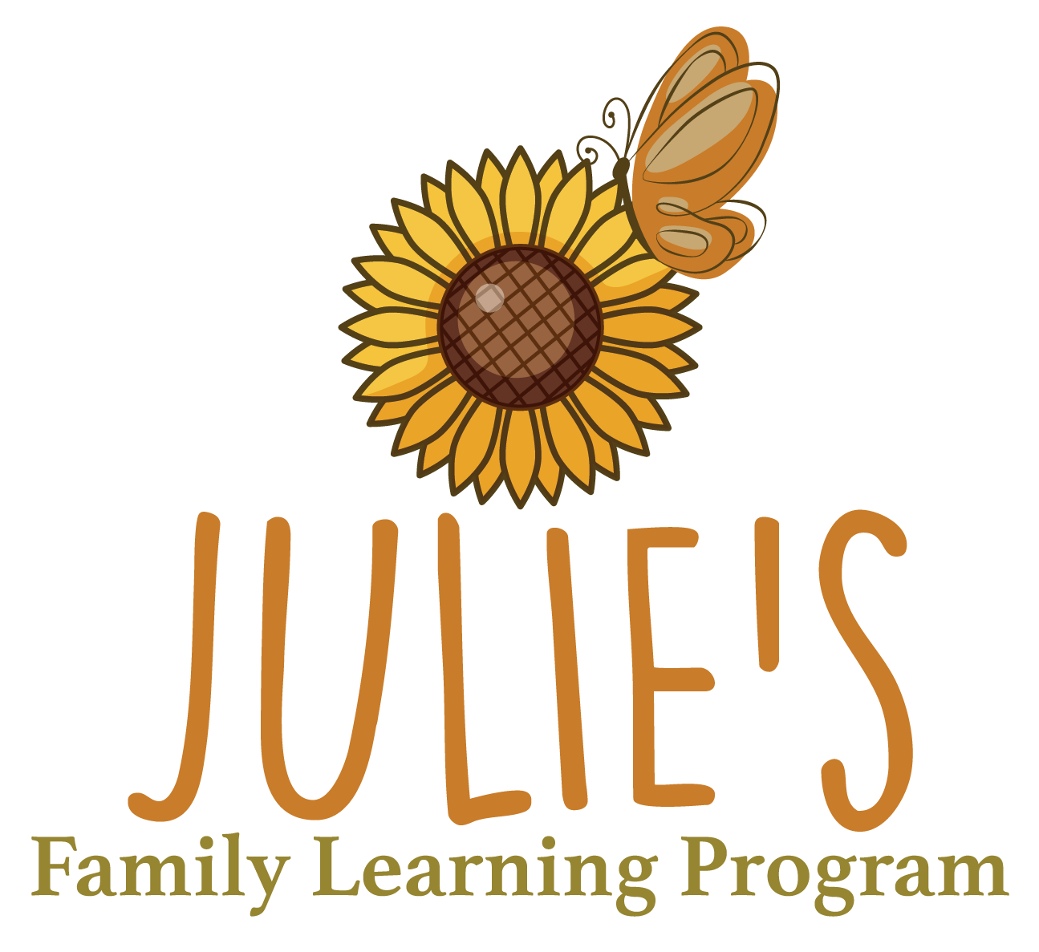  
**Julie’s Family Learning Program**  
133 Dorchester St.  
Boston, MA 02127

**High School Equivalency Instructor/Advisor for Adult Basic Education Program**

**About Julie’s:** Julie’s is a welcoming, inclusive space providing free educational and supportive services to develop strong, successful families and adults. Julie's operates three programs:

1) **Family Development** offers learning opportunities to underserved parents through an intensive curriculum of academic and life management skills. 2) **Adult Basic Education (ABE)** serves anyone age 16+ who is interested in academic classes in preparation for a high school credential. This is a flexible, part-time program with a hybrid option. 3) **Children's Services** offers licensed early childhood education (for infants to age 5) for the children of our adult learners. All adult learners have access to **digital literacy** classes, individual **tutoring**, **career/next step services**, and many **supportive services.** Julie’s staff and students collaborate to develop individualized plans to overcome barriers to achieving their hopes and dreams.

**Job Summary: T**he High School Equivalency Instructor/Advisor provides hybrid group instruction in-person and over videoconferencing for all subjects of the HSE. The learners in these classes are GLE 5-12. Students will be building skills to prepare for the GED or HiSET test. Instructors must maintain student assessment information (both teacher-designed and standardized) to monitor student progress during the year. They help students establish an educational plan and regularly follow up on student goals. They also keep other records, i.e. attendance, so that Julie’s can provide needed statistical data to all funders.

**Essential Duties and Responsibilities:**

* Conduct engaging, organized, and well-developed lessons and units that align with the MA Professional Standards for Teachers of Adult Basic Education
* Create a safe, respectful, and encouraging environment that is conducive to learning
* Maintain accurate and up-to-date student records (testing and attendance)
* Work with the Program Coordinator to align the curriculum to the College and Career Readiness Standards for Adult Education
* Formulate well-defined and consistent learning objectives appropriate to learners’ levels
* Incorporate appropriate technologies in lesson planning and instruction
* Attend staff meetings and collaborate with other Family Development staff to develop services responsive to and supportive of learners’ goals
* Assist students in registering for HISET/GED testing, securing appropriate accommodations, and maintaining records of scores, testing information, etc.

**Preferred Qualifications:**

* Strong commitment to Julie’s mission
* Bachelor’s degree or higher, or equivalent
* Evidence-based reading instruction training strongly preferred
* Familiarity with High School Equivalency, GED and HiSET, strongly preferred
* Familiarity with the College and Career Readiness Standards for Adult Education and the MA Professional Standards for Teachers of Adult Education
* Strong verbal and written communication skills and strong collaborative skills
* 3-5 years of teaching experience, preferably in community-based adult education settings
* Familiarity with trauma informed teaching practice and experience working with learners of diverse and often challenging backgrounds with sensitivity

At Julie’s, we value diversity, inclusion, and belonging. We welcome all applicants and place a high value on those who have lived experiences of adult education, immigration, poverty and/or systemic marginalization and possess a willingness to learn. BIPOC and LGBTQ+ candidates are encouraged to apply.

**Position Hours:** Full time (30+ hours per week) benefited position. Potential evening hours.

**Salary and Benefits:** Salary commensurate with experience between $46,000-$55,000 per year. Benefits include:

* Medical and dental insurance
* 403b retirement plan
* Life Insurance and Long-term disability insurance
* Free staff parking
* Free, on-site childcare for staff children ages 0-5 during school hours
* Daily lunch on school days
* 5 paid school vacation weeks off per year (February, April, June, August and December) plus 5 additional vacation days for a total of 6 weeks paid vacation per year
* Paid sick time
* Employee Assistance Program

**To apply** send cover letter and resume to Anna Fernandez-Buehrens, ABE Program Director, afernandez-buehrens@juliesfamily.org

**Equal Opportunity Employer**

*Julie’s Family Learning Program, Inc. is committed to maintaining a work and learning environment free from discrimination on the basis of race, color, religion, national origin, pregnancy, gender identity, sexual orientation, marital/civil union status, ancestry, place of birth, age, citizenship status, veteran status, political affiliation, genetic information or disability, as defined and required by state and federal laws. Additionally, we prohibit retaliation against individuals who oppose such discrimination and harassment or who participate in an equal opportunity investigation.*