For each scenario below, fill in all the information you can on the Singapore strip diagram. Then use it to ask and answer as many questions as you can. (Also feel free to draw the models differently if you prefer.)
- You have read 210 pages in a book and have 88 pages left to read.
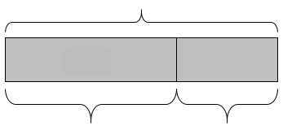

My questions and answers:

- It takes you 45 minutes to get to work in the morning and 20 minutes longer than that to get home.


My questions and answers:

- The cost of three large pizzas and a liter of soda is $29. The soda costs $2.

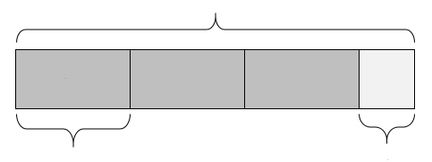

My questions and answers:

- Zaman, Consuela, and Chenda collected canned goods for a food drive. Together they collected 500 cans! Zaman collected 20 more cans than Consuela. Consuela collected twice as many cans as Chenda.
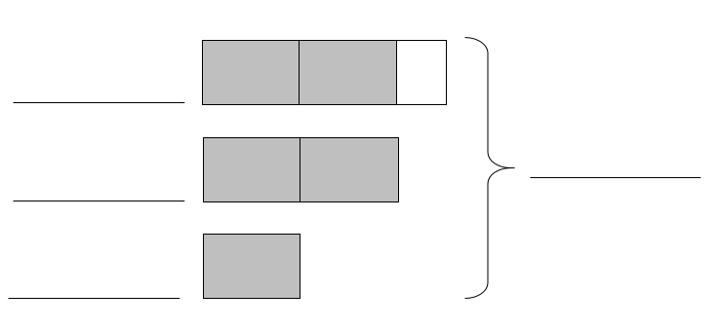

My questions and answers:

For the next set of scenarios, draw a Singapore strip model yourself and then use it to ask and answer questions.
- A recent local election between two candidates was decided by only 15 votes! The winning candidate got 228 votes.
My model:

My questions and answers:

- 29 people went on a trip in 2 vans and 3 cars. Each car held 5 people and every vehicle was full.
My model:

My questions and answers:

- On Tuesday, Liane read the first 20 pages of a book at the library. Then she took the book home and read it at a rate of 6 pages every 10 minutes. Liane read at this rate for 45 minutes. [This scenario is from the 2014 grade 10 MCAS. The question has been removed to make it a scenario.]
My model:

My questions and answers:

- Shirley is saving money to buy a computer.
- The computer she will buy costs $1,200.
- She has already saved $300.
Shirley will save another $60 each week until she has saved enough money to buy the computer.
[This scenario is from the 2017 grade 10 MCAS. The question has been removed to make it a scenario.]
My model:

My questions and answers:

- 650 pounds of food were collected in a drive. Three times as many pounds were collected at the supermarket as at the library. The community center collected 50 pounds more than the library.
My model:

My questions and answers:

- I went to the fair with $35. I spent $15 on admission and went on 4 rides that all cost the same amount. I had $8 left after that.
My model:

My questions and answers:

