For each scenario below, fill in all the information you can on the Singapore strip diagram. Then use it to ask and answer as many questions as you can. (Also feel free to draw the model differently if you prefer.)
- Suong spends $\frac{2}{5}$ of her monthly income on rent. Her rent is $800.



My questions and answers:

- There are 18 students in a class. Yesterday, $\frac{2}{3}$ of the students were absent. $\frac{5}{6}$ of those that were absent went to a rally.
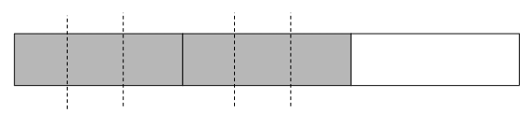

My questions and answers:

- Juan is doing a series of five 2-day trainings. He has completed the first day and a half of training. (Try asking and answering questions that use both fractions and percents!)

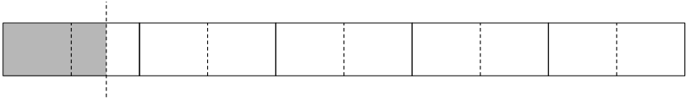

My questions and answers:

- When Danielle left for work this morning, there was $\frac{3}{4}$ of a leftover lasagna in the fridge. When she got home, there was only $\frac{3}{8}$ of that same lasagna left.



My questions and answers:

For the next set of scenarios, draw a Singapore strip model yourself and then use it to ask and answer questions.
- Juanita always tries to put 25% of her weekly take home pay in savings. She then allows herself to spend 10% of what is left on entertainment. She brings home about $300 per week.
My model:

My questions and answers:

- Caleb painted for 2.5 hours in the morning and then declared that he was 20% done with the job.
My model:

My questions and answers:

- $\frac{4}{5}$ of the students in an ABE program signed up for a career workshop. When the day came, only half of those who signed up actually showed up. 6 students showed up.
My model:

My questions and answers:

- A group of ABE students conducted a survey about people’s favorite meal of the day and found that $\frac{1}{4}$ of the people surveyed preferred breakfast, 40% of them preferred lunch, and the remaining 14 people preferred dinner.
My model:

My questions and answers:

