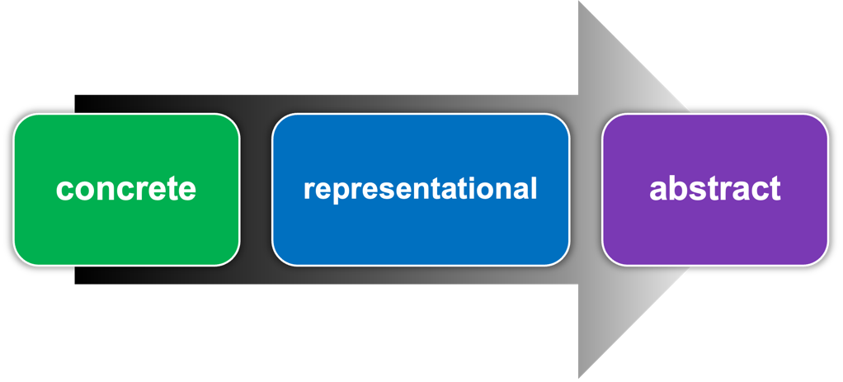
One key to developing conceptual understanding is having experiences that begin with concrete ways of interacting with a concept, move to representational models, and finally push for abstract understanding of the concept.
This sequence positions students to build deep mathematical understanding, fluency, and reasoning.

Concrete
In the video Math Class in Action: Measuring Large Objects with BeCALM: Measurement and Data - Unit 2 (Measuring Length) (see video segment from 1:06–1:52), the teacher used a concrete demonstration to work through a student’s misconception that there are four feet in a yard. To show that it is three feet, the teacher lined three rulers up with the yardstick. Starting with a concrete explanation makes the concept accessible to students at any stage in their learning of the concept.

Representational
A more representational model of the relationship might look like this:
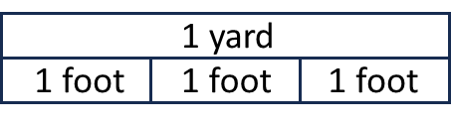
The lengths and their relationships are represented by bars and labels in the diagram, but are not actually one foot (or one yard) long. These simple visuals (i.e. bar models / tape diagrams, number lines, area models, arrays, etc.) are an important bridge between concrete experiences and an abstract understanding of a concept.

Abstract
As students gain more understanding about a concept, they will move towards an abstract way of thinking. An abstract model would state the relationship symbolically.
3 feet = 1 yard
A beginning math classroom will usually have students with varying needs. Some students may need to spend more time at the concrete stage, while others may adopt more efficient representational models more easily. Providing concrete and representational models before moving on to the abstract makes the math accessible and can help students at any level develop deep mathematical understanding.

