Various Variables: SABES ELA PD Center
Using Scientific Thinking to Solve Real-Life Problems

Program: Abisi Adult Education Center | Class/Instructional Level: Intermediate (Pre-ASE)  GLE Range: 4-8 (STAR)
Author(s): Christina Cronin | Date Last Revised: 5/11/2023

PART 1: OVERVIEW
(This part is duplicated on the Scope & Sequence for this level.)
UNIT TOPIC/TITLE  - Frame titles around topics relevant to adults and related to other content areas (e.g., civics/current events/social studies, science and technology, health, literature, workforce preparation, etc.).  - Aim for a pithy topic-related title that can be remembered and used by teachers when referring to the unit. | Various Variables: Using Scientific Thinking to Solve Real-Life Problems
TIME  - Indicate the estimated # of hours (and weeks) required to complete the unit. | 5 week unit  2 classes/week  2 hours/class  TOTAL = 20 hours
RATIONALE  - Explain why this unit is important for adult learners (e.g., how it relates to typical goals of learners at this level). | This is an ELA unit based in science content. It should follow a unit on the basics of the scientific method. Such an initial unit omits the need for variables, but this unit will be all about them.  The unit makes connections between cause and effect and types of variables. With these, students will learn the importance of developing a “fair test,” where only one variable (the cause, or independent variable) is changed to see if that change has any measurable impacts (on the effect, or dependent variable). These higher-level concepts, taught through guided practice, can help students develop critical thinking, make decisions about problems in their own lives, and better understand and evaluate studies reported in the media.  Learners will develop and utilize their reading skills as they 1) identify cause and effect in text while helping them research health conditions and 2) learn about different kinds of variables and fair testing. They will also develop and strengthen their writing skills as they compose clear statements and paragraphs for presentation slides, drafting, and editing pieces before taking them public. Students will use new academic and scientific vocabulary in both spoken and written forms during their presentations and use technology to visually display information to peers. They will also hone their public speaking skills. All of these are essential ELA skills that are given purpose by being contextualized within this science unit.
ESSENTIAL QUESTIONS (optional)  - Include “open-ended, thought-provoking and intellectually engaging questions that call for higher-order thinking.” | How can we determine which lifestyle changes to make to improve our health? (Lessons 1-8)  How does having a better understanding of variables help you solve the problems you face as an adult? (Lessons 8-10)
UNIT OUTCOME / CULMINATING ASSESSMENT  - Describe, in a few sentences, the desired outcome, focusing on the central texts and end products students will use to show their ELA learning (and understanding of the content topic).  - When possible, include one or more authentic performance task(s). | Students will read/analyze/listen to various materials, including online articles, textbook articles, and videos, in order to advance their thinking about how variables and fair test principles affect science and connect to their own lives.  Students will show their learning in two ways. First, they will work within small groups and pairs to create and present a Google Slide on an authentic health-related problem (the Schoolmate Problem) to which they have applied the following:  - A testable question  - A testable hypothesis  - 1 Independent Variable (the Cause)  - Dependent Variable (the Effect)  - Fair test principles (controlling variables; objective measurements; multiple trials)  - Expected results based on research  - Risks if lifestyle changes are not made  Secondly, students will individually draw from their diverse cultures and backgrounds to write their own “real-world” scenarios, with pictures, using Jamboard slides. Students will embed in their scenarios evidence of the combined ELA unit objectives and science skills (cause and effect, variables, fair testing principles, vocabulary words, alphabetics work, digital literacy, and writing clearly). Students will present their Jamboards to each other, and classmates will determine if they have described a fair test.
PRIORITY ELA STANDARDS  - List only the ~3-5 level-specific CCRSAE-ELA standards that will be explicitly taught and assessed.  - Include standards from across the Reading, Writing, Speaking/Listening, and Language domains. | R3C Explain events, procedures, ideas, or concepts in a historical, scientific, or technical text, including what happened and why, based on specific information in the text.  RF3B/C Know and apply grade-level phonics and word analysis skills in decoding words. (Alphabetics)  RF4B/C Read with sufficient accuracy and fluency to support comprehension. (Fluency)  L6C/D Acquire and use accurately level-appropriate general academic and domain-specific words and phrases.  W4C Produce clear and coherent writing in which the development and organization are appropriate to task, purpose, and audience.  SL5D Integrate multimedia and visual displays into presentations to clarify information, strengthen claims and evidence, and add interest.  Also practiced: R5 (text structure), W8D (gather info), W5C (writing process), SL4C (presenting info).
KEY STUDENT MATERIALS  - List authentic and relevant resources (texts, videos, websites, podcasts…) that students will read, listen to, or view.  - Include digital sources and attend to representations of different cultures and perspectives.  - Provide text complexity levels.  - Include texts with lower and higher text complexity levels to support differentiation. | To see all teacher and student materials recommended for the unit, click here.  *Every MA DESE-funded adult education program can access Newsela for free via a state account. Contact your program director to access articles from the site. Wizer.me requires a gmail account. All other educational sites should be automatically accessible or require only a free sign-up.  - Cause and Effect:  - The Latest Buzz (GLE 6)  - Health Articles (related to stress, pre-diabetes, obesity, high blood pressure)  - For Lesson 2:  - TEXT: Attacks of the Nerves (Stress/Anxiety)(GLE5; *www.Readworks.com)  - TEXT: Everyday stresses can be harmful to your health (Stress) (GLE 5; *Newsela)  - TEXT: News about Fast Food (Obesity) (GLE5; *www.Readworks.com)  - TEXT: Salt: The Rock We Eat (Blood Pressure) (GLE6; *www.Readworks.com)  - TEXT: Diabetes: 'It's Just Part of Who I Am': A Teen Learns to Live With Chronic Illness (Diabetes) (GLE7; *www.Readworks.com)  - For Lesson 3  - TEXT: Manage Stress  - TEXT: Adult Obesity: Obesity Rises Among Adults (CDC - GLE7)  - TEXT: Perceived Stress Scale  - TEXT: Prediabetes  - VIDEO: Signs and Symptoms of Diabetes, Explained | JUST THE FAQs  - TEXT: What is High Blood Pressure?  - Variables:  - VIDEO: Variables in Science: Independent, Dependent and Controlled  - VIDEO: Experimental Variables  - TEXT: The Types of Variables (GLE 5/6)  - TEXT: Science Variables (GLE 9)  - Experimental Variables Jamboard  - Fair Testing:  - VIDEO: Fair Test  - TEXT: What is a Fair Test? (GLE 5)  - TEXT: What is a Fair Test? (GLE 7)  - Jamboard: Intro Fair Test  - Jamboard: Fair OR Not?

PART 2: IN-DEPTH VIEW
UNIT OBJECTIVES | ASSESSMENT OF OBJECTIVES
- These should align with the Priority ELA Standards.  - Include objectives for both ELA Skills (directly correlated to the leveled priority standards) and Content Knowledge (related to science, social studies, literature, careers, etc.).  - Add rows as needed. | - Consider how teachers will capture evidence for each objective.  - How will each objective be assessed through the culminating assessment mentioned in Part 1? (e.g., paper, project, problem, presentation)  - (Optional) Attach evaluation tools (e.g., rubrics, checklists) or provide other guidance for teachers.
By the end of this unit, students will be able to: | Students will show their learning by:
Analyze single- and multi-paragraph texts for cause and effect, identifying signal words and relationships. (R3C) | Completing a graphic organizer identifying causes of a specific health issue, gleaned from an Internet source. (Lesson 3)
Identify key details and relationships in scientific texts. (R3C) | Identifying the independent variable, the dependent variable, and the controlled variable in a text describing a “real-world” experiment. (Lesson 5)
Apply knowledge of the prefixes im- and in- to spell and discern meanings of words. (RF3B/C) | Completing a Prefix Quizizz for In- and Im-.  (Lesson 5)  Including at least one word with an in- or im- prefix in the final Jamboard Scenario slides. (Lesson 9)
Read text accurately, at an appropriate rate, and with appropriate expression. (RF4B/C) | Reading aloud a self-written scenario of an experimental design for a real-world problem during the final Jamboard Scenario presentation. (Lesson 10; see Presentation Checklist)
Use general academic vocabulary and terms related to variables and fair testing principles accurately when speaking and writing. (L6C/D) | Correctly using at least 5 terms related to the unit in sentences correctly in their Jamboard Scenario slides. (Lesson 9)
Write sentences and paragraphs that are clear and easy to follow. (W4C) | Constructing a written scenario about a “real-world” experiment to share with the class. (Lesson 9; Peer-Edit Checklist)
Neatly display text, add color, and include appropriate images to slides to enhance presentations. (SL5D) | Creating and using a Google Slide to present a solution to the Schoolmate Problem. (Lesson 8)  Creating and using a Jamboard to present an individual “real-world” experiment. (Lesson 10)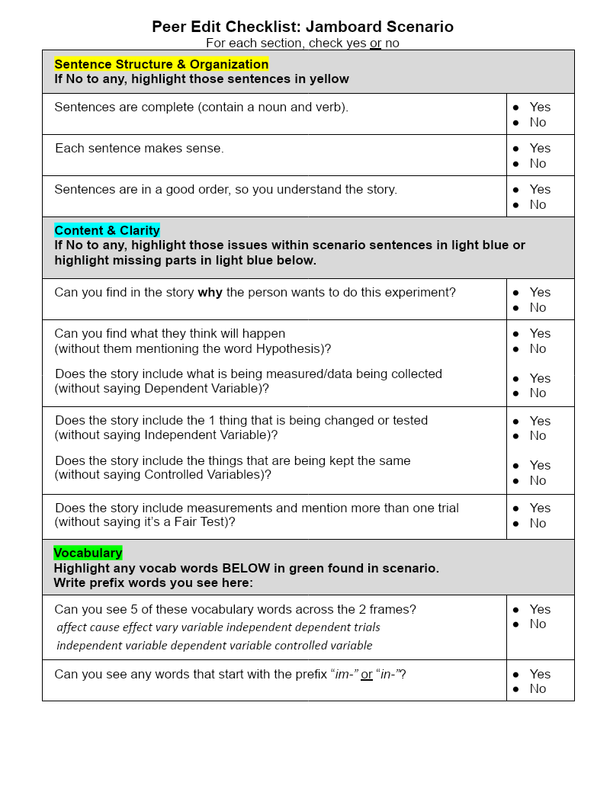

KEY VOCABULARY
- Include academic words or phrases (Tier 2) and key content terms (Tier 3), unless teachers are expected to add these at the lesson plan level. Consider that each set of words will require multiple days of practice.
Tier 2 Words Tier 3 Words
affect  cause  effect | independent  dependent  vary |  | variable  independent variable  dependent variable  controlled variable  trials

LENSES
- Include brief clarifications for how the unit addresses each MA priority lens, providing further recommendations for lenses not transparently addressed in other sections of the unit plan.
Evidence-Based Instruction (including EBRI):
- The essential components of reading (alphabetics, fluency, vocabulary, and comprehension) are included in the unit, with a focus on the low-intermediate level. The teacher will need to use diagnostic assessment tools to determine appropriate reading levels and adjust instruction accordingly.
- The Gradual Release of Responsibility Model (I Do, We Do, You Do) is employed for instruction in all the reading, writing, speaking, listening, language, and digital literacy lessons.
- Sentence and paragraph writing frames are provided as scaffolds for the written portions of the unit.
- Although the writing process is not a priority skill/standard in the unit, students practice the writing process (prewriting, drafting, revising, editing, publishing) as a natural part of their writing activities.

Culturally Responsive Teaching:
- Throughout the unit, students make personal and cultural connections to the content and make choices as to how to demonstrate their learning.
- The slide decks for each lesson include pictures of individuals from different races, genders, and cultures.
- The health issues that are identified in the Schoolmate Problem are intentionally those that are prevalent within certain communities served by ABE. Students will also be prompted to identify those groups that are more likely to be affected by the health issue they are researching.
- As students plan their own experiments around a “real-world” issue, they are equipped to become agents of social change within their families.
- Students are encouraged to share stories, photos, and background information about their own cultures as they create their own experimental scenarios in the culminating project.

Differentiation (especially for English learners and students with learning disabilities):
- Texts written at different complexity levels on the same topic are provided for all fluency lessons. TIP: When leveled groups are used during the fluency lessons, encourage a “jigsaw debrief,” in which each group shares something they learned from their reading.
- Activities throughout the rest of the lessons can be used with texts other than what is specifically mentioned. This flexibility allows teachers to swap out texts as needed to accommodate different reading levels. However, they do need to pay careful attention to the inclusion of cause and effect and/or appropriate content (e.g., the three kinds of variables, fair testing, health issues).
- Other ways the unit may be differentiated according to level:
  - Whereas graphic organizers are provided for the targeted low-intermediate group, higher performing students (or ones already familiar with how the graphic organizer works) can be encouraged to create their own graphic organizer for cause and effect.
  - Whereas sentence and writing frames are provided for the targeted low-intermediate students, these can be minimized or omitted completely for higher-performing students.
  - For students who are close to taking an HSE test, provide pre- and post-unit questions on fair testing and variables, using the format students will see on the test.

Digital Literacy and Technology:
- Students receive explicit instruction and practice in designing Google Slides to support their presentation on their solution to the Schoolmate Problem Scenario.
- Students receive explicit instruction and practice in designing Jamboard Slides, with discussion of similarities and differences with Google Slides. Students create and present a Jamboard Scenario, in which they write a scenario describing a fair test of a proposed solution to a “real-world” problem.
- Students are explicitly taught and/or practice using the remaining parts of the Google Suite (e.g., Google Docs, email).
- Students are reminded about reliable internet resources and health websites.
- Students use multiple online quiz and practice sites (e.g., Quizizz.com, edpuzzle.com, Wordwall.net).

ADDITIONAL RECOMMENDATIONS
- Include guidance for formative assessments and other texts/resources not included in the Key Student Materials section in Part 1.
- What else do teachers need to know? Add these here as well!

Formative Assessments:
- Edpuzzles, Quizizz, Wordwall, and exit tickets are included as formative assessments throughout the unit.
- Where indicated, exit ticket instructions can be found here.

Other Information:
- A slide deck is available for each lesson. Teachers may download the slide decks for each lesson from the Lesson Flow (with Abbreviated Lesson Plans) or the List of All Materials, and customize them as needed.
- While students may use their phones for some digital lesson activities, access to laptops or desktops with internet access and the Google Suite will be necessary for a good amount of the unit.
- It is assumed that students already have a basic knowledge of the Scientific Method. If not, allow more time for the unit.
- Additional time may be needed for preparation and presentations, depending on the class size.

SUGGESTED SEQUENCE OF LESSONS
- Provide a brief overview of what the focus of each lesson would be, as envisioned by the unit developers.
In Lessons 1-8, individual students work with the aid of small groups and pairs to create a “fair test” of a proposed solution to a health issue of a schoolmate described in the Schoolmate Problem. More specifically,

- Lessons 1-4 focus on introducing students to cause and effect relationships along with relevant vocabulary and technology skills needed to better investigate their schoolmate’s health issues in the Schoolmate Problem.

- Lessons 5-8 focus on connecting what was learned about cause and effect to independent and dependent variables in an experiment. In addition, the importance of controlling variables is brought to light along with other fair testing principles necessary to incorporate into their solutions for their schoolmate’s health issue, which they present using Google Slides.

Then, in Lesson 8 (last part)-10, students individually write their own scenario that describes the application of using fair test principles to solve another “real-world” problem of their choosing. A purposeful release of responsibility is given as students work primarily by themselves to develop their own ideas into products that they will present. These lessons bring together all of the priority ELA skills learned throughout the unit and touch upon many other core skills that matter to students in a culminating project using Google Jamboard slides.

- See the Lesson Flow (with Abbreviated Lesson Plans):
  - Slide decks are provided for Lessons 1-8. Follow the links provided.
  - Follow the headings to see how vocabulary, fluency, alphabetics, comprehension, writing, digital literacy, and presentation lessons build off each other.
  - Follow how specific standards are being addressed in each lesson by looking for notations in brackets (e.g., [R3C]).
  - The materials recommended for each lesson are hyperlinked within the instructions. You may also access materials from the List of All Materials and through the Google Drive folder for the whole unit.

- See a full sample lesson plan for Lesson 5, using the ACLS-approved ELA Lesson Plan Template.

