SABES Program Support PD Center

Massachusetts ABE Teacher’s License: MTEL Preparation Resources

The following units of measures will help you prepare for
Subarea III: Mathematics of the ABE MTEL.

US Length Measures
The following facts will help you convert units of length:
- 1 foot (ft) = 12 inches (in)
- 1 yard (yd) = 3 ft
- 1 mile (mi) = 5280 ft (Note: This is generally the most unfamiliar fact.)

Tip: These units of length are all linear measures because they measure distance in one direction (i.e., on a line). You cannot use them to convert square (Area) or cubic (Volume) measures without modifying them.

US Liquid Volume Measures
The following facts will help you convert units of liquid volume:
- 1 cup (c) = 8 fluid ounces (fl oz)
- 1 pint (pt) = 2 c
- 1 quart (qt) = 2 pt
- 1 gallon (gal) = 4 qt

US Weight Measures
The following facts will help you convert units of weight:
- 1 pound (lb) = 16 ounces (oz)
- 1 ton (t) = 2000 lb

Time Measures
The following facts will help you convert units of time:
- 1 minute (min) = 60 seconds (sec)
- 1 hour (hr) = 60 minutes (min)
- 1 day = 24 hr
- 1 week = 7 days
- 1 year = 12 months = 365 days

Metric System
Tip: It’s easier to convert units in the metric system than in the U.S. measurement system. You simply need to move the decimal point the appropriate number of decimal places.

To convert to smaller units move the decimal point right →
kilo-  1000 | hecto-  100 | deka-  10 | meter  gram  liter | deci-  1/10 | centi-  1/100 | milli-  1/1000
← To convert to larger units move the decimal point left

Area Formulas
square | Area = side²
rectangle | Area = length × width
parallelogram | Area = base × height
triangle | Area = ½ × base × height
trapezoid | Area = ½ × (base1 + base₂) × height
circle | Area = π × radius² ; π is approximately 3.14

Perimeter and Circumference Formulas
square | Area = side²
rectangle | Perimeter = 2 × length + 2 × width
triangle | Perimeter = side₁ + side₂ +side₃
circle | Circumference= π × diameter

Volume Formulas
cube | Volume = edge³
rectangular container | Volume = length × width × height
square pyramid | Volume = ⅓ × (base edge)² × height
cylinder | Volume = π × radius² × height
cone | Volume = ⅓ × π × radius² × height

Coordinate Geometry
- The slope of a line is a measure of its steepness. Slope is calculated as "rise over run" (change in y divided by change in x).
- Distance between points = √[(x₂ − x₁)² + (y₂ − y₁)²]
- Slope of a line = (y₂ − y₁)/(x₂ − x₁) when (x₁, y₁) and (x₂, y₂) are two points on a line.
- Slope of a horizontal line is 0; vertical line has no slope.
- All lines with the same slope are parallel.
- Slope-intercept form of a line (where m is the slope and b is the y-intercept)
y = mx + b

Pythagorean Relationship
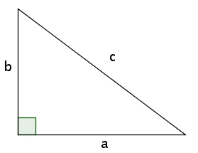
- a² + b² = c²
- a and b are legs and c the hypotenuse of a right triangle.

Measures of Central Tendency
- Mean = (x₁ + x₂ + ... x_{n}) / n (where the x's are values for which a mean is desired, and n is the total number of values for x.)
- Median = the middle value of an odd number of ordered scores, and halfway between the middle values of an even number of ordered scores.
- Mode = greatest frequency
- Range = largest - smallest

Try your knowledge!
Find the mean, median, mode, and range for the following series of numbers; see the correct answers at the end of the page.
2, 2, 3, 4, 4, 7, 7, 7, 9

Distance = rate × time

Cost
Total cost = (number of units) × (price per unit)

Interest
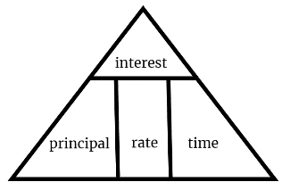
Interest = principal × rate × time

Knowledge Check Answers: Mean =5 Median =4 Mode =7 Range = 2 - 9

