Introduction
This packet is a follow-up to the Make a Kite and Measure Stuff family literacy activities designed for you, the parent. Even if you’ve had to cut back on working toward your own education goals in order to help your children keep up with their own learning, we still want to help you keep building your own skills while you’re helping them.

This packet focuses on geometry, creating and using common benchmark angles. The following activities are similar to ones you might do in a class, starting with things you can build and do with your hands and eventually moving to being able to answer multiple-choice test-like questions. Depending on how old your kids are, you may be able to do these activities with them as well. We hope you find them fun and educational!

Materials You Will Need
Use your circle wedges from the activities in the MPACT packet to explore angles some more. Here’s what you’ll need:
• Blank paper • Ruler for drawing a straight line
• Scissors • Tape
• Angle wedges measuring 180°, 90°, 45°, 60°, 30°, and 15°.
(Create several sets so you have a wide variety of sizes.)

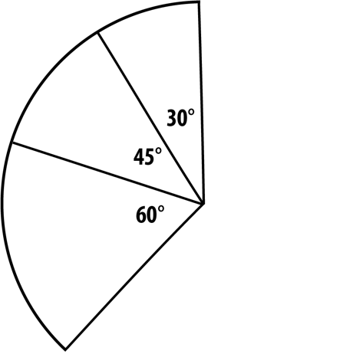
Activity 1: Adding Angles Together
Kaleigh put three of her angle wedges together to make one big angle like the one on the right.

- How many degrees are in her one big angle? _______
- Find three angle wedges you can put together to make a big angle that measures 150°. See how many ways you can do this. Write down or sketch your solution(s).

What other angles can you make by putting wedges together?
Try some of these challenges!

Put three wedges together to make an angle that is smaller than 90°. Use your 90° wedge to check your work.
  - Which three wedges did you use? ____________________________
  - What angle did you make? ____________

Put two wedges together to make an angle that is bigger than 90°. Use your 90° wedge to check your work.
  - Which two wedges did you use? ____________________________
  - What angle did you make? ____________

Put three wedges together to make an angle that is bigger than 180°. Use your 180° wedge to check your work.
- Which three wedges did you use? ____________________________
- What angle did you make? ____________

Activity 2: Right Triangles
STEP 1 Start with a blank piece of paper.
- What angle is at each corner of the paper? ____
(Use your wedges to check if you’re not sure.)

STEP 2 Next, take your 45° wedge and use it to mark a 45° angle on one side of the paper like this:

(You can decide how far up the side of the paper you mark the angle.)
45°

STEP 3 Use a ruler or a straight edge to extend the line all the way down to the other side of the paper, keeping the corner as one of your angles like this:
starting angle

Now you should have a triangle! (If you don’t, try starting with your first angle further down the paper.)

right angle
SPECIAL TRIANGLE ALERT: Your triangle has a 90° angle, also called a right angle. A triangle with one right angle is called a right triangle.

third angle

STEP 4 Label the two angles that you know. What do you think the measure of the third angle is? Make a prediction:

I predict the third angle will measure _____ degrees because ____________________________________________________________________________________________________________________.

STEP 5 Use your angle wedges to see if any of them match the third angle. (Don’t worry if the third angle doesn’t match up with your wedge exactly. When you make wedges by folding and cutting paper, they don’t always come out exactly right.) How close was your prediction?
- What is the measure of the third angle? _____

Repeat the steps with some of your other angle wedges using a new piece of paper each time. You may need to put several wedges together to measure an angle. Complete the following table based on your angle designs.

The right  angle measures… | My starting  angle measures… | I predict the  third angle  will measure… | The third  angle measures ...
90° | 45°
90°
90°
90°

- Did your predictions get better?
If so, what pattern did you discover?

- Add together the two smaller angles in each of your triangles. What do you notice?

Activity 3: Exploring Other Triangles
All the triangles you have made so far have been right triangles. Let’s explore some other triangles and their angles.

STEP 1 Take a piece of paper and this time use two angle wedges to mark two angles on one side of the paper. Your two lines should point toward each other. It might look something like this:

STEP 2 Use a ruler or a straight edge to continue the lines until they meet to make a third angle. Now you have another triangle. It might look like this:
third angle
(If your lines don’t meet on the paper, try moving your starting angles closer together.)

- What wedges did you use for your first two angles? ________________
- What do you think the third angle will measure? Make a prediction and then use your wedges to measure it.

I predict the third angle will measure _____ degrees because___________________________________________________
__________________________________________________________.
The angle actually measures _____ degrees.

STEP 3 Make several triangles using different angle combinations and fill in the following table. As you work through this, keep some notes about how you are making predictions. What are you learning that is helping you make better predictions?

The first  angle measures… | The second  angle measures… | I predict the  third angle  will measure… | The measure of the third angle (using wedges) is…
15° | 30°

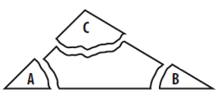
STEP 4 Using one of your triangles, label each of the three angles, then tear them off and put the angles together like you did with the wedges in Activity 1. You might want to use tape to hold them in place. What do you see? What is the name of that angle?
How to make new wedges by tearing off the corners of a triangle
How to make new wedges by tearing off the corners of a triangle

STEP 5 Now add up your angles in each of the triangle in your chart in step 3. What do you notice about the total angle measurement for each triangle? How does that compare to your set of angles that you just lined up?

STEP 6 Based on what you have done so far, write a rule for angle measures for any triangle.

STEP 7 To test out your rule, create some other triangles on your own without using the wedges. Cut out and line up the angles of each triangle. What shape do you see? Line up your angles so the three corners touch the dot in the picture below. How does this connect to your rule?

Activity 4: Tricky Triangle Challenges
Try to create the following triangles on paper. Watch out! Some of them might not be possible! If you think it’s not possible to create a triangle, explain why you think so:

- A triangle with one angle measuring 60° and one angle measuring 45°.
- A triangle with three angles that are 45°, 90°, and 30°.
- A triangle with three angles that are all smaller than 90°.
- A triangle with three angles that are all larger than 90°.
- A triangle with three angles that are all the same.
- A triangle with two angles that are both 90°.
- A triangle with two angles that are both 75°.
- A triangle with two angles smaller than 90° and one angle larger than 90°.
- A triangle with two angles larger than 90° and one angle smaller than 90°.

Reflection
Some triangles were possible and some were not.

- What makes it possible to make a triangle?

- What makes it impossible to make a triangle?

Use this answer key to check your answers to the activity questions. You’ll see that for some questions, there is more than one possible answer! Also, don’t worry if your homemade paper wedges don’t give you perfect measurements.

p. 1 How many degrees are in Kaleigh’s one big angle?
The total measure of her big angle is 135° because 60° + 45° + 30° = 135°

p. 1 Find three angle wedges that you can put together to make a big angle that measures 150°.
Here are some combinations of three angles that add up to a 150° angle:

90° + 30° + 30° 60° + 60° + 30° 90° + 45° + 15°

Other combinations are possible. You can check your work by adding up the measures of your three angles or by putting your wedges together and comparing them to one of the answers listed above.

p. 2 Put three wedges together to make an angle that is smaller than 90°.
Here are some possible combinations of three angles that add up to an angle smaller than 90°:

45° + 15° + 15° (These add up to an angle that is 75°.)
15° + 15° + 15° (These add up to an angle that is 45°.)
30° + 15° + 15° (These add up to an angle that is 60°.)

Other combinations are possible. You can check your work by adding up the measures of your three angles or by putting your wedges together and comparing it to a 90° wedge.

p. 2 Put three wedges together to make an angle that is bigger than 90°.
Here are some possible combinations of three angles that add up to an angle that is bigger than 90°:

45° + 60° + 15° (These add up to an angle that is 120°.)
90° + 15° + 15° (These add up to an angle that is 120°.)
90° + 45° + 30° (These add up to an angle that is 165°.)

Other combinations are possible. You can check your work by adding up the measures of your three angles or by putting your wedges together and comparing it to a 90° wedge.

p. 2 Put three wedges together to make an angle that is bigger than 180°.
Here are some possible combinations of three angles that add up to an angle bigger than 180°:

90° + 60° + 45° (These add up to an angle that is 195°.)
90° + 90° + 90° (These add up to an angle that is 270°.)
60° + 90° + 60° (These add up to an angle that is 210°.)

Other combinations are possible. You can check your work by adding up the measures of your three angles or by putting your wedges together and comparing it to a 180° wedge.

p. 4 What is the measure of the third angle?
The third angle measures 45°.

p. 4 Table of Angles
The prediction column is not filled in because that is a place for your predictions. In the second column, you may have made different choices for the starting angle. This table shows some of the choices you might have made.

The right  angle measures… | My starting  angle measures… | I predict the  third angle  will measure… | The third  angle measures ...
90° | 45° |  | 45°
90° | 60° |  | 30°
90° | 30° |  | 60°
90° | 15° |  | 75°

p. 4 What pattern did you discover?
Here are some patterns you might have noticed:

- When the starting angle is smaller, the third angle is bigger, and when the starting angle is bigger, the third angle is smaller.
- You can subtract your starting angle from 90° to get the third angle.
- The starting angle and the third angle add up to 90°.
If you noticed other patterns, that’s great!

p. 4 Add together the two smaller angles in each of your triangles. What do you notice?
The two smaller angles in each triangle should add up to 90°.

p. 6 Table of Angles
The prediction column is not filled in because that is a place for your predictions. This table shows some of the choices you might have made. If you made other choices, that’s fine!

The first  angle measures… | The second  angle measures… | I predict the  third angle  will measure… | The measure of the third angle (using wedges) is…
15° | 30° |  | 135°
45° | 60° |  | 75°
45° | 30° |  | 105°
60° | 60° |  | 60°
30° | 60° |  | 90°

p. 6 A rule for angle measures of any triangle.
Here are some rules you might have come up with:

- In any triangle, all three angles always add up to 180°.
- In any triangle, all three angles put together make a straight angle.
- You can find the third angle of a triangle by adding the first two and subtracting what you get from 180°.

p. 7 Tricky Triangle Challenges
A triangle with one angle measuring 60° and one angle measuring 45°.
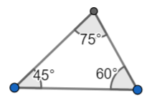

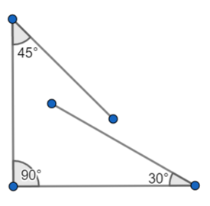

A triangle with three angles that are 45°, 90°, and 30°.

This can’t be done! The angles don’t add up to 180°. Here’s what may have happened if you tried to make this triangle:

A triangle with three angles that are all smaller than 90°.

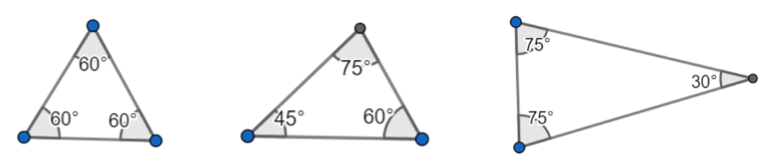
There’s more than one possible triangle that has all three angles smaller than 90°. Here are a few examples.

A triangle with three angles that are all larger than 90°.

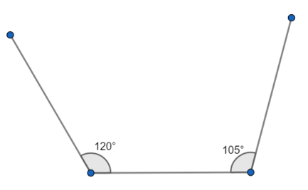
This can’t be done! If all three angles are larger than 90°, the angles will add up to more than 180°. As soon as you make two angles that are bigger than 90°, the sides won’t come together to make a triangle!

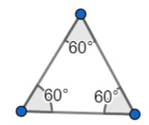

A triangle with three angles that are all the same.

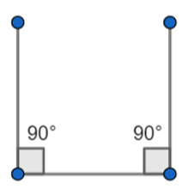

A triangle with two angles that are both 90°.

This can’t be done! If you make two angles that are 90°, the sides of the triangle won’t come together! It might look like this if you tried:

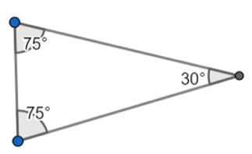

A triangle with two angles that are both 75°.

A triangle with two angles smaller than 90° and one angle larger than 90°.

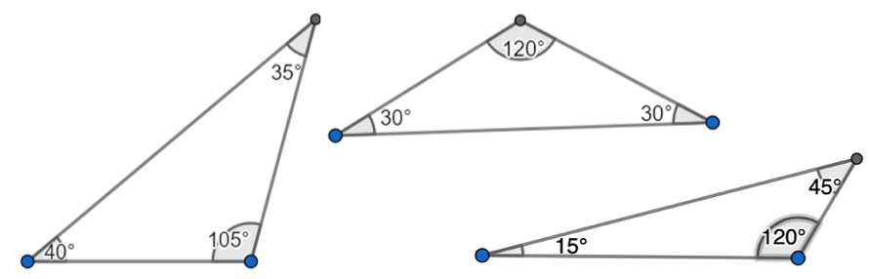
There’s more than one possible triangle with two angles smaller than 90° and one larger. Here are a few examples.

A triangle with two angles larger than 90° and one angle smaller than 90°.

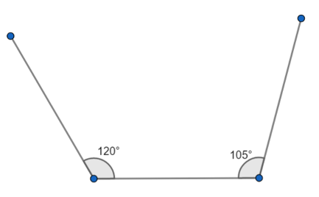
This can’t be done! When two of the angles are larger than 90°, the sides of the triangle won’t come together, like this:

Reflections
What makes it possible to make a triangle?

Here are some ideas about what makes it possible to make a triangle:
You can only make a triangle when all three angles add up to exactly 180°.
There can only be one 90° angle in a triangle.
There can only be one angle that’s larger than 90° in a triangle.
It is possible to have all three angles smaller than 90° in a triangle.

What makes it impossible to make a triangle?

Here are some ideas about what makes it impossible to make a triangle:
If the angles don’t add up to exactly 180°, you can’t make a triangle.
You can’t have more than one 90° angle in a triangle.
You can’t have more than one angle that’s bigger than 90°in a triangle.

