­



Benchmark Fractions

**STUDENT PACKET**



Created with funding from the Adult and Community Learning Services division of the Massachusetts Department of Elementary and Secondary Education by the SABES Mathematics and Adult Numeracy Curriculum & Instruction PD Center, which is managed by TERC, Inc.



**Acknowledgements**

The titles in the BeCALM series were developed and piloted in the classroom by Melissa Braaten for the SABES Mathematics and Adult Numeracy Curriculum & Instruction PD Team, with contributions from Yvonne Readdy, Emily Rudd, and Sherry Soares.

The topics in the BeCALM series include:

* Number Sense
* Operation Sense
* Geometry
* Multiplication Concepts
* Division Concepts
* Measurement and Data
* Benchmark Fractions

The activities on pages 8–11, 31, 36–40, 51–62, and 65 in this document originally appear in the *EMPower Plus Everyday Number Sense: Mental Math and Visual Models* Student Book, and are used and/or adapted with permission from the author, TERC, Inc.

UNIT 1: One-Half

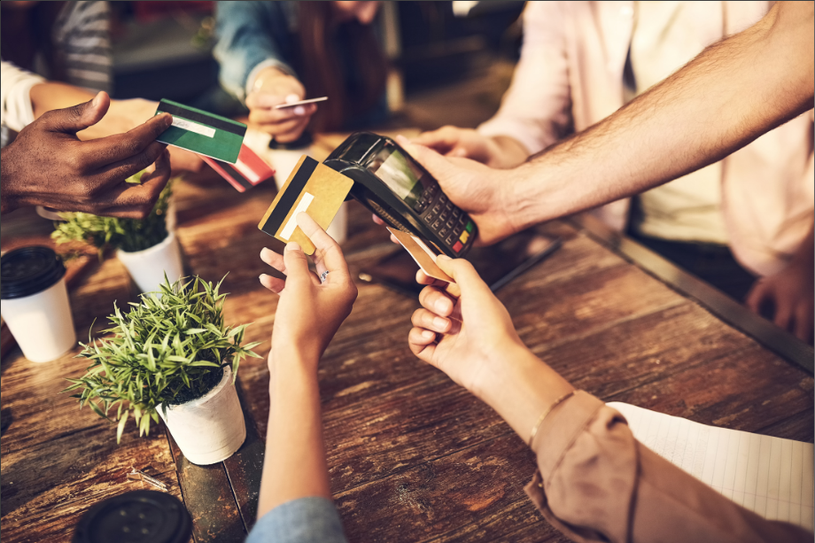

In this unit, you will learn about a useful benchmark fraction, one-half.

**Think and share:**

A time when you had to split something with someone else. Did you split it equally? How did you decide?

# Vocabulary List for This Unit

| **Word** | **Definition** | **Example** |
| --- | --- | --- |
| part-whole | a _____ of something  The part is ________ in the whole. | A group of 6 stars. 4 of them are circled  4 is the part,  6 is the whole  “4 of 6” or “4 out of 6” |
| one-half $$\frac{1}{2}$$ | one of two_________ parts or groups | two representations of one-half the first is a triangle with half shaded yellow the second is 6 asterisk symbols with 3 of them circled |
| numerator | the ________ number in a fraction, representing the __________ | the fraction 3 over 6, with an arrow pointing to the 3, indicating the numerator |
| denominator | the ________ number in a fraction, representing the __________ | the fraction 3 over 6, with an arrow pointing to the 6, indicating the denominator |

|  |  |  |
| --- | --- | --- |
| **Word** | **Definition** | **Example** |
|  |  |  |
|  |  |  |
|  |  |  |
|  |  |  |

# One-Half of a Shape

Shade half of each shape in three different ways.

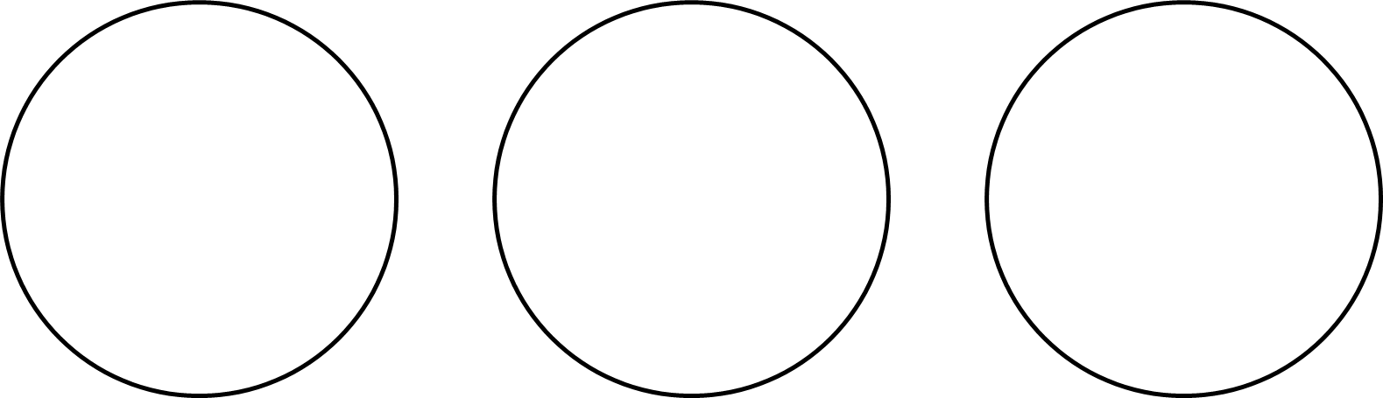



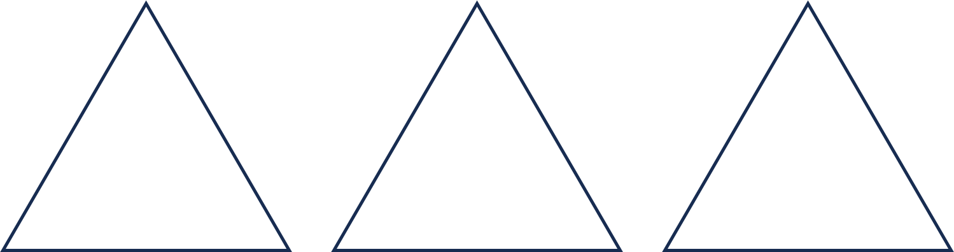

# More Shapes

Shade one-half of each shape. How do you know that you shaded one-half?

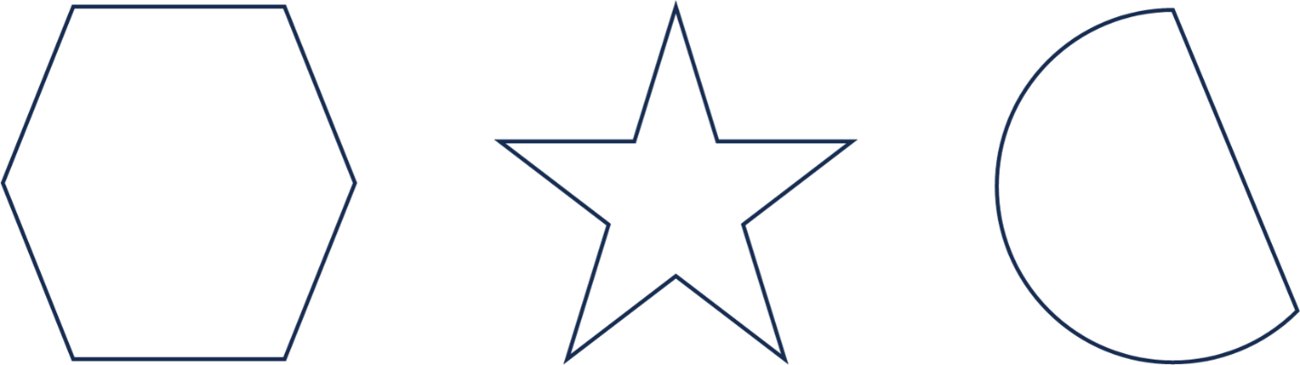

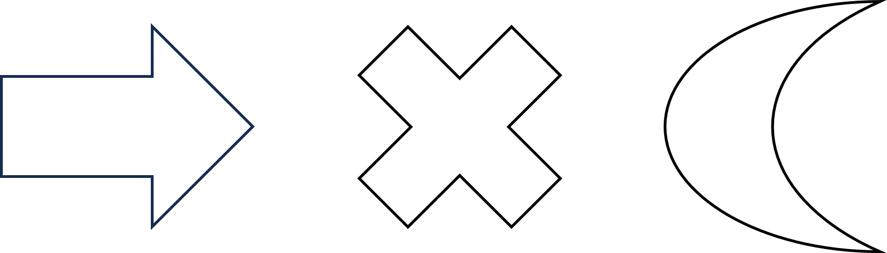



# Show Me One-Half

1. Shade half of the candles in two different ways.

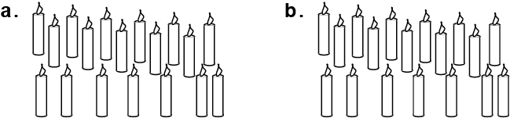

1. This measuring cup can hold 8 fluid ounces. Shade $\frac{1}{2}$ of 8 ounces (oz).

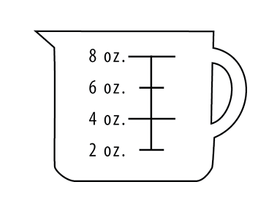

From EMPower™ Using Benchmarks: Fractions and Operations (Student Book). © TERC. Adapted with permission.

1. Show one way to paint the wall below so that it is $\frac{1}{2}$ green and $\frac{1}{2}$ yellow. Don’t paint the window!

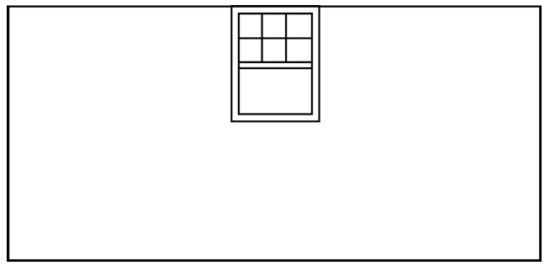

1. Now show another way to paint the wall half green and half yellow.



From EMPower™ Using Benchmarks: Fractions and Operations (Student Book). © TERC. Adapted with permission.

# Find Half of It

Find half of each amount. Then write the fraction.

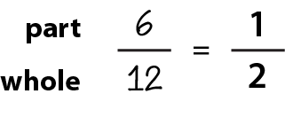

**Example:**  12 hours

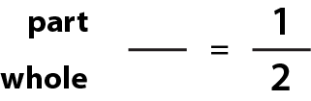

1. 88 years



1. 16 ounces of chocolate



1. 30 days



1. $25

From EMPower™ Using Benchmarks: Fractions and Operations (Student Book). © TERC. Adapted with permission.



1. 750 people



1. 90 feet



1. 400 years



1. 72 miles



1. 54 minutes

From EMPower™ Using Benchmarks: Fractions and Operations (Student Book). © TERC. Adapted with permission.

# Doubling

How do you double a number?

Double each of the numbers. Write the double below the number.

1 2 3 4 5

6 7 8 9 10

How are doubles related to one-half?

Now double each of these numbers. Write the double below the number.

1. 10 20 30 40 50
2. 60 70 80 90 100
3. 12 21 33 44 52
4. 15 25 35 45 55
5. 26 37 48 56 69

# What is the Whole?

What if you know what one-half of a number is? How do you find the whole?

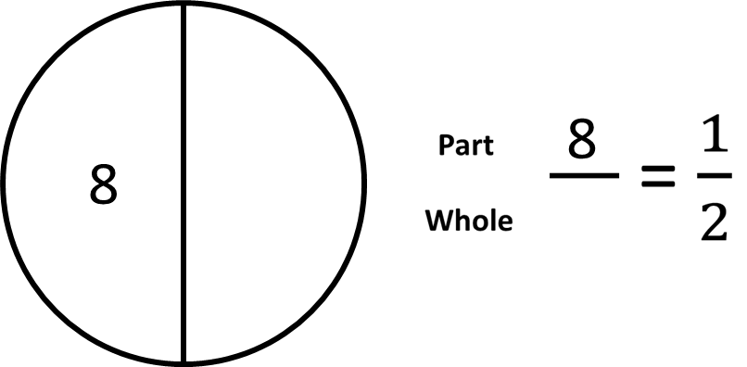

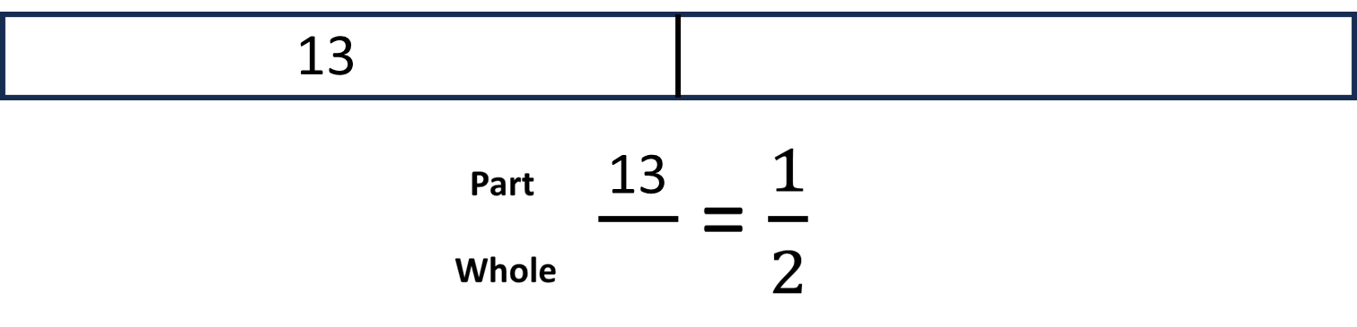

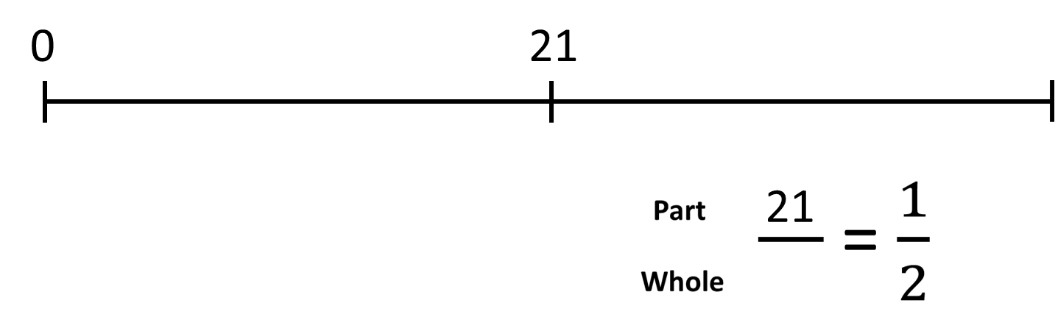

# Practice: What is the Whole?

In the table below, you are given half of a number. Find the whole and write a fraction for the whole.

|  |  |  |
| --- | --- | --- |
| $\frac{1}{2}$**of the number** | The whole number | Fraction for the whole |
| 6 | 12 | $$\frac{12}{12}$$ |
| 15 |  |  |
| 23 |  |  |
| 75 |  |  |
| 36 |  |  |
| 335 |  |  |
| 2.50 |  |  |

# Talking About Parts and Wholes

Which of the following is true?

A) 10 is $\frac{1}{2}$ of 20.

B) 20 is $\frac{1}{2}$ of 10.

# Talking About Parts and Wholes

Which of the following is true?

A) 10 is $\frac{1}{2}$ of 20. **TRUE**

B) 20 is $\frac{1}{2}$ of 10. **FALSE**

One-half is a portion that involves a part and a whole. We use the word “of” before the whole.

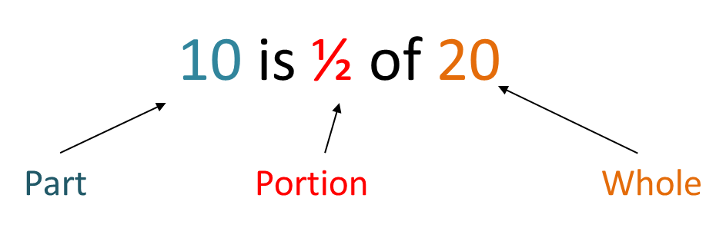



Fill in the blanks below so that the sentences are true.

__ is $\frac{1}{2}$ of 18.

part whole

__ is $\frac{1}{2}$ of 26.

part whole

__ is $\frac{1}{2}$ of 84.

part whole

8 is $\frac{1}{2}$ of __.

part whole

14 is $\frac{1}{2}$ of __.

part whole

32 is $\frac{1}{2}$ of __.

part whole

Fill in the blanks below so that the sentences are true, then turn each into a fraction.

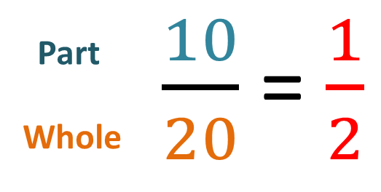



___ is $\frac{1}{2}$ of ___

part whole



___ is $\frac{1}{2}$ of ___

part whole



___ is $\frac{1}{2}$ of ___

part whole

# Portion of Whole

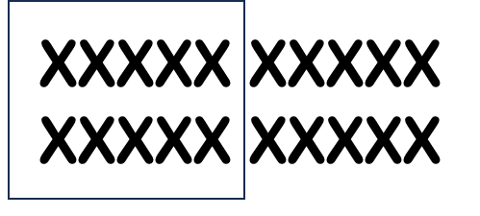

Even if the word order changes, the phrase is still “portion of **whole**.”

10 is ½ of **20.**

½ of **20** is 10.

What is ½ of **20**?

10 is ½ of **what**?

# Practice: Portion of Whole

Fill in the blanks for the image below.



___ is $\frac{1}{2}$ of **____** . $\frac{1}{2}$ of **____** is ____ .

whole whole

**What** is $\frac{1}{2}$ of **____**? ____ is $\frac{1}{2}$ of **what**?

whole whole

# Practice: Portion of Whole

Fill in the blanks for the image below.

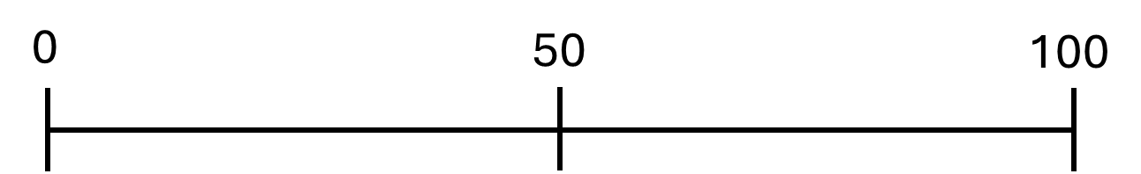



___ is of **____** . of **____** is ____ .

whole whole

**What** is of **____**? ____ is of **what**?

whole whole

# Practice: Portion of Whole

Fill in the blanks for the image below.

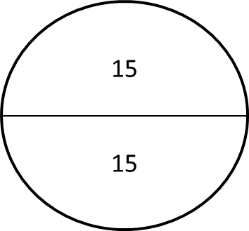



___ is of **____** . of **____** is ____ .

whole whole

**What** is of **____**? ____ is of **what**?

whole whole

# Practice: Portion of Whole

Fill in the blanks for the image below.

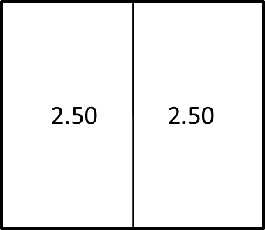



___ is $\frac{1}{2}$ of **____** . $\frac{1}{2}$ of **____** is ____ .

whole whole

**What** is $\frac{1}{2}$ of **____**? ____ is $\frac{1}{2}$ of **what**?

whole whole

**Word Problem Practice**

Ask yourself: What is the part (half)? What is the whole?

1. 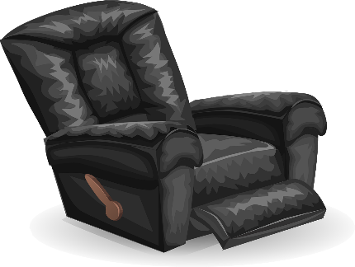Daria is buying a new chair.

She has to pay half of the price now and half later.

The price of the chair is $146.

How much did she pay now?

1. 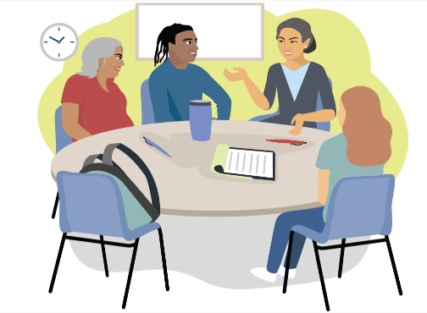One half of the students enrolled in the class are absent today.

9 students are absent.

How many students are enrolled in the class?

1. Pierre’s paycheck will pay for half of his rent.

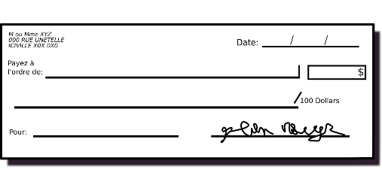His rent is $1,200.

How much was his paycheck?

1. Marlo finished grading half of the student papers.

They graded 23 papers.

How many student papers are there in total?

# Exit Ticket/Homework

You went out to dinner with a friend. You need to pay one-half of the bill. Find the amount you need to pay. Show how you know it is one-half of the bill.

a bill from Snowstar Diner, showing a meal total of $44



**____** is of **____**

UNIT 2: More or Less than One-Half?

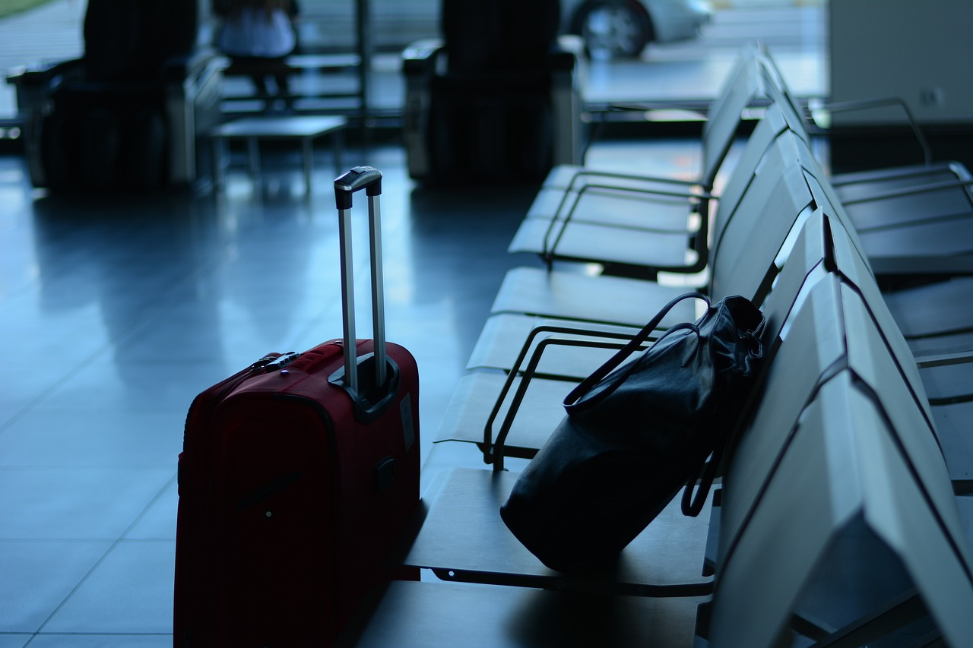

In this unit, you will learn how to use the benchmark fraction one-half to decide if other fractions are more or less than one-half. You will also learn about other ways to say one-half, using decimals and percentages.

**Think and share:**

A time when you had to travel far. How long did it take? How did you keep track of how far you had gone?

# Vocabulary List for This Unit

| Word | Definition | Example |
| --- | --- | --- |
| benchmark fractions | A fraction that is _____­­_ to understand and calculate.  We can ___________ other fractions to the benchmark. | more than $\frac{1}{2}$ less than $\frac{1}{2}$ almost all |
| percent (percentage) | A percentage is a part of _____________ (the whole is 100). | 50% is equal to one half. |
| decimal | The place values that come after the decimal _________.  These represent ___________ or parts of a whole. | .5 or .50 are decimals equal to one half. |
| circle graph/ pie chart | A graph that shows _____________ by breaking up a circle into parts.  The whole circle represents _______ . |  |

|  |  |  |
| --- | --- | --- |
| **Word** | **Definition** | **Example** |
| data | _______________ or _________ of things in the real world. | I am 5’2” tall.  The US population is about 336 million people. |
| to the nearest $\frac{1}{2}$ inch | When measuring, this means you choose the closest _______ or _______ inch on the ruler | a ruler with half inches |

# Why is 50% a Half?

1. How many small squares are in the grid below? How do you know?
2. Use pictures, words, or the grid to show why 50% is $\frac{1}{2}$.

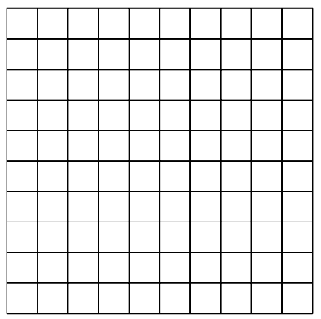

From EMPower™ Using Benchmarks: Fractions and Operations (Student Book). © TERC. Adapted with permission.

# Half of a Dollar

How much is $\frac{1}{2}$ of a dollar?

How do you know?

We write dollars and cents using decimal places.

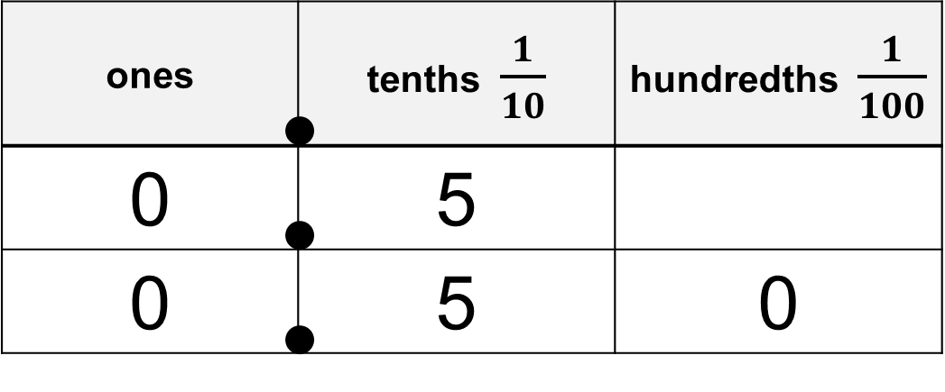

0.5 means $\frac{5}{10}$ 0.50 means $\frac{50}{100}$

Like 5 out of 10 dimes Like 50 out of 100 pennies

# Women in the Workforce

This data is about working women in the United States.

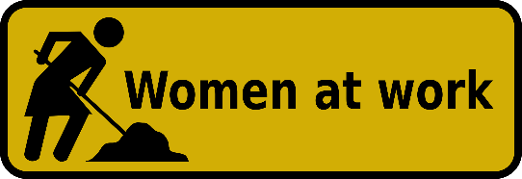

For each percentage, decide if it is more or less than half (50%).

|  |  |
| --- | --- |
| Data | More or less than half? |
| Women who work: 58% |  |
| Women with children under 18 years old who work: 73% |  |
| Women make up 35% of workers in STEM (science, technology, engineering, and math) occupations. |  |
| 36% of lawyers are women. |  |
| 92% of childcare workers are women. |  |
| 9% of firefighters are women (although most are volunteers). |  |

Data from US *Department of Labor, DataUSA, National Science Foundation, and Women in Fire. All statistics are from 2020-2024.*

# Are We There Yet?

Label each number line below with the number of miles for 0%, 50% and 100% of the trip.

Boston to Worcester: 50 miles

a blank number line with tick marks at the beginning, middle, and end

Boston to New York City: 240 miles

a blank number line with tick marks at the beginning, middle, and end

Boston to Philadelphia: 300 miles

a blank number line with tick marks at the beginning, middle, and end

Boston to Chicago: 980 miles

a blank number line with tick marks at the beginning, middle, and end

# Stations: Comparing Fractions to One-Half

At each station, find the part and the whole.

Write the fraction.

Is the fraction you wrote more or less than one-half?

|  |  |  |  |  |
| --- | --- | --- | --- | --- |
| **Item at each station** | **Part** | **Whole** | **Fraction** | **More than $\frac{1}{2}$**  **Less than $\frac{1}{2}$**  **Equal to $\frac{1}{2}$** |
| Station 1:  one month | 16 days |  |  |  |
| Station 2: |  |  |  |  |
| Station 3: |  |  |  |  |
| Station 4: |  |  |  |  |
| Station 5: |  |  |  |  |

From EMPower™ Using Benchmarks: Fractions and Operations (Student Book). © TERC. Adapted with permission.

# Choose an Amount

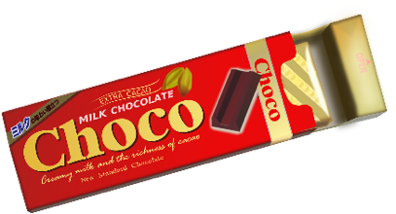There are many correct answers for each question.

1. More than $\frac{1}{2}$ of the chocolate bar (16 oz.)

1. Less than half of her age (42 years old)
2. More than $\frac{1}{2}$ of the class (26 students)
3. More than half of a million dollars ($1,000,000)
4. Less than 50% correct on the test (45 questions)
5. Less than $\frac{1}{2}$ the time (6 hours 20 minutes)

From EMPower™ Using Benchmarks: Fractions and Operations (Student Book). © TERC. Adapted with permission.

**Is It Half?**

1. Sherry dropped a box of crackers. There were 80 crackers in the box. 60 crackers broke.

|  |  |  |
| --- | --- | --- |
| **Fraction for the whole (total)** | **Fraction for half of the whole** | **Fraction of crackers that broke** |
|  |  |  |

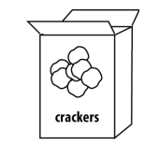

The number of broken crackers was

1. more than $\frac{1}{2}$ of the box
2. less than $\frac{1}{2}$ of the box
3. exactly half of the box
4. Vernon had $15. He gave $7 to his sister.

|  |  |  |
| --- | --- | --- |
| **Fraction for the whole (total)** | **Fraction for half of the whole** | **Fraction of money he gave to sister** |
|  |  |  |

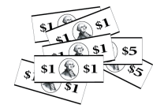

Vernon gave his sister

1. more than 50% of his money
2. less than 50% of his money
3. exactly 50% of his money

From EMPower™ Using Benchmarks: Fractions and Operations (Student Book). © TERC. Adapted with permission.

1. A ream (package) of paper has 500 sheets. Allie used 228 sheets.

|  |  |  |
| --- | --- | --- |
| **Fraction for the whole (total)** | **Fraction for half of the whole** | **Fraction of sheets Allie used** |
|  |  |  |

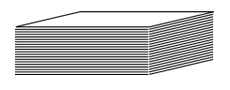Allie used

1. more than 50% of the ream
2. less than 50% of the ream
3. exactly 50% of the ream
4. Kari bikes 7 miles to work. Today she biked 3.5 miles, then stopped for coffee.

|  |  |  |
| --- | --- | --- |
| **Fraction for the whole (total)** | **Fraction for half of the whole** | **Fraction of the trip that Kari biked** |
|  |  |  |

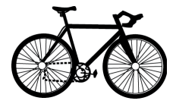Kari was

1. more than halfway to work
2. less than halfway to work
3. exactly halfway to work

From EMPower™ Using Benchmarks: Fractions and Operations (Student Book). © TERC. Adapted with permission.

**More “Is it Half?” Problems**

1. 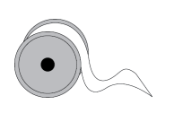Irina had a 21-inch ribbon. She cut off 10 inches for her daughter. She then had
2. more than $\frac{1}{2}$ of the ribbon left.
3. less than $\frac{1}{2}$ of the ribbon left.
4. exactly half of the ribbon left.
5. 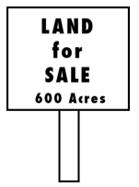The Marquez-Brown family owns a ranch with 1,300 acres of land. They plan to sell 600 acres.

They will sell

1. more than $\frac{1}{2}$ of their land.
2. less than $\frac{1}{2}$ of their land.
3. exactly half of their land.
4. 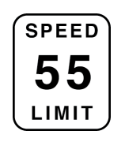Luz was driving at 55 mph (miles per hour) when traffic suddenly slowed to 25 mph.   
   Luz’ speed became
5. more than half of what it had been.
6. less than half of what it had been.
7. half of what it had been.

From EMPower™ Using Benchmarks: Fractions and Operations (Student Book). © TERC. Adapted with permission.

# Notes on Using a Ruler

1. Point the ruler in the same direction as the length that you want to measure.

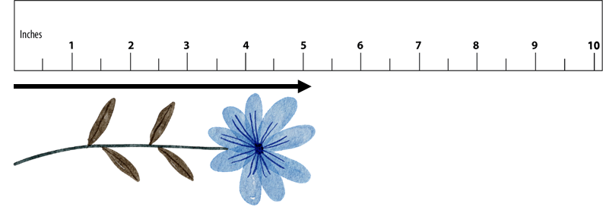

1. Start measuring at the 0 on the ruler. It might not be labeled.

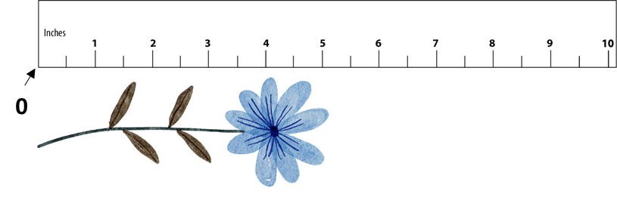

1. Choose the inch (the labeled number) or the half inch closest to the end of the length.

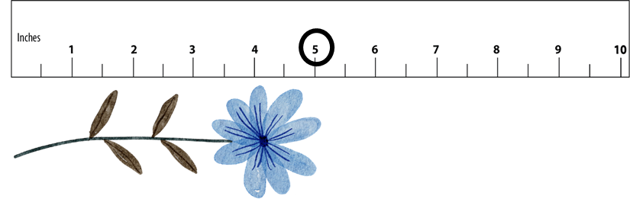

# Measuring to the Nearest Half Inch

****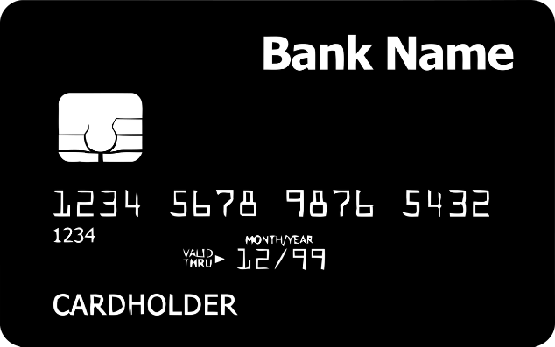

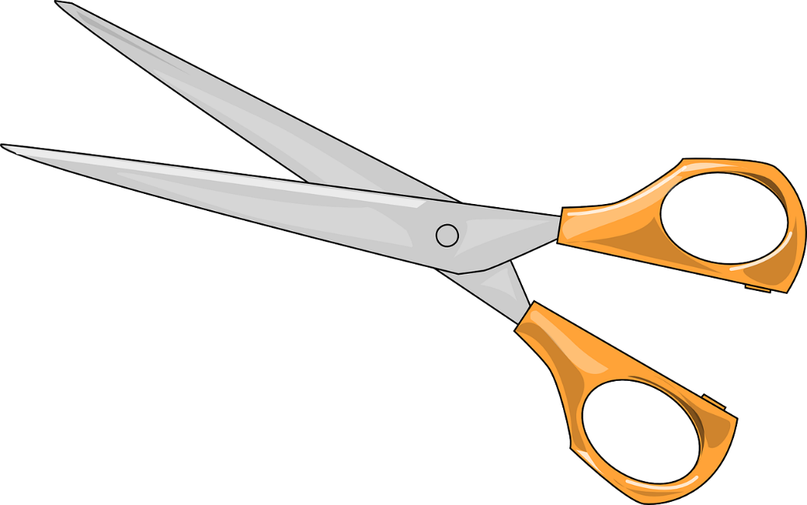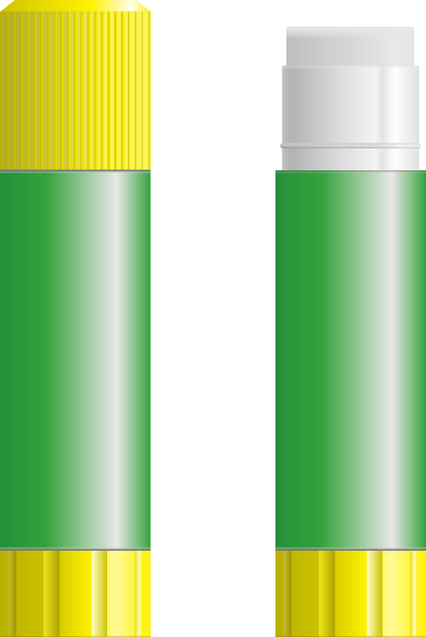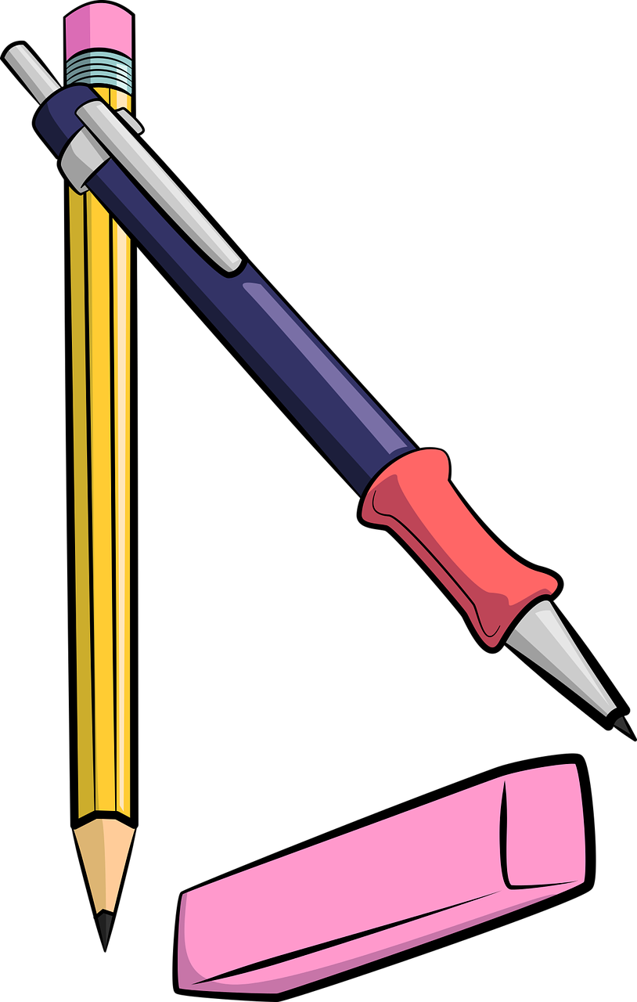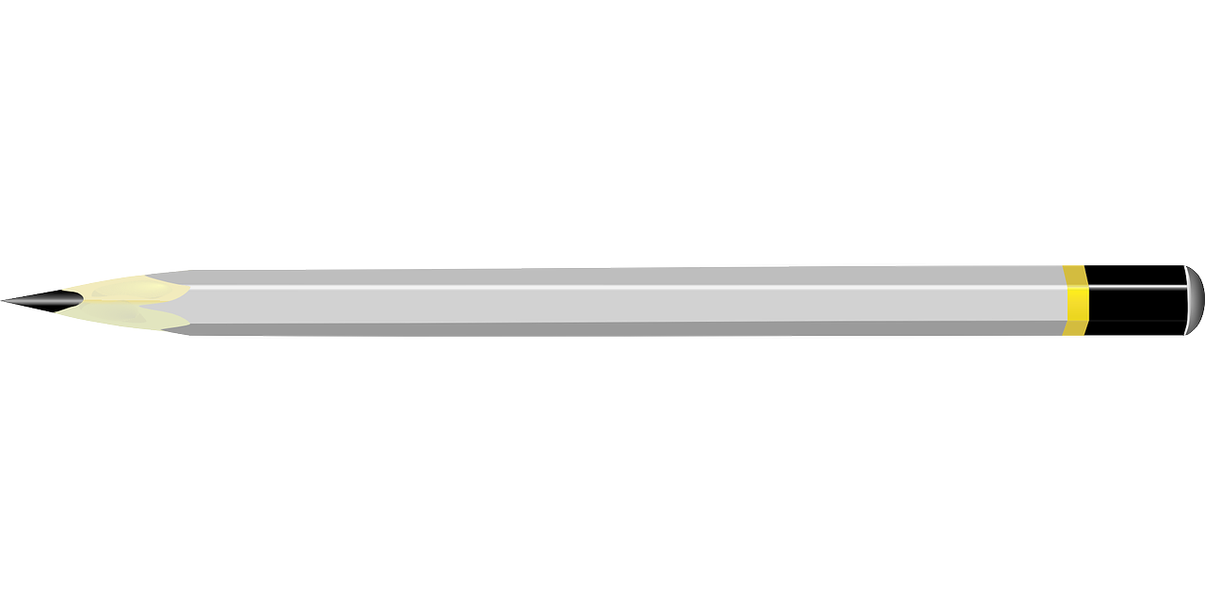

# Financial Literacy: Comparing Sales

With a partner, discuss which sale you think is the best deal and why.

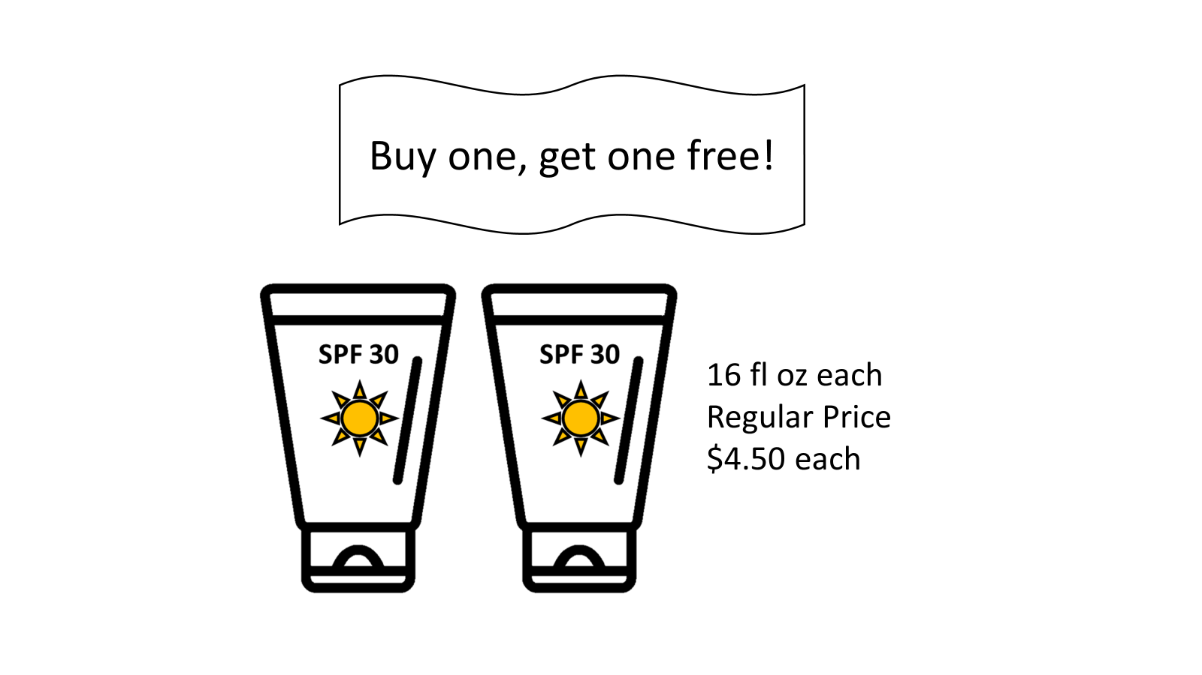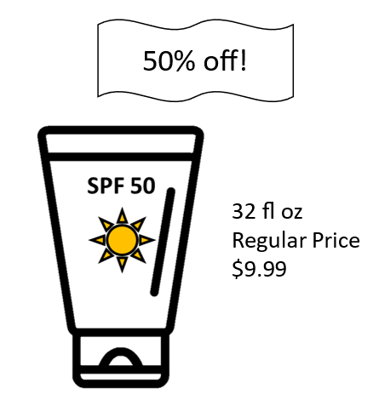**Sale A Sale B**

**Sale C**

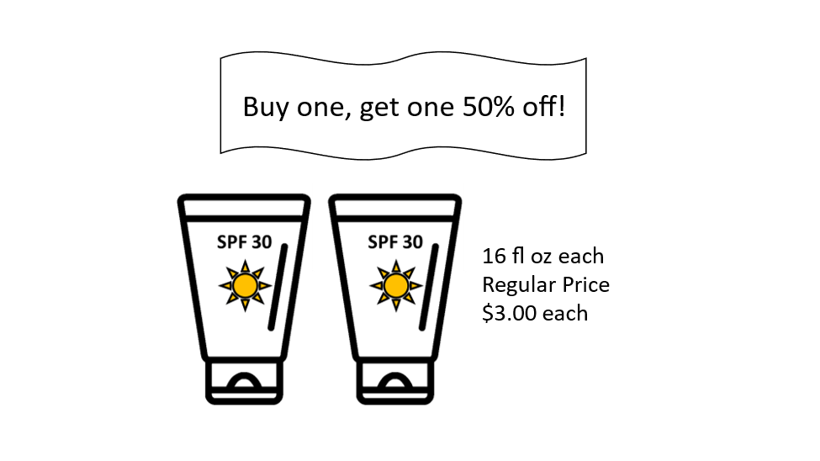

# Exit Ticket

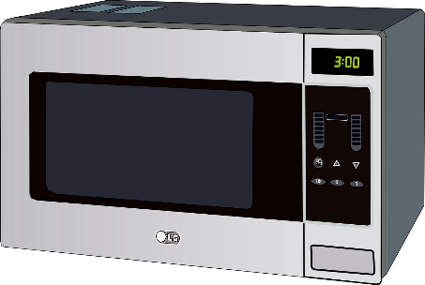

“The original price was $120, but it was on sale! I bought it for only $70!”

The discount was

1. 50%
2. more than 50%
3. less than 50%

Show how you know.

UNIT 3: One-Fourth

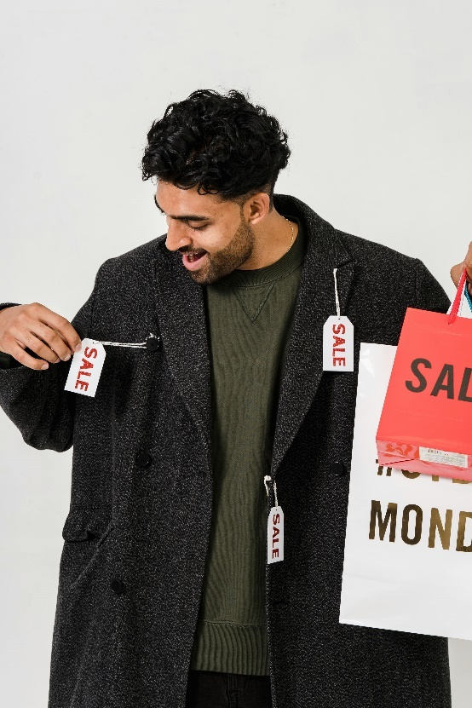

In this unit, you will learn a new benchmark, one-fourth. You will also practice applying your knowledge of benchmark percents to find discounts.

**Think and share:**

A time when you got a really good deal on something you bought.

| **Word** | **Definition** | **Example** |
| --- | --- | --- |
| one-fourth  one quarter $$\frac{1}{4}$$ | One out of _____ equal parts or portions  “______ of a half”  As a decimal: _____  As a percent:_____ | rectangle broken into four equal parts with the diagonals.  one part is shaded.  12 stars with three of them circled |
| discount | When a price has been lowered |  |
|  |  |  |

# Vocabulary List for This Unit

| **Word** | **Definition** | **Example** |
| --- | --- | --- |
|  |  |  |
|  |  |  |
|  |  |  |
|  |  |  |

# What a Bargain!

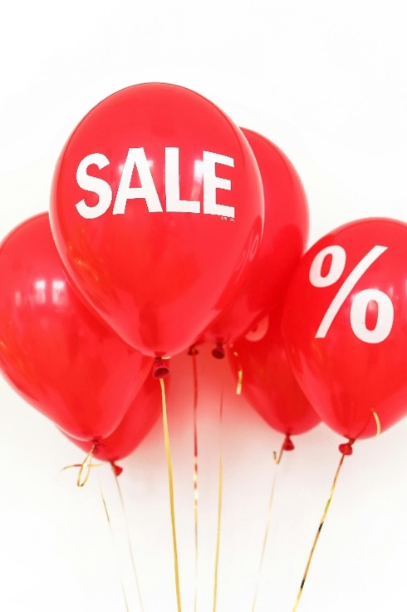

What are some words that mean that a price has been lowered?

 Watch out for:

|  |  |
| --- | --- |
| **for sale** | **on sale** |
| the item can be bought | the price has been lowered (a discount) |

|  |  |
| --- | --- |
| **25% of** | **25% off** |
| A portion of an amount, such as 25% of the class was absent | A discount. 25% of the price is removed. 25% off of $20 means a sale price of $15. |

# Thinking About Discounts

# 

1. Moira has a coupon for 50% off of each item she buys. The cashier says that he is going to find the total and then take 50% off of the total. Is that the same? Why or why not?
2. Josef wants to buy a table. The table is on sale for 50% off. He also has a coupon for 50% off the purchase price. Does that mean he gets the table for free? Why or why not?

# One Fourth of a Shape

Shade one-fourth of each shape. How do you know that you shaded one-fourth? Are there any shapes that will not work?

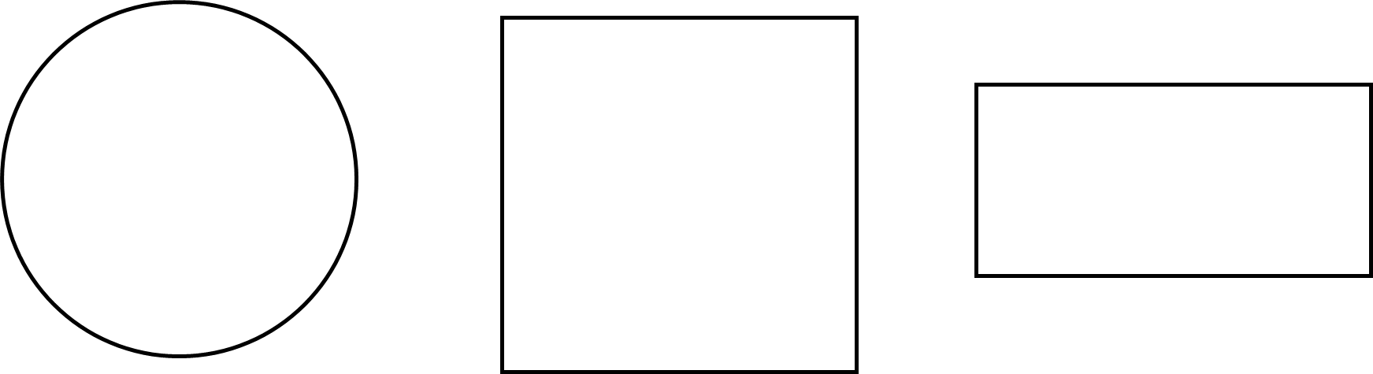

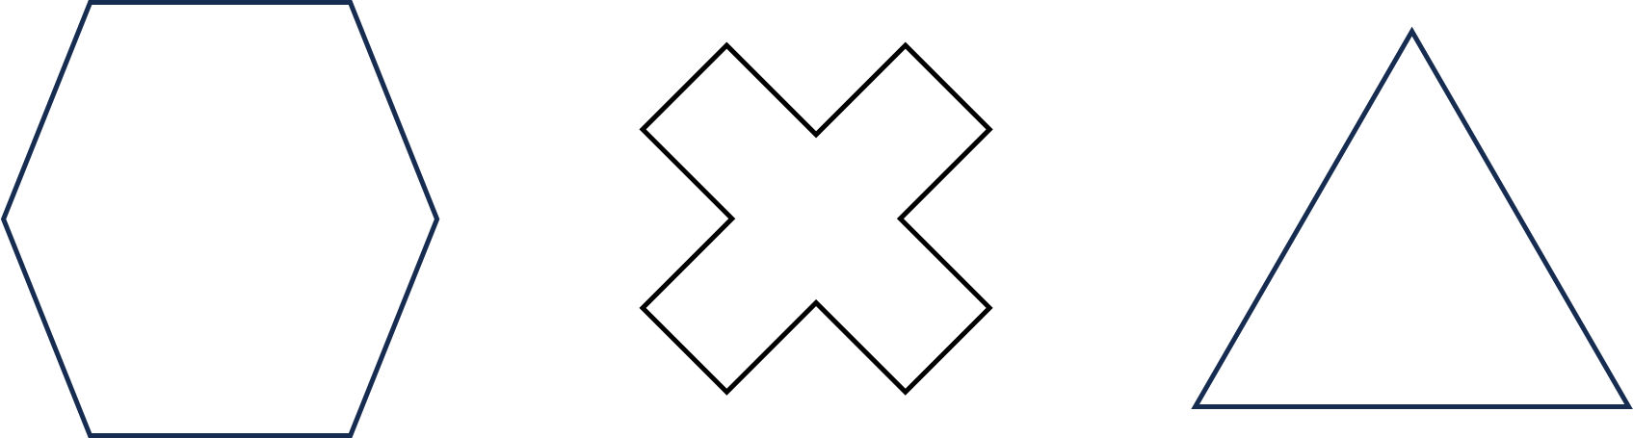



# One-Fourth Spent

# If you spend, waste, or lose $\frac{1}{4}$ of something, you have $\frac{3}{4}$ left.

$\frac{1}{4}$ spent + $\frac{3}{4}$ left = $\frac{4}{4}$ (the whole) 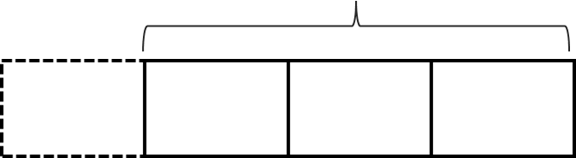

Find how much is spent and how much is left in each situation.

1. Whole: $10 in all

$\frac{1}{4}$ spent $\frac{3}{4}$ left



1. Whole: $5 in all

$\frac{1}{4}$ spent $\frac{3}{4}$ left



From EMPower™ Using Benchmarks: Fractions and Operations (Student Book). © TERC. Adapted with permission.

1. Whole: $90 paycheck

$\frac{1}{4}$ spent $\frac{3}{4}$ left



1. Whole: $220 paycheck

$\frac{1}{4}$ spent $\frac{3}{4}$ left



1. Whole: $300 electric bill

$\frac{1}{4}$ paid $\frac{3}{4}$ owed



From EMPower™ Using Benchmarks: Fractions and Operations (Student Book). © TERC. Adapted with permission.

# Supermarket Power Lost

After the supermarket lost power, some of the food went bad. Find the missing amounts in each situation.

1. 82 lbs. of meat in total

$\frac{1}{4}$ bad $\frac{3}{4}$ still good



1. 200 containers of yogurt in total

$\frac{1}{4}$ bad $\frac{3}{4}$ still good



From EMPower™ Using Benchmarks: Fractions and Operations (Student Book). © TERC. Adapted with permission.

1. How much cheese in total?

$\frac{1}{4}$ bad $\frac{3}{4}$ still good



5 lbs.

1. How much chicken in total?

$\frac{1}{4}$ bad $\frac{3}{4}$ still good



15 lbs.

1. How much ice cream in total?

$\frac{1}{4}$ bad $\frac{3}{4}$ still good = 18 cartons



From EMPower™ Using Benchmarks: Fractions and Operations (Student Book). © TERC. Adapted with permission.

# What Makes It a Quarter?

Look at the grid below. Explain how you know that the shaded portion is $\frac{1}{4}$, .25, or 25%.

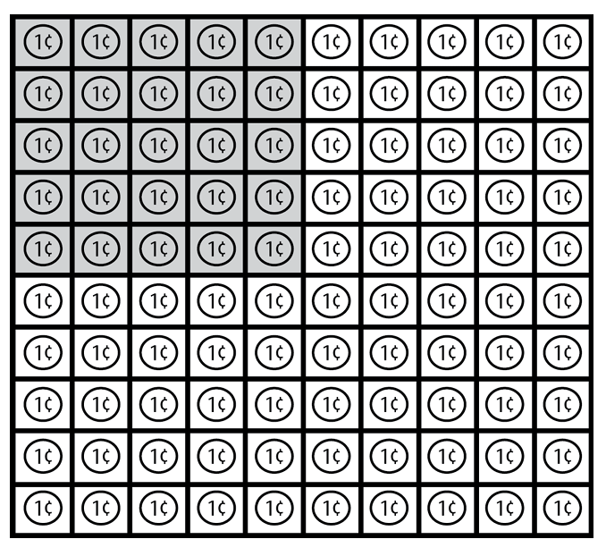

From EMPower™ Using Benchmarks: Fractions and Operations (Student Book). © TERC. Adapted with permission.

# Show Me $\frac{1}{4}$

Shade one-fourth of each of the following shapes or sets of objects, then write a fraction.

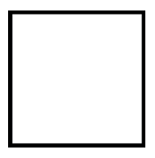

1. 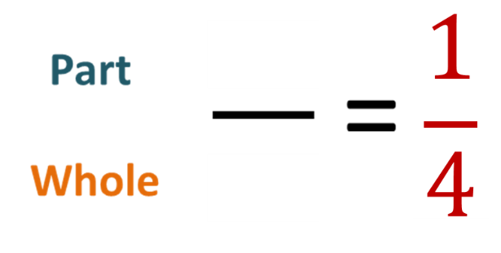

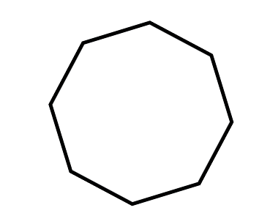



1. 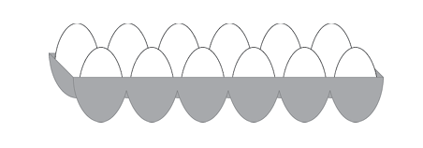

From EMPower™ Using Benchmarks: Fractions and Operations (Student Book). © TERC. Adapted with permission.

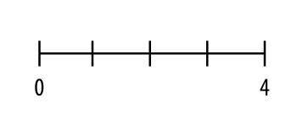For problems 4–6, shade one-fourth of the number line and write a fraction.

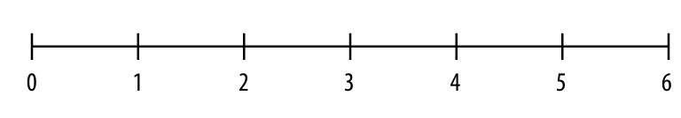



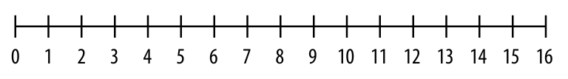



From EMPower™ Using Benchmarks: Fractions and Operations (Student Book). © TERC. Adapted with permission.

# A one cup measuring cupOne-Fourth Measurements

1. Shade one-fourth of 1 cup.

How much did you shade?

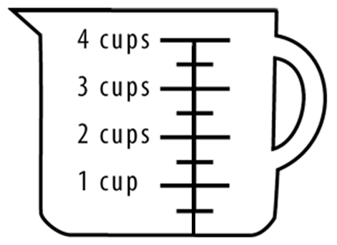

1. Shade one-fourth of 4 cups.

How much did you shade?

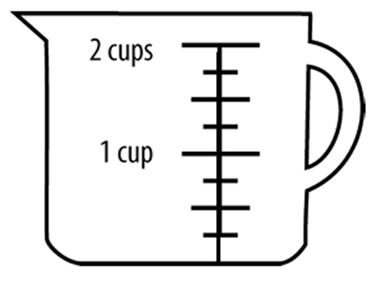

1. Shade one-fourth of 2 cups.

How much did you shade?

1. Shade one-fourth of 12 inches.

How much did you shade?

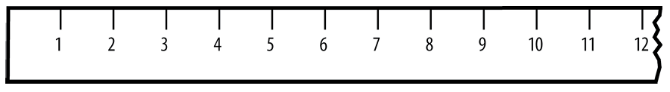

From EMPower™ Using Benchmarks: Fractions and Operations (Student Book). © TERC. Adapted with permission.

1. $\frac{1}{4}$ of 5 pounds = ______ pounds
2. $\frac{1}{4}$ of a day (24 hours) = ______ hours
3. Shade $\frac{1}{4}$ of an hour on the clock below.

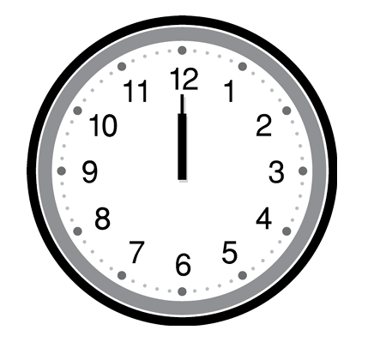

1. $\frac{1}{4}$ of an hour (60 minutes) = ______ minutes

From EMPower™ Using Benchmarks: Fractions and Operations (Student Book). © TERC. Adapted with permission.

# How Many, How Far

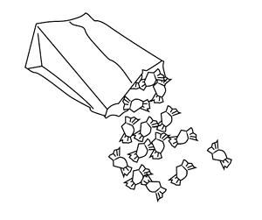

1. DaQuan and Lulu agreed to share a bag of candies. DaQuan took 45 candies and Lulu took 15.   
     
   Kurt was watching and said, “This sharing is not fair! That is not a 50-50 split!”
2. How many candies were in the bag? How do you know?
3. What fraction of the candies did Lulu get? (Label the part and the whole.)
4. Is Kurt right? Explain.
5. Suggest a different way of sharing the candy.
6. Would Kurt say that this way of sharing is fair? Why?

From EMPower™ Using Benchmarks: Fractions and Operations (Student Book). © TERC. Adapted with permission.

1. Enrique walks 18 blocks to the Farmers’ Market. He takes his granddaughters with him.

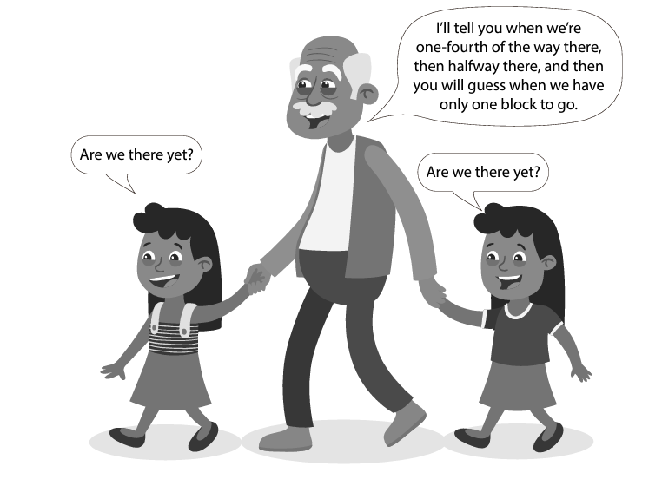

1. At what block will Enrique tell the girls that they are one-fourth of the way there?
2. At what block will Enrique tell them that they are halfway there?
3. How do you know? Use a number line to show your reasoning.

From EMPower™ Using Benchmarks: Fractions and Operations (Student Book). © TERC. Adapted with permission.

1. One-fourth of Shana’s hourly wages go to cover healthcare benefits. Shana makes $16 an hour.
2. How many dollars an hour does Shana contribute to healthcare benefits? Show how you know.

1. If she gets a raise and the cost of health insurance stays the same, will Shana pay more or less than one-fourth of her new wage? Show how you know.

1. The education budget is fully funded at $200 million. If lawmakers decide to cut 25% of that budget, how much will they cut? Show how you know.

From EMPower™ Using Benchmarks: Fractions and Operations (Student Book). © TERC. Adapted with permission.

# Discounts

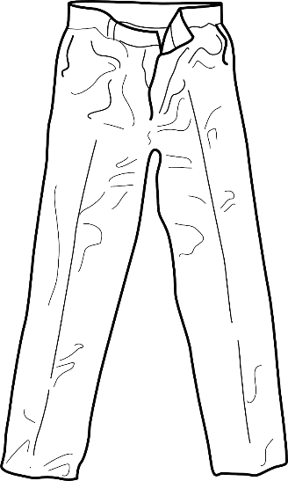When a sale advertises 25% off, it means that one-quarter is removed from the price.

**25% off!**

Original Price: $24

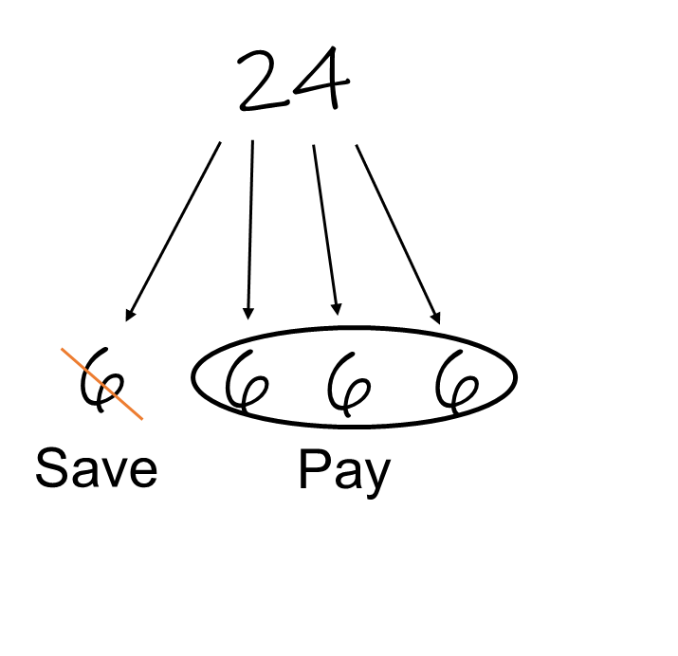

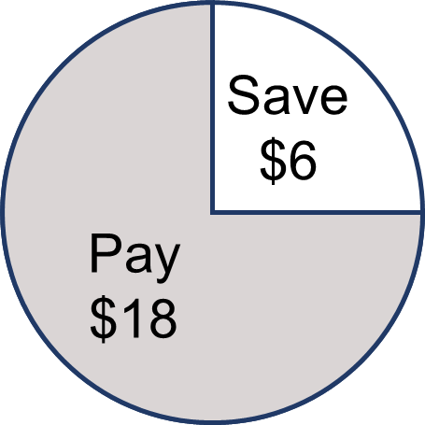

In this case, you save $6.

You pay $18 for the pants.

# Discounts: Practice

|  |  |
| --- | --- |
| **50% off!**  Original Price: $48    You save: _____  You pay: _____ | **25% off!**  Original Price: $32    You save: _____  You pay: _____ |
| **25% off!**  Original Price: $52    You save: _____  You pay: _____ | **Clearance: 75% off!**  Original Price: $60    You save: _____  You pay: _____ |

# Comparing Fractions to One-Fourth

For each example, find the part and the whole.

Write the fraction.

Is the fraction you wrote more, less, or equal to one-fourth?

|  |  |  |  |  |
| --- | --- | --- | --- | --- |
| **Example** | **Part** | **Whole** | **Fraction** | **More than $\frac{1}{4}$**  **Less than $\frac{1}{4}$**  **Equal to** |
| 1. 8 days of rain out of 30 | 8 days | 30 days |  |  |
| 1. 125 yards run in a 440 yard race |  |  |  |  |
| 1. 20 minutes out of an hour |  |  |  |  |
| 1. 1,320 feet out of a mile (5,280 feet) |  |  |  |  |

From EMPower™ Using Benchmarks: Fractions and Operations (Student Book). © TERC. Adapted with permission.

# Extension: Missing Quantities—Parts and Wholes

Find the missing amounts and explain how you found the answer.

|  |  |  |
| --- | --- | --- |
|  |  |  |
| 12 | a bar diagram showing fourths.  Each fourth is labeled 12, and three fourths are shaded.  Labeled "so 3 fourths is 36." | If 12 people is 1 fourth, and 4 fourths is 4 times 12, then 48 is the whole, or four fourths. |
|  | 12 |  |
|  |  | 12 |
| 10 |  |  |
|  | 18 |  |

# Open Sentences with $\frac{1}{4}$

Fill in the blanks so the sentences are true. Circle or highlight the whole in each sentence.

1. _________ is $\frac{1}{2}$ of _________.
2. _________ is 50% of _________.
3. _________ is $\frac{1}{4}$ of _________.
4. _________ is one quarter of _________.
5. _________is 25% of _________.
6. $\frac{1}{2}$ of _________ is _________.
7. 25% of _________ is _________.
8. What is one-fourth of _________? _________
9. _________ is 25% of what? _________

# Test Practice Problems

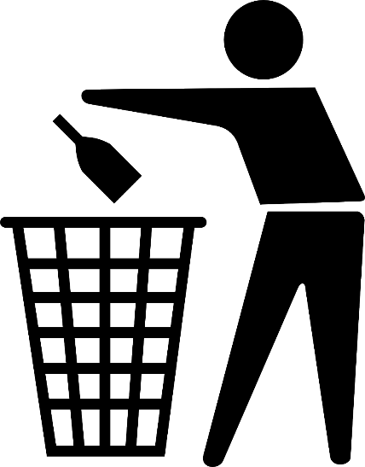

1. There are 150 clear glass bottles in a recycling bin. These are $\frac{1}{4}$ of the total bottles in the bin. How many bottles are in the bin?
2. 150
3. 154
4. 300
5. 450
6. 600
7. 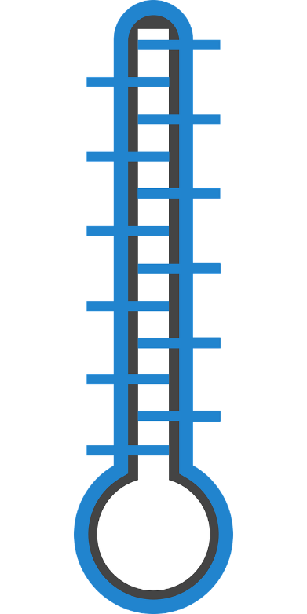Guy plans to raise $1,000 for the asthma fund. To figure out the amount that represents one-fourth of his goal, Guy can
8. Divide $1,000 by 4.
9. Find $\frac{1}{2}$ of $1,000 and multiply by 2.
10. Multiply $1,000 by 4.
11. Divide $1,000 by 2.
12. Divide $250 by 2.
13. In the graph below, which age group made up about $\frac{1}{4}$ of the total voters?

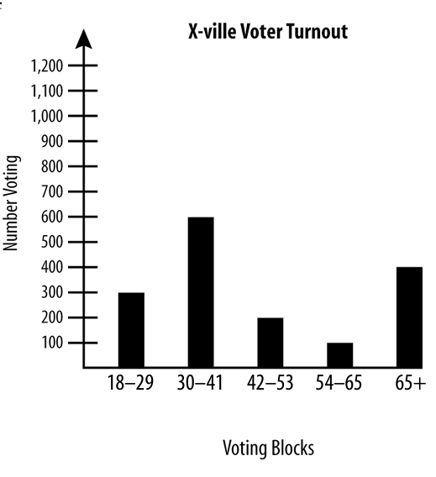

1. 18 to 29
2. 30 to 41
3. 42 to 53
4. 54 to 65
5. 65+

# Financial Literacy: Getting Paid

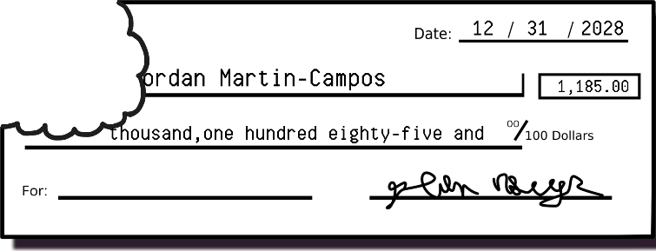Have you ever had money taken out of your paycheck? Why? What are some reasons that you might not “take-home” all of the money you earn?

|  |  |
| --- | --- |
| Gross pay | the _____________ of money a person earns in each paycheck |
| Net pay/Take-home pay | the amount of money the person is paid, after ______________ |
| Deductions | to deduct means to ____________. Deductions are amounts _________ from the gross pay (money that you don’t get to take home!). |

# Common Deductions

**Income Tax:**   
Most people who are working pay some tax on their income. Usually this tax is deducted (or subtracted) from the gross pay in each paycheck. Income taxes are based on a percentage of your income.

**Health Insurance:**   
If a job offers health insurance that means the cost of the insurance plan is shared: the employer pays part of the cost, and the employee pays part of the cost. This is usually deducted from the gross pay in each paycheck.

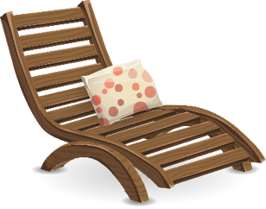**Retirement:**   
Some jobs offer a retirement plan (401K or 403B). Employees can choose to put part of each paycheck into their retirement account. This money is invested so it can increase in value and can be used when the person retires (or reaches a certain age).

What are some other possible deductions?

# Practice: Marie’s Pay

1. Marie earns $1,800 of gross pay each month. Her deductions for income tax and health insurance are about 25% of her gross pay.   
     
   What is her take-home pay each month?
2. Marie is looking for a new job. She guesses that her deductions for income tax and health insurance will still be about 25% of her gross pay. She wants at least $1,500 of take-home pay per month to pay her rent and other expenses.

How much gross pay does Marie need to earn each month? Show how you know.

# Ming’s Paystub

1. Ming is looking at his paystub. His gross pay was $1,200. His take-home pay is $940. Ming’s deductions are
2. less than 25% of his gross pay
3. exactly 25% of his gross pay
4. more than 25% of his gross pay

Show how you know.

1. Use benchmarks to sketch a circle graph of Ming’s gross pay. Label one section “Deductions” and the other section “Take-home Pay.”

# Exit Ticket

Janine’s math class met twice a week for 14 weeks. She missed 7 classes. Janine’s attendance percentage was:

1. 25%
2. 50%
3. 75%
4. 100%

Show how you know.

UNIT 4: Survey Project

In this unit, you will complete a project where write your own survey question, collect data, and graph and describe your results.



**Think and share:**

A time when you filled out a survey. What was the survey about? Why do you think someone wanted to collect that information?

# Vocabulary List for This Unit

| **Word** | **Definition** | **Example** |
| --- | --- | --- |
| survey | A tool used to collect _______. A survey asks people to __________________. Can be done face-to-face, on paper, or electronically. |  |
|  |  |  |
|  |  |  |
|  |  |  |

| **Word** | **Definition** | **Example** |
| --- | --- | --- |
|  |  |  |
|  |  |  |
|  |  |  |
|  |  |  |

# Writing Yes or No Survey Questions

You are going to write survey questions that can be answered yes or no. Here are examples of good yes or no questions:

* Do you have a pet?
* Do you live on the first floor?
* Did you drink coffee this morning?

Some questions do not always give a yes or no answer.

Weak: Do you eat rice? (could be “sometimes”)

**Better: Did you eat rice yesterday?**

Weak: Do you walk to school? (could be “sometimes”)

**Better: Did you walk to school today?**

Weak: Can you speak English? (could be “a little”)

**Better: Is English your native language?**

**Name(s)**_________________________________________________

**Survey Question Report**

**Question**

________________________________________________________________________________________________________

**Data** **Circle Graph** (Label!)

|  |  |
| --- | --- |
| Yes |  |
| No |  |
| Total Responses |  |

**Conclusion** (Use benchmarks to describe your results.)

____________________________________________________

____________________________________________________

____________________________________________________

____________________________________________________