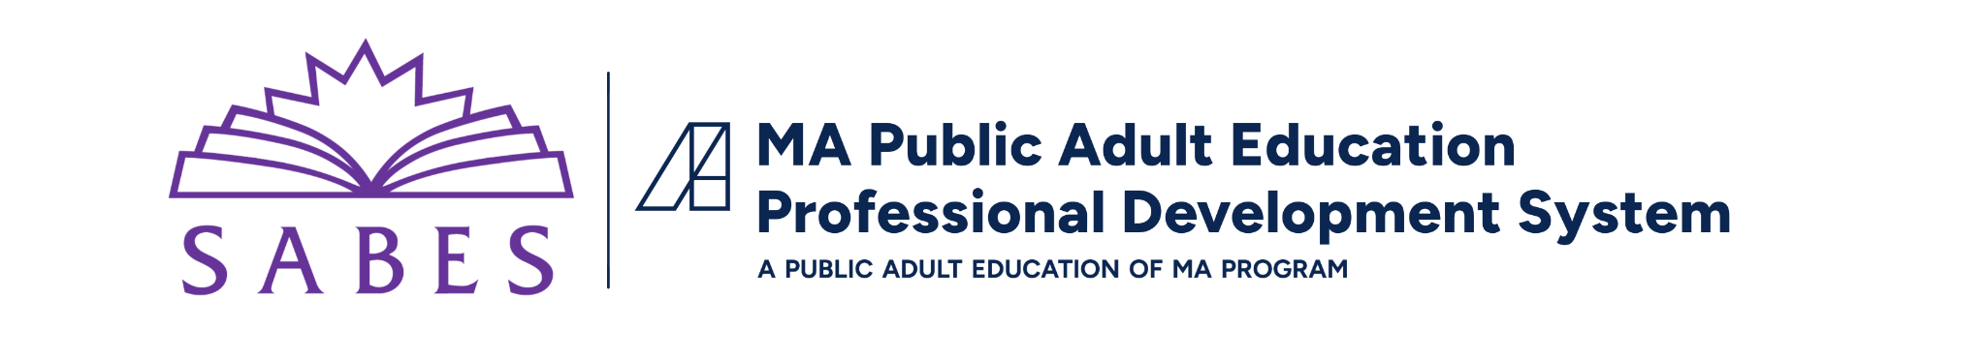

Building a Program-Wide Approach to Workforce Skills
Topic Overview

Introduction
As adult educators, helping students prepare for or advance in their careers and education has always been part of our work. Taking a program-wide approach to this work can strengthen program efficiency and effectiveness, creating the conditions for better student outcomes and workplace success.
The goal of a program-wide approach is to help students recognize, practice, and talk about essential workforce skills, so that they can contextualize and apply these skills in academic and career contexts beyond our programs. Alongside core academic competencies and traditional career exploration and job search skills (such as resume prep and networking), this includes foundational workforce skills that help students succeed in any career path.

Building a Program-Wide Approach
Building a program-wide approach to workforce skill-building does not have to mean starting from scratch. Programs can take an incremental, sustainable approach by focusing on one area where there is substantial room for growth, or where continuous improvement work is already planned.
Consider the following four program areas, and the related tools and systems that programs can leverage in their work:
- Program Design and Practices: A common list or framework of workforce skills, shared repositories, integration into student touchpoints and staff collaboration
- Curriculum and Instruction: Common ways of identifying workforce skills in curricula, units, and lesson plans
- Advising: Integration into advising meetings and workshops, alignment to career pathways and employer engagement, student goal setting
- Data and Measurement: Measurement and reporting on skill usage and growth (includes new methods, or integrate into existing self-assessments), progress reports, LACES data
Programs looking to develop a program-wide approach to workforce skills are encouraged to collaboratively develop a goal for concrete, measurable change within a chosen program area using the SMART template. SABES has developed a Goal and Action Plan Template to help programs refine their goals and develop action plans.

Real-World Examples

Recent work with Massachusetts adult education programs offers examples of how programs are addressing each of these areas. Among the eight participating programs, half focused their action plans on advising. Three programs addressed curriculum and instruction, two addressed data and measurement, and one program addressed program design and practice. Three programs chose two or more areas.

Across these diverse efforts, popular strategies included:

Adopting shared language among staff: Adopting standardized frameworks (like Teaching Skills that Matter) so all staff and instructors use the exact same terms. Programs planned to use teacher onboarding, staff meetings, common PD, and staff documents to introduce the framework and support teachers in using it.

Creating opportunities for students to name the skills: Teaching students to explicitly name and explain their own skills in a variety of ways and contexts, including exit tickets, student portfolios, and story-writing activities.

Tracking student progress: Measuring progress through real-world evidence like student portfolios, exit tickets, and monthly surveys rather than just test scores.

Creating opportunities and resources for collaboration: Connecting classroom teaching directly with advising and orientation to help staff better contextualize the skills and promote consistency across the program. Programs planned to achieve this through shared repositories of student information and work samples, common prep time, and push-in advising workshops.
For additional and more detailed examples of how programs are approaching this work, review the “Program Examples” resource on the Building a Program-Wide Approach to Workforce Skills Resources page.

Lessons Learned

Regardless of program area, three core lenses help create a workforce skill-building plan that is both effective and sustainable:

Contextualization: Connect skill instruction directly to academic, career, and community contexts. For example, goal-setting or time management can be used to support practical student tasks. Since workforce skills are rarely used in isolation from one another, opportunities to name and practice multiple skills at the same time are especially important.

Collaboration: Bridge classroom instruction and advising through tools like shared student files, shared repositories of student data and work, and regular check-ins. Advisors can use this information to tailor advising meetings, and instructors can use it to further contextualize instruction. Job aids (such as meeting and lesson templates) can support staff with consistent implementation.

Scale: Start with pilot programs, single classes, or designated "champion teachers" to test resources, gather lessons learned, and build momentum before scaling program-wide.
For directors and program leaders looking to communicate the work that they are doing, consider using the following

Resources

Workforce Skills Frameworks

Several frameworks exist to help programs name and define workforce skills, including:

Employability Skills Framework

Teaching Skills that Matter

MN ATLAS Transitions Integration Framework

Further Reading and Resources
There are many resources available to support programs in doing this work, including:
- The “Building a Program-Wide Approach to Workforce Skills” Resource Page is a collection of relevant resources, including a tailored Action Plan Template, case studies of program-wide approaches, and other resources.

Inspiring Career Development & Action: a curriculum guide for integrating workforce skills that demonstrates how to contextualize these competencies alongside standard academic and career readiness content

SABES Newsletter: Building Workforce Skills Across Adult Education: featuring several articles on strategies for integrating workforce skills across multiple facets of programming
- Advising Scope and Sequence Examples: a holistic approach to teaching core academic and workforce skills

Training and Technical Assistance
SABES offers training and individualized support that programs can integrate into their action plan or to support implementation.
- Program Design and Practices and Data and Measurement: Continuous Improvement Planning supports program leaders and teams to use data to develop a collaborative goal and action plan. Programs can choose between a course, community of practice, and individualized coaching based on their needs and capacity.
- Curriculum and Instruction: Inspiring Career Development and Action: Strategies for Teachers and Advisors uses the Inspiring Career Development and Action Curriculum Guide to help teachers, advisors, and program teams strengthen their approach to integrating standards and contextualizing instruction with career exploration content.
- Advising: Building an Advising Curriculum provides strategies, tools, and resources to help advisors and program teams to build or improve their advising program’s curriculum, framework, or scope and sequence.
- SABES Coaching Hub: Did you know that SABES offers program-based coaching? Use the Coaching Hub to learn about and request coaching on this topic or others.

