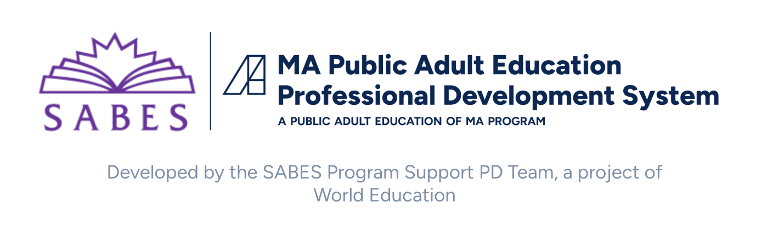

Continuous Improvement Planning Toolkit

About the Toolkit
This toolkit is designed to support program leaders in their work to lead a collaborative, rigorous, and data-driven process to develop a continuous improvement plan that leads to stronger instruction, learning, and student outcomes. It includes an overview of the five phases of continuous improvement, along with key considerations for each phase, and connections to relevant tools. The toolkit and related tools are meant to be used and adapted by each program, according to need and context. All tools are available in Canvas and on the SABES website.

Core Ideas & Definitions
- Continuous improvement provides the structure for programs to function as learning communities, shifting the focus from individual “fix-it” tasks towards a shared, sustainable culture of inquiry and reflection.
- A collaborative approach to continuous improvement planning supports a more inclusive and equitable program culture, fosters a sense of shared ownership and responsibility, and drives innovation.
- Data-informed decisions are decisions that account for the realities of our students and programs and by an understanding of how specific actions relate to specific outcomes.
- Every program is different. Planning can and should begin with an understanding of your specific context, goals, and capacity so that you can tailor the process as you go.

Overview of the Planning Process
The continuous improvement planning process consists of five phases:
- Prepare: gather the people, purpose, context, and data that will inform the rest of the process
- Inquire: use quantitative and qualitative data and an inquiry stance to study the program’s strengths, challenges, and areas of growth and opportunity
- Hypothesize: consider and name how specific changes in the program can be expected to support desired outcomes and identify related metrics
- Plan: set specific goals and develop an action plan for achieving goals
- Implement: implement the plan, reflect on process and results, and use new learnings to inform additional decisions
The process is designed to be cyclical: programs are encouraged to repeat the cycle once they have completed and fully implemented their initial plan.

Phase 1: Prepare
As you prepare to develop a continuous improvement plan, gather the following resources:
People: Identify a diverse planning team of 5-8 people. Set expectations for how they will work together and dedicate time for collaboration.
Purpose: Connect with any existing shared vision (e.g. mission, vision, and values) and the purpose of continuous improvement planning
Context: Identify any institutional challenges and parameters for the plan, including a rough timeline, grant or other requirements, and key decision-makers. Reflect together on identities and biases.
Data: Gather quantitative and qualitative data to use throughout the process.

Tools & Resources for This Phase
- Context: Planning Pitfalls and Strategies
- Context: Summary of ACLS Accountability Tools & Resources
- Data: Data Inventory

Phase 2: Inquire
Use collaborative inquiry along with quantitative and qualitative data to study your program and identify specific challenges and opportunities.
Identify an overall focus: Identify an initial direction for your continuous improvement work. The overall focus should be grounded in data, tied to the Indicators of Program Quality, and reflective of conversations with the Program Specialist.
Conduct root cause analysis: Collaboratively analyze qualitative and quantitative data to identify progressively more specific issues related to the overall focus and generate ideas for change.

Tools & Resources for This Phase
- Root Cause Analysis: Data Checklist by IPQ
- Root Cause Analysis: Reflect, Observe, Interpret, Decide Protocol
- Root Cause Analysis: Fishbone Diagram
- Root Cause Analysis: Five Whys
- Root Cause Analysis: Common Issues and Causes, Organized by Overall Focus

Phase 3: Hypothesize
Choose specific issues to address and changes that you will implement to address them. Make a prediction about how this will impact your program to establish a clear vision and benchmarks for success.
Brainstorm and choose specific changes: Consider potential solutions to the challenges identified during root cause analysis. Engage staff, students, and partners. Seek out new ideas through PD, conversations with colleagues, and research.
Write a working theory of change: Use collaborative or consensus-driven approaches to choose changes for implementation. Identify expected outcomes and write a statement connecting proposed action to expected outcomes.

Tools & Resources for This Phase
- Choosing changes: Matrix for Selecting a Focus
- Coach feedback on the working theory of change

Phase 4: Plan
Write an action plan for how you will collectively achieve the change that you’ve proposed, with concrete goals and clear responsibilities.
Write clear, measurable goal statements: Write SMARTIE goals that address both the outcome (what you will achieve) and process (how you will know that you are making progress).
Write a detailed action plan: Decide who will do what and by when, and identify the resources that they will need. Create a plan for communicating progress and sharing resources.

Tools & Resources for This Phase
- Goal statements: SMARTIE Template
- Action plans: SABES Planning Template
- Action plans: Sample Action Plans

Phase 5: Implement
Congratulations! You’ve made it this far. As you implement your action plan, track and manage change within your program, as well as information about the change.
Manage change: Establish clear and transparent communication with the rest of your program. Decide in advance how to convey changes.
Communicate and track progress: Document and communicate about progress using a living document. Continue to set aside time for collaborating and reflecting.
Continue to collect and study data: Gather data that helps you measure progress. Study and analyze the data, and turn analysis into action.
Reflect: Reflect regularly on both progress (what have we achieved and what has shifted as a result?) and process (how effective was our plan and execution?).

Tools & Resources for This Phase
- Reflect: Reflection Tools and Resources
- Ongoing coaching

References
Center for Leadership and Educational Equity: “Resource & Protocol Library.” Available: CLEE Resource Library
Duhigg, Charles. “What Google Learned From Its Quest to Build the Perfect Team.” New York Times Magazine, February 25, 2016. Available: “What Google Learned From Its Quest to Build the Perfect Team.”
Harvard Business Review. “What Makes a Great Leader?” Featuring Dr. Anita Hill. Youtube video, 6:23. September 20, 2022. Available: “What Makes a Great Leader?”
Imani, Jakada, Monna Wong, and Bex Ahuja. Management in a Changing World: How to Manage for Equity, Sustainability, and Results. Hoboken, NJ: John Wiley & Sons, 2023. Available: The Management Center
Knips, Andrew, Sonya Lopez, Michael Savoy, and Kendall Loparo. Equity in Data: A Framework for What Counts in Schools. Arlington, VA: ASCD, 2022. Available: Equity in Data - ASCD
Massachusetts Department of Elementary and Secondary Education, Adult and Community Learning Services Unit. FY24-FY28 Massachusetts Policies for Effective Adult Education. 2025. Available: Adult Education Policies - ACLS
Massachusetts Department of Elementary and Secondary Education, Adult and Community Learning Services Unit. Indicators of Program Quality for Community Adult Learning Centers and County Houses of Correction. 2022. Available: Program Quality - ACLS
Merrifield, Juliet. “Performance Accountability: For What? To Whom? And How?” Focus on Basics Volume 3, Issue B (June 1999). Available: National Center for the Study of Adult Learning and Literacy
Vermont Agency of Education. Plan-Do-Study-Act (PDSA) Toolkit. 2019. Available: PDSA Toolkit - Vermont Agency of Education
U.S. Department of Education. Continuous Improvement Planning in Education: A Toolkit for Schools and Districts. U.S. Department of Education, Institute of Educational Sciences, National Center for Education Evaluation and Regional Assistance, 2020. Available: Continuous Improvement in Education: A Toolkit for Schools and Districts

