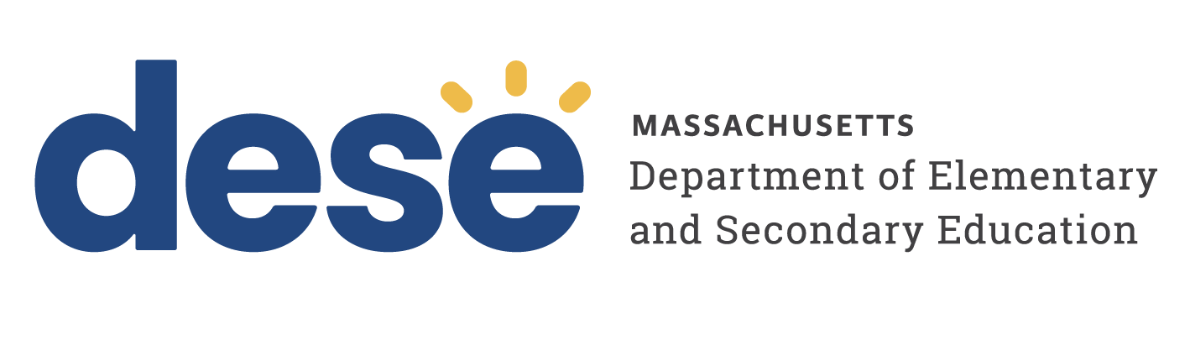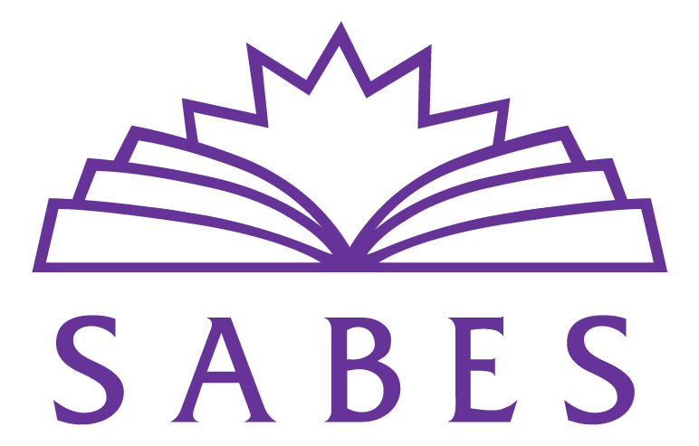
Date: November 1, 2022
To: All Massachusetts DESE-Funded Program Staff
From: ACLS and SABES
Re: ACLS and SABES Digital Literacy Advisory Group Invitation

ACLS and SABES are planning to convene a Digital Literacy Advisory Group (AG) to help inform discussions on how to maximize opportunities for programs to integrate digital literacy. The purpose of this AG is to help ACLS and SABES understand program strengths and needs, what’s working and where challenges exist, the factors that influence this work, and what specific actions can drive change and support programs in doing this work.

We are in the process of recruiting a diverse group of AG members who can represent a range of roles, experience, and types of programs from across the state. ACLS will provide programs with up to $600 to ensure costs will be covered to either pay a part-time person for extra hours or to release a full-time person. In FY23, two 90-minute virtual meetings are planned for 3/7/23 and 5/23/23. Additionally, AG members may facilitate a session at the annual MCAE Conference (optional), tentatively scheduled for 5/5/23.

We invite interested applicants to submit a brief online application by 12/30/22. Keep in mind:
- Attendance at both meetings is required.
- AG members must be from DESE-funded programs.
- We welcome diverse perspectives. If staff other than the director is applying, they must obtain the approval of the program director.
- AG members are appointed for two years with the possibility of extending a term to three years.
- This commitment entails approximately 6 hours per meeting for a total of 12 hours:
- Two 90-minute meetings
- Preparation (on average two hours per meeting) for some pre-reading and/or discussion of key issues with colleagues
- Follow-up (on average two hours per meeting)
- Orientation and email/communications (1 hour total for the year)
- AG members are expected to actively contribute to discussions in a positive and thoughtful way, and to listen respectfully to different views.

Please share this letter with your staff and colleagues. Important information for this process:
- 12/30/22 Deadline to apply
- 1/28/23 Notification of AG members selected
- 3/7/23 First AG meeting (virtual, time TBD)
- 5/5/23 MCAE conference session (optional)
- 5/23/23 Second AG meeting (virtual, time TBD)

Thank you, in advance, for considering this important work. Please feel free to contact Luanne_teller@worlded.org if you have questions or if we can provide additional information.

Paula Jurigian Luanne Teller
ACLS Digital Literacy Liaison Director, SABES Program Support PD Center

