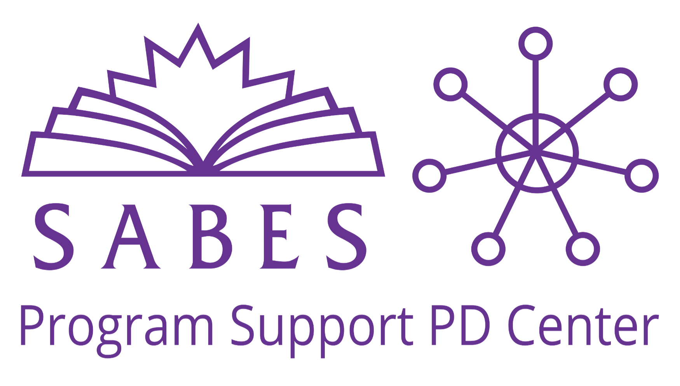

The [SABES Program Support PD Center](https://www.sabes.org/pd-center/laces) works with ACLS and LiteracyPro to coordinate LACES trainings, which we post on the [SABES Calendar](https://www.sabes.org/calendar) for you to register. If you have questions, email Jane Brandt at jane_brandt@worlded.org.

***Please note*** that for ***two part-trainings***, you must attend both days, but will register only for the first date. ***To register,*** click on the dates, which are linked to the SABES Calendar.

**~Upcoming LACES Trainings: September-December, 2023~**

**Beginner LACES Training** (Two-Part Training)

[**9/19/23 and 9/20/23**](https://www.sabes.org/event/44171) (8-10:00 a.m.) ***OR***

[**12/18/23 and 12/19/23**](https://www.sabes.org/event/44176) (8-10:00 a.m.)

This two-part training is for those new to LACES data entry. It provides an overview on how to use the LACES management information system (MIS) for your student, class, and staff data.

**LACES for MassSTEP Integrated Education Programs**

[**9/26/23**](https://www.sabes.org/event/44181) (1-3:00 p.m.)

This training will provide an overview of LACES data entry related to MassSTEP programs for state and federal reporting.

**LACES Periods of Participation (PoP)**

[**10/17/23**](https://www.sabes.org/event/44191) (8-9:00 a.m.)

LiteracyPro System’s Shannon Stangis will facilitate this one-hour webinar and discuss the federal guidelines regarding Periods of Participation (PoP) and how they can affect your overall completion rates.

**LACES Messaging**

[**10/26/23**](https://www.sabes.org/event/44196)(1-2:00 p.m.)

In this webinar, you will be introduced to the Messaging functionality in LACES and how to use it for reaching students for scheduling and follow-up purposes.

**LACES Desk Review**

[**11/9/23**](https://www.sabes.org/event/44201) (1-3:00 p.m.)

The Desk Review is a required state report generated using searches in LACES to review important data points. This webinar will explain how to access the desk review searches and how to improve your data cleanliness around the data points.

**LACES Follow-Up Surveys**

[**11/14/23**](https://www.sabes.org/event/44206) (8-10:00 a.m.)

This webinar describes the process for conducting follow-up with students to report on Table 5. During follow-ups, you obtain information about their employment and educational progress after exiting your program. We will explain the criteria necessary for inclusion in the Table 5 denominators and provide guidance on entering the data for outcomes when students attain these measures.

**LACES Data Analysis**

[**12/7/23**](https://www.sabes.org/event/44211) (8-10:00 a.m.)

This webinar discusses how to review your performance data to recognize patterns and trends in behavior that affect completion and outcome rates.

**LACES Retention and Persistence**

[**12/12/23**](https://www.sabes.org/event/44221) (8-10:00 a.m.)

You will learn how to use LACES to track retention and persistence among students, and how to analyze staff performance related to retention and persistence.