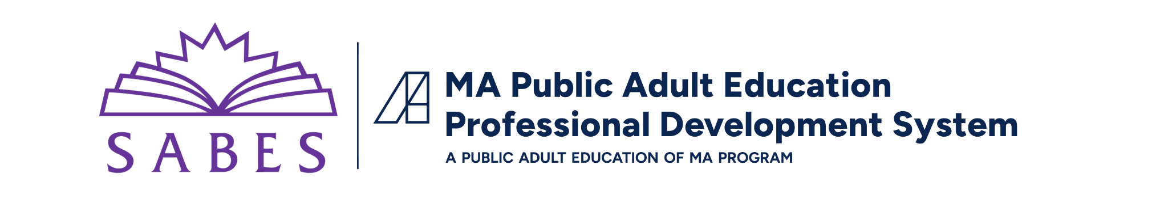

Educator Growth and Evaluation Model:

Coaching Self-Assessment
Adapted from the Leadership Guide for Teacher Induction

Coaching Self-Assessment
Instructions: Use the following self-assessment to get a picture of your strengths and limitations as a coach. Review your self-evaluation with your EGE Team Leader to discuss ways to develop your coaching skills.
Read each statement and indicate in the “Score” column how consistently you demonstrate each attribute in the following four tables.
Score each attribute on a scale of 1 to 4: 1 being “Not at all,” 2 being “Occasionally,” 3 being “Often,” and 4 being “Almost Always.”
Coaching Skill 1: Create an Open, Supportive Climate for Communication | Score
I am a good team member and build effective relationships with those around me.
I believe that all people have potential and can improve.
I respect and try to understand other people’s points of view.
I don’t assume that inabilities are weaknesses or are due to character flaws.
I reflect on and manage my feelings.
I expect to make mistakes.
I don’t mind others seeing me make a mistake.
I learn from constructive feedback.

Coaching Skill 2: Effectively Communicate Experience and Elicit Thinking | Score
I feel confident about my abilities overall and have a realistic view of my strengths and abilities.
I can articulate the teaching strategies I use and how I make instructional decisions.
I reflect on the assumptions I might be making and check their validity.
I provide evidence for my beliefs and conclusions.
I ask others about the evidence for their reasoning and to elaborate on their thinking.
I ask authentic questions to elicit thinking and demonstrate genuine interest.

Coaching Skill 3: Demonstrate Active Listening and Good Follow-Up | Score
I listen to others with full attention and do not interrupt.
I suspend judgment while listening to another person.
I paraphrase what I’m hearing or ask questions to check that I’ve understood.
I divide tasks into manageable steps.
I follow through on promised tasks and deadlines.

Content Mastery | Score
I keep up with the evidence-based research and practices in my content area.
I participate in the communities of practice available in my content area.
I implement and reflect on improvements to my teaching practice.
I am able to articulate the concepts and big ideas that underlie procedures and applications.
I am able to identify points at which students commonly get “stuck.”
I am able to focus instruction on defined objectives while also responding to “teachable moments” (student questions and interests that emerge).
I use student work to inform my practice.

Reflection
- Summarize the strengths you have identified in the self-assessment.
- Summarize areas that you have identified as needing attention.
- Note the strategies and resources you can use to build your strengths.

