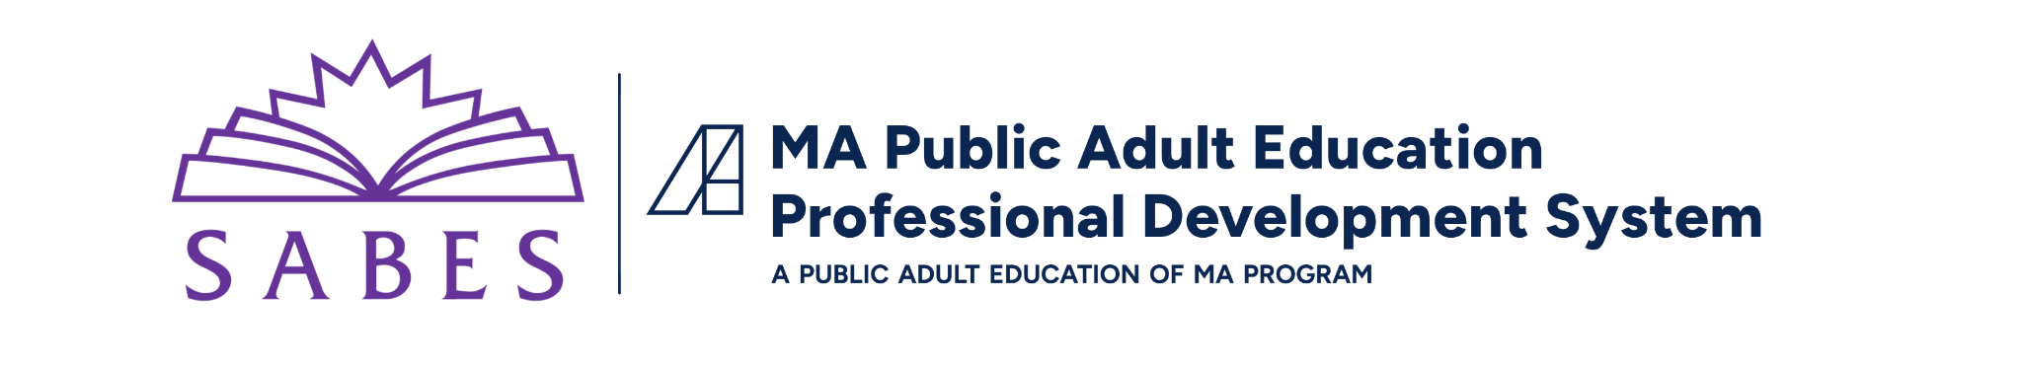

Educator Growth and Evaluation Model: Program Conditions Self-Assessment

This worksheet is a tool to help program leaders inventory and examine current capacity for supporting a successful EGE process and to explore ways to move toward readiness. Rate your program conditions using the following 3-point scale:
Where 3 indicates “condition is in place,” 2 indicates “condition is being addressed,” and 1 indicates “condition is not in place.”
For conditions at levels 1 or 2, use the worksheet to identify steps for improving readiness.
Program Conditions | 1 | 2 | 3 | How would we know or see this? | What steps could improve readiness?  Who can help us with this?
There is a supportive program leader who serves as a champion for EGE and is committed to ensuring that adequate resources are in place
There is a clear vision for how EGE aligns with program improvement plans
There are one or more teachers interested in using the EGE growth model
There is a program culture of continuous improvement and expectation of /support for participation in professional learning
The program models using data for program improvement
There are resources to support the teacher (and coach) time to:
- Develop a professional learning plan (self-assessment, goal-setting, identifying PD)
- Attend and reflect on PD
- Gather evidence of change (lesson plan, student work, data, etc.)
- Plan, conduct, and meet about classroom observation
- Reflect on goals, progress, and next steps

