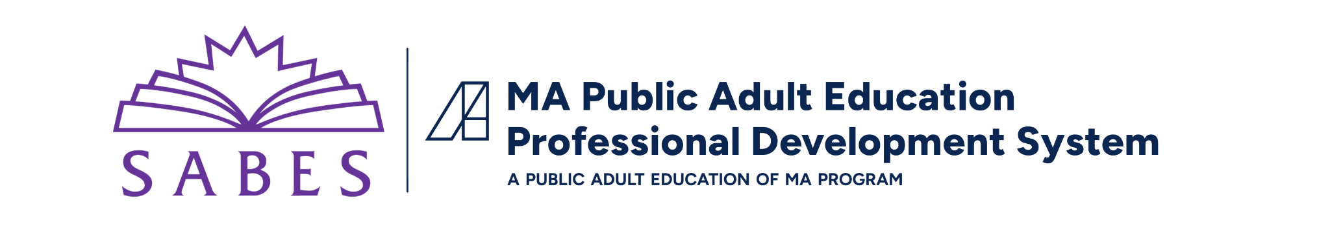

Foundations for New Staff:
Summary of Course Resources

For questions about the Foundations for New Staff course, please contact the SABES Program Support PD Center Director, Alexandra Papagno, at alexandra_papagno@worlded.org.

SABES Contact Information
SABES Mathematics and Adult Numeracy Curriculum and Instruction (C&I) PD Team
TERC｜2067 Massachusetts Avenue, Cambridge, MA 02140
Heidi Schuler, heidi_schuler@terc.edu
SABES English Language Arts (ELA) C&I PD Team
World Education｜44 Farnsworth Street, Boston, MA 02210
Evonne Peters, evonne_peters@worlded.org
SABES English for Speakers of Other Languages (ESOL) C&I PD Team
Education Development Center (EDC)｜300 5th Ave, Suite 2010, Waltham, MA 02451
Kate Anderson, kateanderson@edc.org
SABES Program Support PD Team
World Education, Inc.｜44 Farnsworth Street, Boston, MA 02210
Alexandra Papagno, alexandra_papagno@worlded.org
SABES System Communication Team
Education Development Center (EDC)｜300 5th Ave, Suite 2010, Waltham, MA 02451
Heidi Larson, hlarson@edc.org

Resources

Publications
- The Change Agent: Thanks to our partnership with NELRC, you have free access to The Change Agent, a magazine with a social justice focus featuring writings by adult learners.
- The COABE Journal: The SABES Program Support PD Center provides access to MA adult educators to the national COABE Journal for free.
- ACLS Monthly Mailings: Note: Find mailings on the ACLS website and register to be sure you receive them automatically via email using this registration link.

ACLS Resources
- ACLS Mission
- State as Equity Partner Meetings
- Public Education of MA website
- Guidance and standards for programs
  - Indicators of Program Quality (IPQs)
  - FY24-FY28 MA Policies for Effective Adult Education in Community Adult Learning Centers and Correctional Institutions
  - Annual PQR Summative Reports
  - ACLS Accountability System: Note that as of spring 2026, this system is under review
- Guidance and Standards for Instructors
  - Educator Effectiveness
  - Professional Standards for Teachers of Adult Education (Math, ELA, and ESOL) (see: “Professional Standards”)
- Learning standards
  - ACLS Curriculum and Instruction: See “College and Career Readiness Standards for Adult Education (CCRSAE)” for Math and ELA learning standards and the “MA English Language Proficiency Standards for Adult Education (MA ELPS)” for ESOL standards
- Student assessment
  - Massachusetts Adult Education Assessment Policies
  - ACLS Test Help Blog
- WIOA Partner Resources
  - WIOA Massachusetts Combined State Plan
  - List of Outstationing Coordinators
- ACLS Adult Education Glossary (see “Links and Resources”)
- LACES Resources
  - LACES Intake Form Template
  - Release of Information (ROI) Form
- National Association of State Directors of Adult Education (NASDAE) fact sheets for MA

SABES Resources

General SABES Resources
- SABES website and this article on How to Navigate the SABES Website
- SABES Registration Calendar
- SABES Resource Library
- SABES Diversity, Equity, and Inclusion Resource Library
- NRS Assessments
- MA Adult Education Job Postings
- SABES High Quality Professional Development (HQPD) Standards
- COABE Membership sponsored by SABES

SABES Program Support PD Team
- MA Adult Education Help Desk and update portal
- LACES Training Schedule
- MA ABE Teacher’s License Resources: Adult Development and Learning Theorists
- Program Support Diversity, Equity, and Inclusion (DEI) Resources
- Basic Disability Screening for Adult Ed Programs
- Inspiring Career Development and Action: A Curriculum Guide for Adult Educators

SABES Math C&I PD Center
- Math PD Plan and Offerings
- Math Curriculum Resources
- Math Curriculum for Adults Learning Math (CALM)
- Diversity, Equity, and Inclusion (DEI) Resources

SABES ESOL C&I PD Center
- ESOL PD Plan and Offerings
- MA ELPS Resources
- ESOL Diversity, Equity, and Inclusion (DEI) Resources

SABES ELA C&I PD Center
- Evidence-Based Reading Instruction (EBRI)
- So You Want to Build a Curriculum
- Curriculum Hub
- ELA Diversity, Equity, and Inclusion (DEI) Resources

Massachusetts Resources
- The Massachusetts Association of Teachers of Speakers of Other Languages
- Massachusetts Coalition for Adult Education (MCAE)
- MA Commission for the Blind
- MassHire Department of Career Services
- MA Rehabilitation Commission

National Partners
- Coalition on Adult Basic Education (COABE)
- New England Literacy Resource Center (NELRC)
- Adult Numeracy Network (ANN)
- Teaching English to Speakers of Other Languages (TESOL)
- The Literacy Information and Communication System (LINCS):
  - LINCS Resource Collection: Vetted resources for AE practitioners
  - LINCS Community: Online community of practice
  - Learning Portal: Online courses for AE practitioners
  - Learner Center: Resources for adult learners

Federal Resources
- National Reporting System (NRS)
- Office of Career, Technical, and Adult Education (OCTAE)
- Workforce Innovation and Opportunity Act (WIOA)

