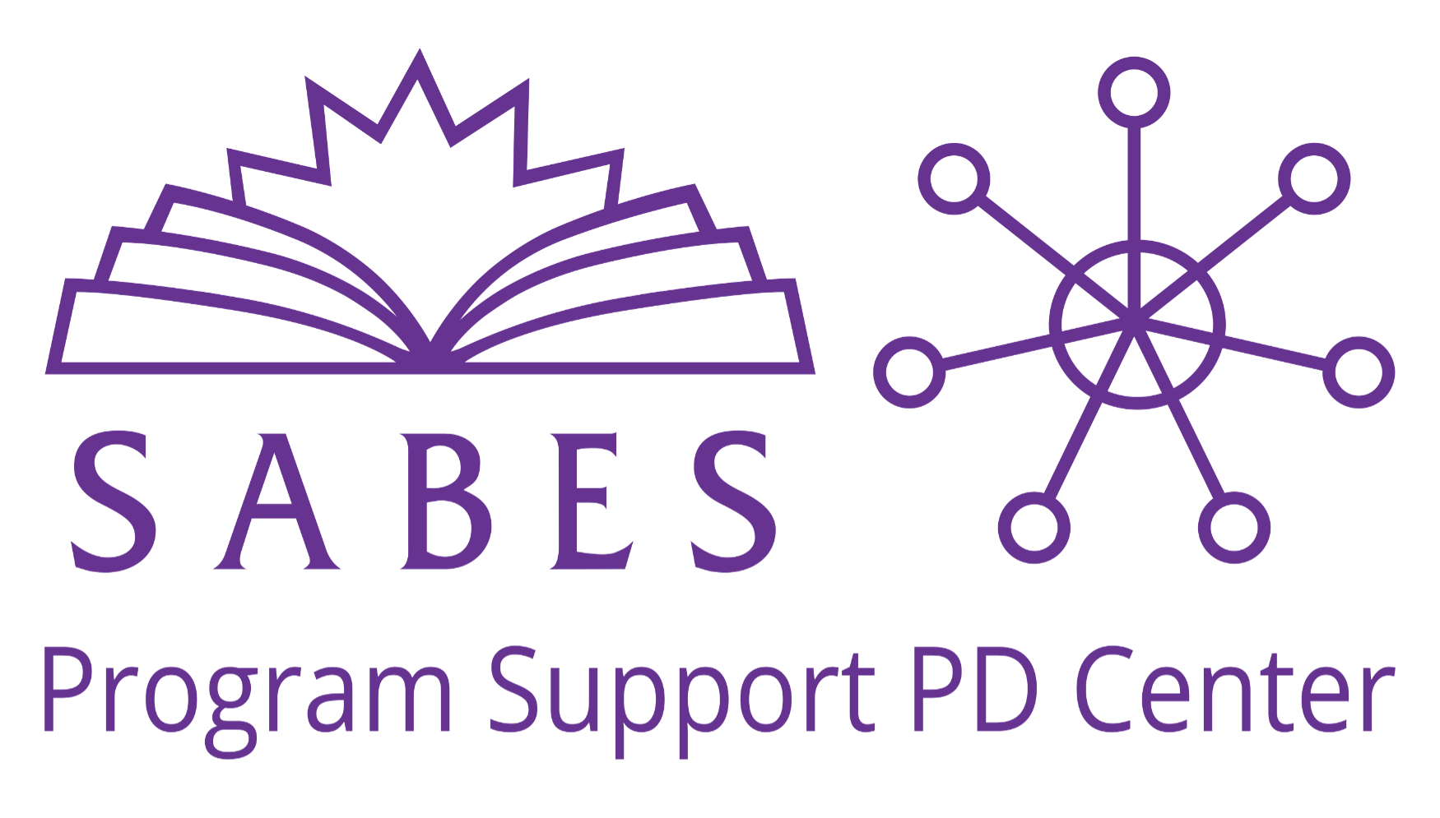

Foundations for New Staff: Summary of Course Resources

For questions about the Foundations for New Staff course, please contact the SABES Program Support PD Center Director Alexandra Papagno at alexandra_papagno@worlded.org

SABES Contact Information

SABES Mathematics and Adult Numeracy Curriculum and Instruction (C&I) PD Center
TERC
2067 Massachusetts Avenue, Cambridge, MA 02140
Contact: Heidi Schuler-Jones, (617) 873-9882, heidi_schuler-jones@terc.edu

SABES English Language Arts (ELA) C&I PD Center
World Education, Inc.
44 Farnsworth Street, Boston, MA 02210
Contact: Evonne Peters, (617) 385-3781, evonne_peters@worlded.org

SABES English for Speakers of Other Languages (ESOL) C&I PD Center
Education Development Center (EDC)
43 Foundry Avenue, Waltham, MA 02453
Contact: Dori McCormack, (617) 618-2061, dmccormack@edc.org

SABES Program Support PD Center
World Education, Inc.
44 Farnsworth Street, Boston, MA 02210
Contacts:
Alexandra Papagno, 617-385-3765, alexandra_papagno@worlded.org
Dani Scherer, (617) 385-3739, dani_scherer@worlded.org

SABES System Communication Center
Education Development Center (EDC)
43 Foundry Avenue, Waltham, MA 02453
Contact: Heidi Larson, (617) 618-2886, hlarson@edc.org

The SABES Program Support Professional Development Center is a project of World Education, funded by a grant from the Massachusetts Department of Elementary and Secondary Education.
Resources

Publications
- The Change Agent: Thanks to our partnership with NELRC, you have free access to The Change Agent, a magazine with a social justice focus that features writings by adult learners.
- The COABE Journal: The SABES Program Support PD Center provides access to MA adult educators to the national COABE Journal for free.
- ACLS Monthly Mailings: Note: Find mailings on the ACLS website here and register to be sure you receive them automatically via email here.

Adult and Community Learning Services (ACLS): https://www.doe.mass.edu/acls/

ACLS Resource | Website
ACLS Mission | https://www.doe.mass.edu/acls/
Indicators of Program Quality (IPQs) | https://www.doe.mass.edu/acls/accountability/program-quality/
FY19-FY23 MA Policies for Effective Adult Education in Community Adult Learning Centers and Correctional Institutions | https://www.doe.mass.edu/acls/abeprogram/policies.docx
Annual PQR Summative Reports | https://www.doe.mass.edu/acls/accountability/program-quality/reviews.html
Educator Effectiveness | https://www.doe.mass.edu/acls/edueffectiveness/default.html
Professional Standards for Teachers of Adult Education (Math, ELA, and ESOL) | https://www.doe.mass.edu/acls/edueffectiveness/default.html
College and Career Readiness Standards for Adult Education (CCRSAE) – For Math and ELA | https://www.doe.mass.edu/acls/frameworks/about.html
MA English Language Proficiency Standards for Adult Education (MA ELPS) | https://www.doe.mass.edu/acls/frameworks/about.html
ACLS Curriculum and Instruction | https://www.doe.mass.edu/acls/frameworks/about.html
ACLS Adult Education Glossary | https://www.doe.mass.edu/acls/abeprogram/default.html
State as Partner Meetings | https://aclsdese.wixsite.com/state-as-a-partner
ACLS Accountability System | https://www.doe.mass.edu/acls/accountability/
LACES Intake Form Template | https://www.doe.mass.edu/acls/laces/intake-form/
Release of Information (ROI) Form | https://www.doe.mass.edu/acls/laces/release-form/
WIOA Massachusetts Combined State Plan | https://www.mass.gov/doc/fy2020-workforce-innovation-and-opportunity-act-wioa-massachusetts-combined-state-plan/download
Massachusetts Adult Education Assessment Policies | https://www.doe.mass.edu/acls/assessment/assessmentpolicies.pdf
ACLS Test Help Blog | https://blogs.umass.edu/aclstesthelp/
National Association of State Directors of Adult Education (NASDAE) fact sheets for MA | https://public.tableau.com/app/profile/patricia.tyler/viz/OnlineFinaltoPublic01082021_16107288089680/NASDAE_Fact_Sheet
System for Adult Basic Education Support (SABES)

SABES Resources: https://www.sabes.org/
- SABES Registration Calendar: https://www.sabes.org/calendar
- SABES Resource Library: https://www.sabes.org/resources
- SABES Diversity, Equity, and Inclusion Resource Library: https://www.sabes.org/resources/dei-resources-library
- NRS Assessments: https://www.sabes.org/pd-center/massachusetts-nrs-assessments
- How to Navigate the SABES Website: https://sabes.org/sites/default/files/resources/SABES Website Overview.pdf
- MA Adult Education Job Postings: https://www.sabes.org/content/SABESJobBoard
- SABES High Quality Professional Development (HQPD) Standards: https://www.doe.mass.edu/acls/pd/hqpd-standards.pdf

SABES Program Support PD Center: https://www.sabes.org/pd-center/program-support
- MA Adult Literacy Hotline (Hotline): http://mass.gov/edu/literacyhotline
- Program Support PD Catalog: https://www.sabes.org/content/sabes-program-support-pd-center-fy22-pd-catalog
- LACES Training Schedule: https://www.sabes.org/pd-center/laces
- MA ABE Teacher’s License Resources: Adult Development and Learning Theorists: https://www.sabes.org/sites/default/files/resources/ABE Teacher License- Adult Development and Learning Theorists Dec 2020_0.pdf
- Program Support Diversity, Equity, and Inclusion (DEI) Resources: https://sabes.org/pd-center/diversity-equity-and-inclusion
- The Effective Practices Aligned with IPQ 7 Guide: https://www.sabes.org/content/effective-practices-aligned-indicator-program-quality-7-guide

SABES Math C&I PD Center: https://www.sabes.org/pd-center/math-and-numeracy
- Math PD Plan and Offerings: https://www.terc.edu/adultnumeracycenter/sabes-math-pd-support/
- Math Curriculum Resources: https://www.sabes.org/content/math-curriculum-resources
- Math Curriculum for Adults Learning Math (CALM): https://www.terc.edu/calm
- Diversity, Equity, and Inclusion (DEI) Resources: https://www.sabes.org/content/diversity-equity-and-inclusion-math

SABES ESOL C&I PD Center: https://www.sabes.org/pd-center/esol
- ESOL PD Plan and Offerings: https://sites.google.com/hcc.edu/esolstandardspd/home
- MA ELPS Resources; https://www.sabes.org/content/ma-elps-massachusetts-english-language-proficiency-standards-document-and-overview-videos
- ESOL Diversity, Equity, and Inclusion (DEI) Resources: https://sabes.org/content/esol-resources-promote-diversity-equity-and-inclusion
SABES ELA C&I PD Center: https://www.sabes.org/pd-center/ela
- ELA PD Plan and Offerings: https://www.sabes.org/content/ela-pd-FY22
- Evidence-Based Reading Instruction (EBRI): https://www.doe.mass.edu/acls/rfp/star.html
- So You Want to Build a Curriculum: https://www.sabes.org/sites/default/files/resources/So You Want to Build Curriculum.pdf
- Curriculum Hub: https://sabes.org/content/ela-curriculum-hub
- ELA Diversity, Equity, and Inclusion (DEI) Resources: https://www.sabes.org/content/dei-ela

Massachusetts Resources
- The Massachusetts Association of Teachers of Speakers of Other Languages: https://www.matsol.org/
- Massachusetts Coalition for Adult Education (MCAE): https://mcae.net/about/mission-and-vision/
- MA Commission for the Blind: https://www.mass.gov/orgs/massachusetts-commission-for-the-blind
- MassHire Department of Career Services: https://www.mass.gov/orgs/masshire-department-of-career-services
- MA Rehabilitation Commission: https://www.mass.gov/orgs/massachusetts-rehabilitation-commission

National Partners
- Coalition on Adult Basic Education (COABE): https://coabe.org/
- New England Literacy Resource Center (NELRC): https://nelrc.org/about-nelrc/
- Adult Numeracy Network (ANN): https://adultnumeracynetwork.org/
- Teaching English to Speakers of Other Languages (TESOL): https://www.tesol.org/
- The Literacy Information and Communication System (LINCS):
  - LINCS Resource Collection: Vetted resources for AE practitioners
  - LINCS Community: Online community of practice
  - Learning Portal: Online courses for AE practitioners
  - Learner Center: Resources for adult learners

Federal Resources
- National Reporting System (NRS): https://nrsweb.org/
- Office of Career, Technical, and Adult Education (OCTAE) https://www2.ed.gov/about/offices/list/ovae/index.html
- Workforce Innovation and Opportunity Act (WIOA): https://www.govinfo.gov/content/pkg/PLAW-113publ128/pdf/PLAW-113publ128.pdf

