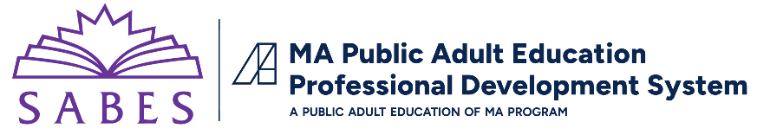

Motivating Adult Learners to Persist with Fluency Instruction:

Factors that Foster Motivation and How They Apply to Fluency Instruction

Building Learners’ Self-Efficacy
Self-efficacy refers to what people believe about their abilities in a certain area, in this case, reading fluently. Learners need opportunities to succeed so that they expect to succeed when they approach the next fluency practice.

Setting Appropriate Goals
When we talk about fluency instruction, learners should set mastery goals, where they compare present performance to past performance to gauge improvement. Learners shouldn’t worry about how they compare with other learners when they practice fluent reading. Helping them see their own progress, from the first time they read a text to the last time they read the same text OR from the beginning of the month to the end of the month can help them stay motivated.

Offering Concrete Feedback
When teachers give feedback to students about how fluent their reading is, learners are likely to evaluate their own fluency more accurately in the future. Being specific about which aspect of fluency the student is doing well with (e.g., rate, phrasing, adhering to punctuation, reading with expression) and which need more work makes learning more concrete. Furthermore, regularly modeling fluent reading as part of feedback helps learners remember what fluent reading is.

Using Assessments Appropriately
Emphasizing assessment can backfire, leading learners to compare themselves to others or completely shut down. To ensure that fluency assessment is viewed more positively by learners, instructors should ensure privacy, sharing results away from other students. Focus on the learner’s efforts and improvement, not on their innate abilities.

Cultivate Intrinsic Motivation
People can be motivated by external rewards (extrinsic motivation) or from their own intrinsic sense of enjoyment/satisfaction with a task (intrinsic motivation). In fluency instruction, there are ways to set up activities and fluency practice so that adult learners want to spend the time practicing. Preparing to read to children or grandchildren, or to share a favorite poem or song with the class, or to perform in a readers’ theater—all of these foster the learners’ own internal/intrinsic motivation.

Providing Choice and Autonomy
Offering students what we call “managed choice”—a choice from a defined set of options—can cultivate motivation. In fluency instruction, providing choice and autonomy can be as simple as inviting learners to choose the text they want to read (from among options) and/or how they want to practice (for instance, with an audio recording OR with a partner).

Helping Students Value Instruction
Adult learners also need to understand the purpose of fluency instruction – how it will help them ultimately become better readers. Taking a few minutes on a regular basis to remind students why they are working on fluency can help them sustain their motivation.

Using and Inspiring Learners’ Interests
The motivation research suggests that learners are more likely to stick with a fluency task if they either have personal interest in the topic covered in the text or if they have situational interest, which arises if the teacher shows how the topic is relevant or sets up a fluency task that taps into the learners’ intrinsic motivation (like reading to a grandchild).

Encouraging Collaboration and Cooperation
When learners work together, they have opportunities to build interpersonal connections and be exposed to different perspectives. Fluency instruction can incorporate collaboration by having learners read in pairs or triads and give feedback to each other.

Adapted from: National Research Council (2012). Improving adult literacy instruction: supporting learning and motivation. Washington, DC: The National Academies Press. https://doi.org/10.17226/13469.

