


SABES Program Support PD Center

Planning for Continuous Improvement
Session 2: Leading With Data
Participant Packet
March, 2023

Session 2 Goal: Program teams evaluation the strengths and limitations of multiple qualitative and quantitative data sources in order to select appropriate resources that are relevant to individual program improvement needs and goals.

- Small Group Guiding Questions for Session 2

- Data Considerations
  - Determining the Quality of Data
  - Types of Data
  - Reluctance for Using Data
  - Benefits of Using Data
  - Leadership: Establishing Effective Data Management Processes

- ACLS Components and Tools of Accountability Online Resources

- Sources of Data by IPQ Chart

- LACES Reports
  - Desk Reviews
  - NRS Reports
  - Student Alerts
  - LACES Automatically Generated Reports
  - Available Fields for Generating Customized Reports in LACES

March, 2023


The SABES Program Support Professional Development Center is a project of
World Education, funded by a grant from the
Massachusetts Department of Elementary and Secondary Education.
PCI Session 2: Leading With Data: Handout 1

Small Group Guiding Questions

Activity 2: Data vs. Information (20 minutes)
- Share other pieces of data you found.
- What “information” did you learn about your program as a result of these data?
- What other questions did it prompt you to ask?
- Did you find some data easier to find? More useful?

Activity 3: Effective Leadership in Using Data (10 minutes)
- In light of the challenges and benefits in using data, how do we move our teams from reluctant to enthusiastic users of data.

Activity 4: Program Accountability System (20 minutes)
- Share at least one piece of data related to performance accountability you use and how.
- What factors influence those data? What qualitative information might inform someone’s understanding of these quantitative data?
- What else would you want your program specialist to know when they look at these numbers? How can you communicate that?

Activity 5: Thinking about Program Goals: Where to Begin (15 minutes)
- Pick one or two IPQs you might focus on.
- What sources of data would be relevant? Are there others you can think of?
- How feasible does it feel to gather the necessary data for your CIP?

Activity 7: Using Data Findings and Sharing Conclusions (15 minutes)
- What was interesting about this example?
- Have you done a similar process in your program? What did you learn?
- How does this example inform your thinking about how to proceed?

PCI Session 2: Leading With Data: Handout 2

Measures for Determining the Quality of Data
Consider the “who, what, and why of it” to understand the quality and validity of data.
- What is the source?
- When was data collected?
- Where/why was it collected?
- Is it relevant to YOUR context?
- How well trained are the people who collected and analyzed the data?
- What is the bias?

An important note about bias: All data have a bias; they are collected by a person/entity for a specific purpose. That’s why research studies describe their limitations. This doesn’t mean the data are invalid, just that it’s important to understand the basis and bias for a set of data.

Types of Data

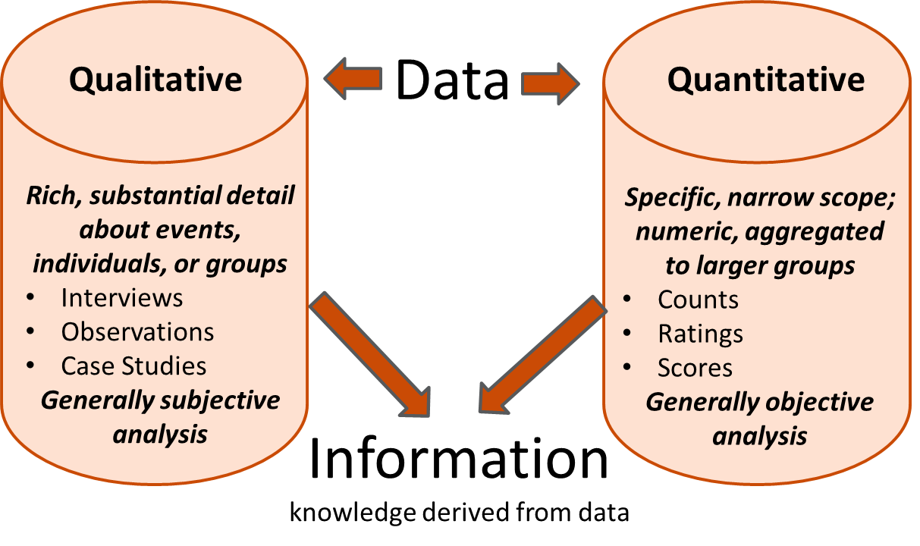

Reluctance for Using Data (Holcomb, 2004)
- Lack of training
- Lack of time
- Feast or famine
- Fear of evaluation
- Fear of exposure
- Confusing a technical problem with a cultural problem

Benefits of Using Data
- Clearly identify strengths and areas for improvement
- Helps programs understand and address the real rather than perceived issues
- Provide information to help deliver services in the most effective and efficient manner
- Help programs make policy decisions and then evaluate the impact of them
- Provide partners and stakeholders with information about the value of the program
- Enable programs to understand and focus on results
- Helps programs and their partners to understand, take pride in, and promote their accomplishments
- Ensure that formally reported information is accurate
- Helps programs to retain and attract funding

Leadership: Establishing Effective Data Management Processes
- Develop and maintain system record keeping protocols
- Provide adequate training and support related to collecting, analyzing, and reporting data
- Check for accuracy….don’t second guess when records/documents aren’t clear
- Collect, enter, analyze, and share data regularly on an ongoing basis:
    - Timely data entry is critical
    - Transparency is important…share with staff, students, and other key stakeholders
- Review reports and triangulate data for accuracy. Find additional evidence that can confirm or reject assumptions and conclusions.
- Regularly review and use data to inform continuous improvement

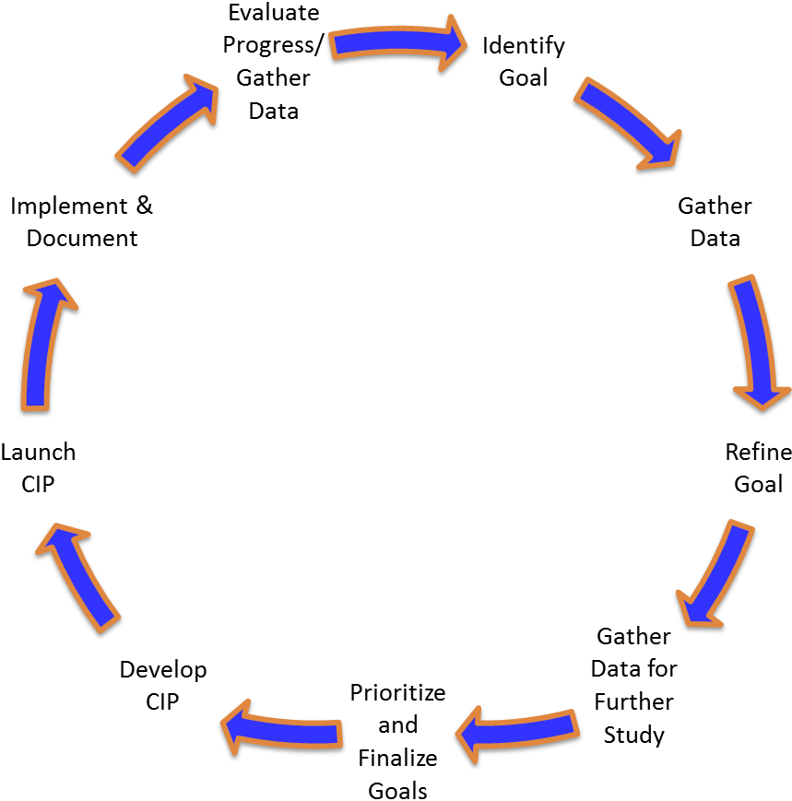

PCI Session 2: Leading With Data: Handout 3

ACLS Components and Tools of Accountability

Important Note: We strongly encourage programs to familiarize themselves with the ACLS Accountability System webpage for the programs that it funds.

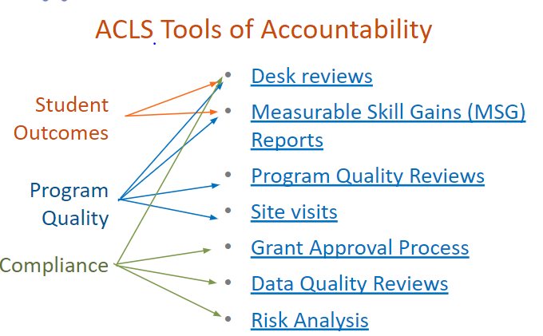

ACLS categorizes its accountability system into four main components:
- Enrollment: The average monthly enrollment relative to the program’s targets.
- Student Outcomes: Also known as measurable skills gain or MSG---specific to ABE and ESOL learners and important for AE programs because they can be reported without Social Security numbers.
- Program Quality: The ACLS Indicators of Program Quality represent ACLS’ best thinking at this time of what high quality programming entails so programs are held to these standards of quality. Evaluated through Program Quality Reviews (PQRs), once per funding cycle for each program. Annual PQR Summative Reports provide a state snapshot of strengths, challenges, and promising practices.
- Compliance: A third component of the accountability system is compliance, which measures the extent to which local programs operate in accordance with federal and state programmatic, financial, and reporting requirements and deadlines. These requirements are outlined in the FY24 – FY28 Massachusetts Policies for Effective Adult Education in Community Adult Learning Centers and Correctional Institutions.

Accountability Resources
- Finding Your FY23 MSG Target
- Desk Review Resources, including the FY23 Change to the Desk Review Process
- SABES Program Support PD Center: LACES Resources and Trainings
- ACLS Annual PQR Summative Reviews
- Ed Grants: Budget and Financials
- FY24-FY28 Massachusetts Policies for Effective Adult Education
PCI Module 2 Leading with Data Handout 4
Sources of Data

IPQ | Types of Data | Data Sources | Qualitative/ Quantitative | Answers questions about…
Indicator 1  Program Design  The program, in alignment with its mission, implements the services approved by ACLS. | - Class focus Class design options (e.g., in person, distance or hybrid)  - Student barriers to participation  - Class size  - Actual vs. target enrollment  - Outreach efforts and partners  - Wait list | - Desk Reviews  - Class Records (e.g., EFLs, class size, tutor hours and matches, cost per student)  - Staffing charts  - Budgets  - Community Partners for Recruiting and Support | Qualitative and quantitative | - Do our program services align with the proposed design and the purposes for which it was funded?  - Does our program provide adequate supports and options that enable students with barriers to participation to attend?  - Is our program design of adequate intensity to promote student outcomes?
Indicator 2  Equitable Access  Guided by data and a responsibility for diversity, equity and inclusion, the program ensures that all adult learners in the local workforce area have equitable access to high quality educational services. | - Student demographics  - Enrollment  - Class levels  - Dropout rate  - MOAs with partners  - Local employment (and other) needs and assets  - High need regional employment sectors | - Desk Review  - LACES Reports  - Program Records  - Local WDB Plan  - NRS Tables 2, 6  - Accommodations  - Census Equity Data  - Community Resilience Estimates  - Household Pulse Surveys  - Statistical Atlas  - Mass. Occupational and Industry Projections | Quantitative, can also be qualitative | - Who are the adults in need of classes in our community?  - Among those, who do we serve? Who are we not serving?  - Is our program responsive and accessible to those in the community most in need of services? How do we know?  - How do we address the needs of applicants/learners with diagnosed or self-disclosed learning and other disabilities?
Indicator 3  Career Pathways Collaboration  The program ensures all staff understand the essential role that the program plays to access career pathway opportunities as outlined in the local plan. | - Student goals  - Referrals to and from WIOA partners  - IET participants and Industry Recognized Credentials earned  - Transitions to postsecondary education, training, or employment  - Median income | - Desk Reviews  - Integrated advising curriculum  - Job descriptions and/or staff handbook that describe the process for identifying and sharing student goals across the program  - Formal partnerships with WIOA partners  - WDB Local Plan  - Student goals, advising records, and outcomes  - NRS Table 5a; 9 for workplace programs and 10 for AECI  - Notes and results from meetings with local partner agencies (education, WFD, training, social services) | Qualitative and quantitative | - Are all staff engaged in the process of helping students understand career pathways and options?  - Is our process for advising students on next steps effective?  - Do employers, WIOA partners, and other key community organizations know about our program?  - Do all staff in our program know about relevant community organizations, services, resources, and key employers?  - Are there clear, seamless pathways for students to be referred to WIOA partners and for their clients to be referred to us?  - How do we monitor, capture, and communicate student progress toward meeting their next step goals across the program?

Indicator 4  Curriculum  Curriculum is standards-based, vertically and horizontally aligned in all content areas and levels, contextualized and relevant, and supports the diverse needs of all learners. | - Curriculum aligned to CCRSAE or MA English Language Proficiency Standards (MA ELPS)  - Curriculum that show proficiency indicators within and across levels  - Online/digital tools, resources, and devices  - Curricula/resources that reflect students’ diverse identities/cultures | - Curricula, Lesson Plans  - Digital literacy integrated into instruction  - Examples of accommodations  - Evidence of differentiation in instruction  - Instructional materials and resources that reflect the diversity of learners in the program | Qualitative | - Do we have high expectations for all students at all levels? How do we know?  - Is curriculum aligned to CCRSAE and/or the MA ELPS?  - Do students see themselves reflected in the materials we use in our classes?
Indicator 5  Instruction and Assessment  The program consistently uses high quality instructional strategies to meet all students’ academic needs and prepare them for family sustaining employment and/or postsecondary education, and civic engagement. The program has an assessment system to inform planning and decision-making, monitor and communicate learner progress, and improve teaching and learning. | - Lesson Plans with formative and summative assessments  - Processes and tools for formally and informally assessing learners  - Processes for sharing assessment results with students | - Teacher observations with feedback  - Formative and summative assessments  - Standardized/NRS assessments  - Assessment results  - Formalized process for teachers to analyze and share assessment results with students that informs both teaching and learning | Qualitative and quantitative | - How do curriculum and standards drive instruction?  - How well are our students learning?  - How do assessment results inform and strengthen teaching and learning?  - How can we improve learner gains?  - Is instruction of adequate rigor to help students successfully transition to further education, training, and employment?  - Are students empowered to take control of their own learning?  - Do we celebrate achievement?
IPQ 6  Student Progress  The program consistently meets or exceeds state student performance targets for academic growth, and for postsecondary education, training, and employment. | - Follow-up process for tracking student outcomes  - Student Learning Data: MSG is only one measure, but an important one  - HSE attainment  - Transitions to PSE, training, or employment but also broader than that  - IET/Industry-recognized credentials | - Pre- and post-test %  - % of Social Security numbers collected  - Assessment scores  - Formative and summative assessments  - Teacher checklists of student competencies  - Portfolios  - Desk Review  - NRS Reports 4, 4b, 4c  - Advising records  - Data matching  - Self-reporting  - Focus groups  - Surveys | Qualitative and quantitative | - Are students’ meeting their purposes for attending AE classes?  - Do we provide the necessary supports to prepare students for next steps?  - What role do our WIOA and other community partners play in creating opportunities for our learners?  - Do we help students persist long enough to meet their goals?  - Is our follow-up process efficient enough?
Indicator 7  Advising and Student Support Services  The program ensures effective and equitable delivery of advising and support services. | - Student demographics  - Student goals and barriers  - Information about community resources  - Student attendance and persistence | - Advising curriculum  - Advising notes  - Student outcomes (see also IPQs 3, 4, and 5)  - MOAs and other partnerships  - Student persistence rates  - Student attendance | Qualitative and quantitative | - What are students’ barriers to learning and next steps?  - What resources/partnerships do we leverage to help students overcome barriers?  - Do all students have access to advising and other supports they need?  - Do students use/take advantage of advising services? If not, why not?

Indicator 8  Organizational Support The organization’s policies, practices, and facilities sufficiently support the adult education program. | - Suitable and safe, classroom space  - Accessibility and safety guidelines  - Minimum staff requirements for level of education, experience, and professional licensure  - New staff onboarding process  - Staff compensation and benefits  - Type of classroom, advising, office, and other space  - Staff longevity  - Staff PD plans  - Meetings with agency leaders  - Devices and technology infrastructure for staff and students | - Accessibility checklist  - Job descriptions with minimum qualifications  - Staff retention vs. turnover rates  - Staff and student handbook policies  - Staff salaries and benefits  - Number of full-time and part-time positions and staff  - Staff credentials and experience  - Number/% of staff with relevant K-12 or ABE licensure  - Classroom, office, advising, and record-keeping space  - Staff PD participation and completion records  - Continuous improvement data and plans | Qualitative and Quantitative | - Are the organizational systems in place compliant and effective?  - Do we have suitable and appropriate space for classes, private advising, offices, and secure record keeping?  - Do all staff meet minimum requirements?  - Does our staff compensation package and other relevant working conditions allow us to attract and retain high quality staff?  - Is space accessible to all current and potential staff and students?  - Do our staff attend PD that supports professional growth and program goals?  - What is the impact of PD learning on classroom and program effectiveness?

IPQ | Types of Data | Data Sources | Qualitative/ Quantitative | Answers questions about…
Indicator 9 Educational Leadership  Educational leaders guide a continuous improvement planning process that supports high quality practices and a shared vision for student and staff success with the goal of improving student outcomes. | - Staff and student perceptions of quality  - Values, beliefs, and attitudes  - Staff and student feedback  - Program Continuous Improvement Plans (CIP), data, and progress reports  - Staff observation protocols, schedules, and tools  - Mission and Vision Statements  - Support for all staff to engage in high quality professional learning and support for them to implement new learning  - Data-driven professional learning plans based on what students need to know and be able to do  - Transparent and high expectations for all staff and students | - Desk reviews  - Staff observation notes and reflections  - Surveys  - Focus groups  - Program handbooks  - Student Leadership structure and process  - PQR reports  - Site visit summaries  - Data-driven program continuous improvement plans developed through an inclusive process that engages all stakeholders and holds everyone accountable for the programs’ effectiveness  - Plan for creating a an inclusive program culture that is welcoming of diverse staff and students  - PD budget and plans | Qualitative  and quantitative | - Do we have a quality program? How do we know?  - Are our mission, vision, and values transparent and understood by all?  - Do we practice what we say we value? What evidence is there that we do or we don’t?  - Do we improve every year?  - Do we have high expectations of all staff, students, and other stakeholders?  - Do we believe that every student can succeed?  - Is program and instructional practice regularly informed by student data?  - Do all staff, students, and other key stakeholders have opportunities to contribute in meaningful ways to the success of the program?  - Do all staff, students, and other key stakeholders understand their role in being accountable for the success of the program?  - How do we use data to the benefit of staff, students, and the program?
Indicator 10  Fiscal and Data Accountability  The organization maintains a stable financial condition operating in a financially sound and publicly accountable manner. The program has a system for collecting and reporting data that ensures its integrity. | - Organizational and program fiscal procedures and oversight policies  - Budget balances and line item expenditures (grant funding, match, donors, other)  - Process for approving payroll, expenditures  - Process for capturing and entering data into LACES | - Desk Reviews: Year-to-date total funding vs. expended funds  - EdGrants: Monthly drawdown amounts  - Internal budget records, including match  - Time sheets/staff time records  - Org chart with oversight structure  - Annual audit and tax returns  - LACES Reports  - Fiscal Audits | Mostly quantitative | - Are we efficiently managing our budget consistent with funded purposes?  - Do our accounting procedures comply with funder requirements and with regulations related to the use of public monies?  - Are we making the best use of our funding?  - Can we afford to do “X”…?

Planning for Continuous Improvement
Session 2: Leading with Data

Handout 5: LACES Reports

Dashboard Reports: https://laces.literacypro.com/laces/Dashboard/Standard/26

Desk Review Reports
- In the student tab, select Searches > Desk Review > and then one of the five dropdown reports

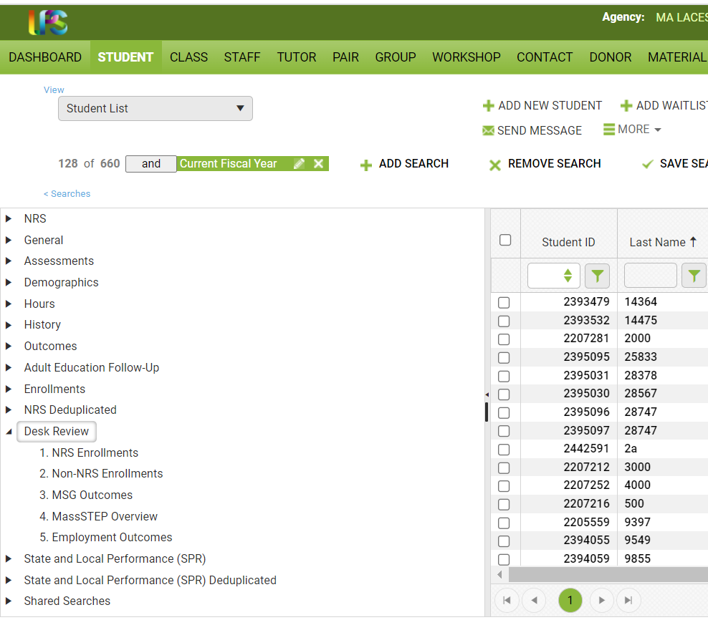

NRS Reports
- Go to student screen
- Click on “Searches” (beneath Student List)
- Click on NRS
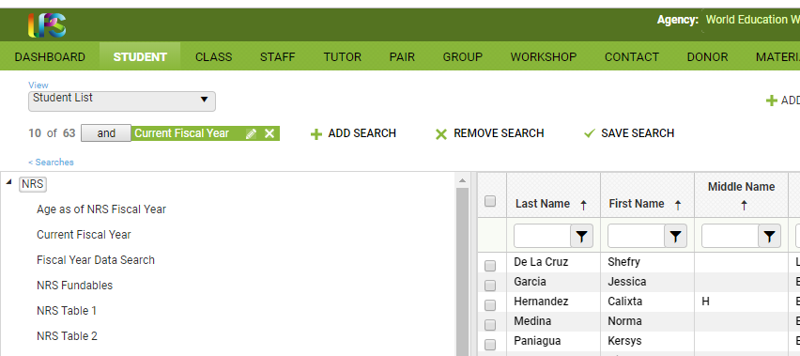

- For more information, see https://nrsweb.org/resources/nrs-reporting-tables
- Massachusetts state summary: https://nrsweb.org/policy-data/state-performance
- Massachusetts NRS Statewide Tables: https://nrs.ed.gov/rt/ma

 | Fiscal Year Data Search
 | NRS Fundables
Table 1 | Participants by Entering Educational Functioning Level, Ethnicity, and Sex
Table 2 | Participants by Age, Ethnicity, and Sex
Table 2a | Reportable Individuals by Age, Ethnicity, and Sex
Table 3 | Participants by Program Type and Age
Table 4 | Measurable Skill Gains by Entry Level
Table 4a | Educational Functioning Level Gain
Table 4b | Educational Functioning Level Gain and Attendance for Pre- and Post-tested Participants
Table 4c | Measurable Skill Gains and Attendance by Entry Level for Participants in Distance Education (Optional)
Table 5 | Primary Indicators of Performance
Table 5a | Primary Indicators of Performance for Participants in Distance Education (Optional)
Table 6 | Participant Status and Program Enrollment
Table 8 | Outcomes for Participants in Family Literacy Programs (Optional)
Table 9 | Outcome Achievement for Participants in Integrated English Literacy and Civics Education
Table 10 | Outcome Achievement for Adults in Correctional Education Programs
Table 11 | Outcome Achievement for Integrated Education and Training Participants
Table 14 | Local Grantees by Funding Source
 | Student Diagnostic Search

Student Alerts

Dashboard > Widget Library > Student Alerts

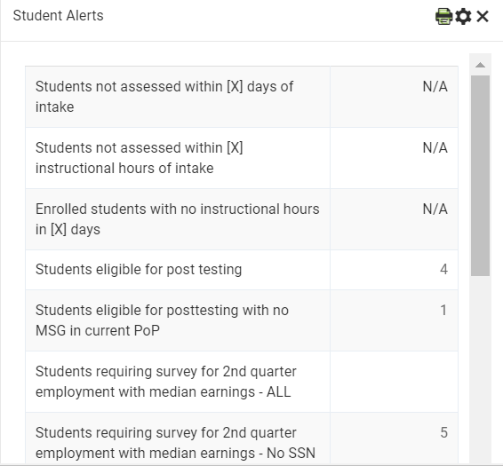
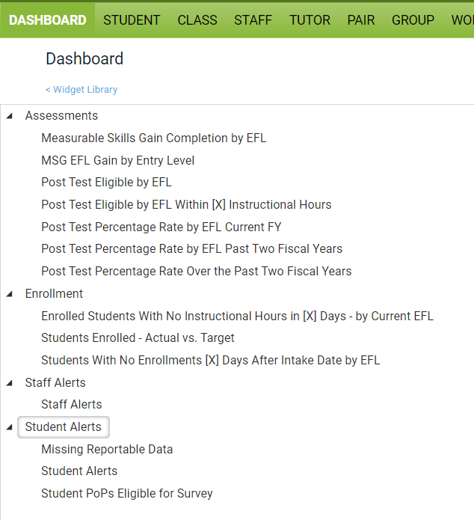

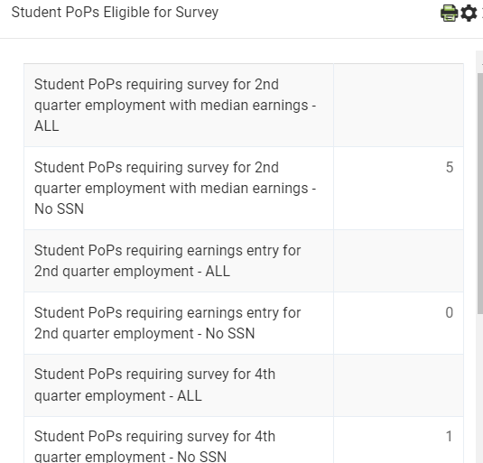 Automatically Generated Reports

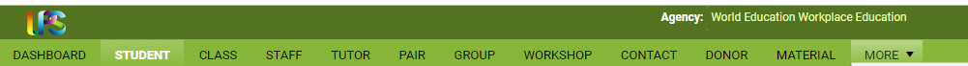

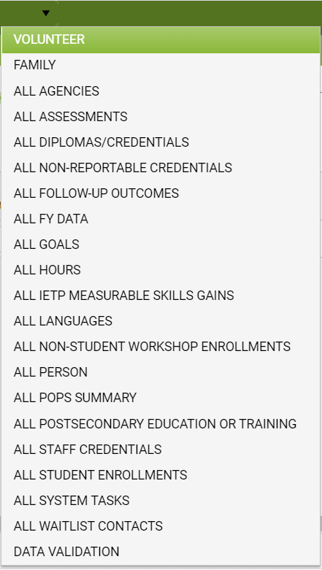

Available Fields for Generating Customized Reports in LACES

View Manager
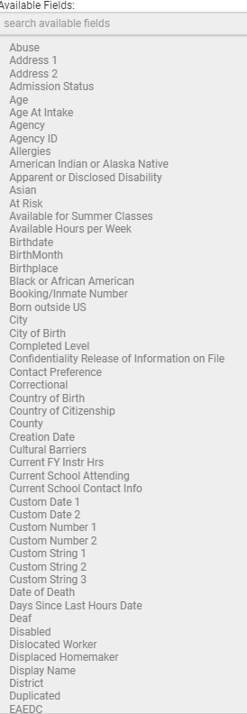
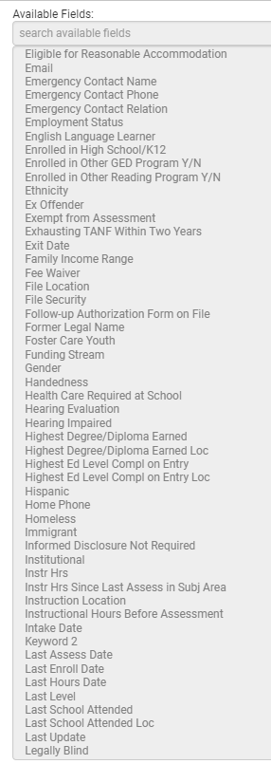

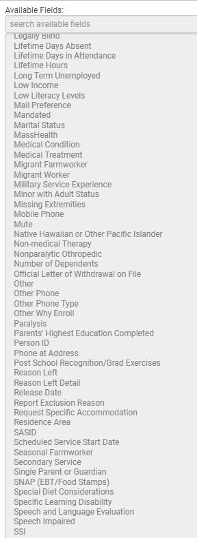
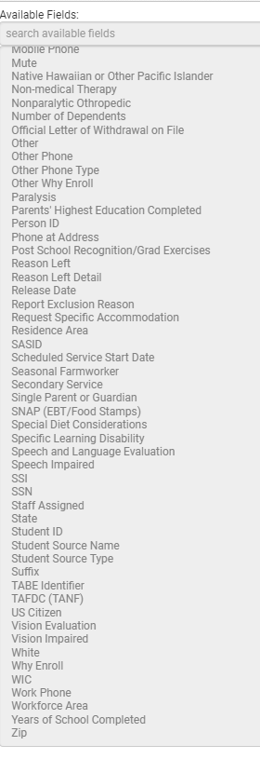

lanning for Continuous Improvement
Session 2: Leading with Data

References for Module 2

Berinato, Scott. (2019, January-February). “Data Science and the Art of Persuasion.” Harvard Business Review. Retrieved from https://hbr.org/2019/01/data-science-and-the-art-of-persuasion

Blink, Rebecca. (2007). Data-Driven Instructional Leadership. New York: Routledge Eye on Education

Holcomb, Edie L. (2004). Getting Excited about Data Second Edition: Combining People, Passion, and Proof to Maximize Student Achievement. Thousand Oaks, CA: Corwin Press

