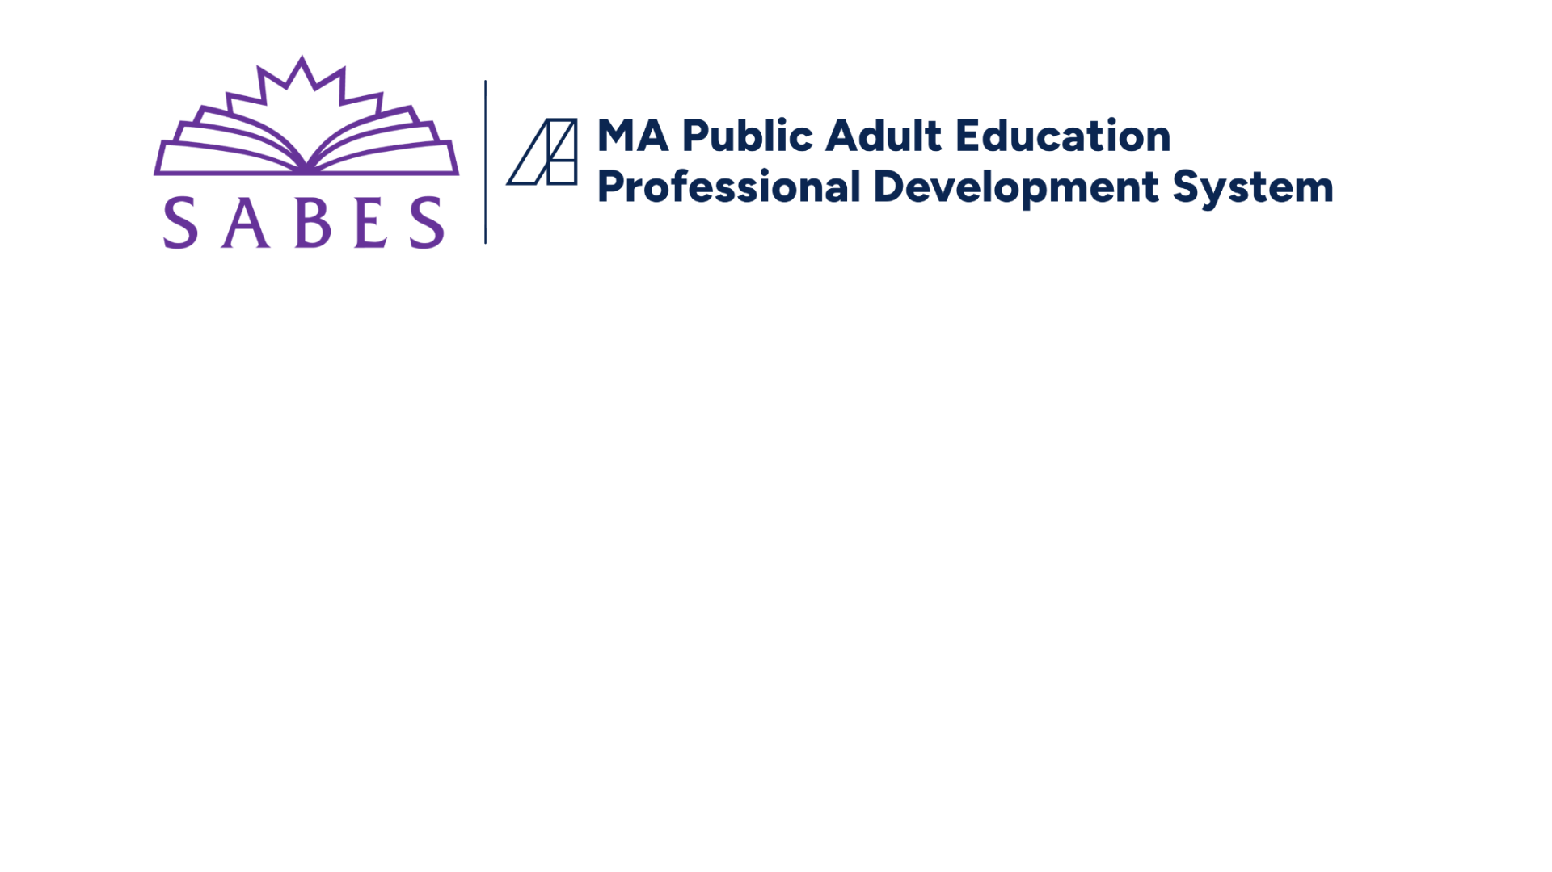___________________________________________________________________________________

**REVIEW GUIDE: ELA Unit Plan**

The purpose of this review guide is three-fold:

* To support program staff in **writing robust and cohesive unit plans** that address [DESE priorities for curriculum and instruction](https://sabes.org/content/priority-lenses-ela-curriculum-instruction/ela-sabes-english-language-arts-curriculum) (items with a * reflect these priority lenses)
* To help programs revise their unit plans with the goal of **continuous improvement**
* To guide programs and teachers in **creating exemplary unit plan models** for others to follow

|  |  |  |  |
| --- | --- | --- | --- |
| **Program** |  | | |
| **Unit Title** |  | **Class Level / GLE Range** |  |
| **Reviewer(s)** |  | **Review Date** |  |

***Check the box only if the answer to the question posed is "yes." Unit designers are encouraged to see the resource*** [*Design Tasks & Resources for ELA Unit Planning*](https://docs.google.com/document/d/1y5cJAdzecIOEsY-kd4xuC5VMiMqB57u-kX6R-j_N9VI/edit?tab=t.0) ***for any boxes not checked.***

|  |  |  |
| --- | --- | --- |
| **PART 1: OVERVIEW**  *This section covers most of Part 1 of the* [*unit plan template*](https://docs.google.com/document/d/1zosx7jKsEt27BZ7XYxIajM__L529_FaCAvWu_sPn5gk/edit?tab=t.0) *and*  *draws primarily from the following priority lenses:* | | **COMMENTS/NOTES** |
| *[Contextualization & Relevance](https://www.sabes.org/content/ela-lens-contextualization-and-relevance/ela-sabes-english-language-arts-curriculum)  *[Culturally Responsive Teaching](https://www.sabes.org/content/ela-lens-culturally-responsive-teaching/ela-sabes-english-language-arts-curriculum) | * [CCRSAE & Standards-Based Teaching](https://www.sabes.org/content/ccrsae-and-standards-based-teaching/ela-sabes-english-language-arts-curriculum-instruction)  * [Assessment](https://sabes.org/content/ela-lens-assessment/ela-sabes-english-language-arts-curriculum-instruction-pd-team) |
| **UNIT TOPIC/TITLE**  Does the unit topic represent a **real-life/**[**authentic**](https://docs.google.com/document/d/18eY0fR14rvkFX4QpE8ehUraPNOP4rq0V8EfPr67S5_M/edit?tab=t.0) **context** in which ELA  skills are used by adults (e.g., civics/current events, health, financial literacy,  workforce preparation, parenting; see [TSTM](https://www.doe.mass.edu/acls/frameworks/tstm.html))?  Does the unit topic reflect the diverse identities, goals, and needs of  learners at this level? Will they see it as **relevant**?  If separate classes are not provided for content area instruction (e.g. social  studies, science, workforce preparation, financial literacy), does this unit  **build knowledge** in one of those areas? (For ASE students: Does the unit  topic relate to topics students will see on the HiSET/GED or in their next  steps?) | |  |
| **RATIONALE & ESSENTIAL QUESTIONS**  Does the **rationale** effectively explain why the topic and ELA skills are  important for adults to learn, referencing real-life experiences and practical  applications of ELA skills?  Do **essential questions** address the unit topic, require more than a yes/no or  simple factual response, and promote deep thought, lively discussion, and  more questions? | |  |
| **UNIT OUTCOME/CULMINATING ASSESSMENT**  Does the unit outcome/culminating assessment use the [sentence stems](https://docs.google.com/document/d/1SFKh_dYEOo0yepG2FDI7LWfq-ZE3_jdYERJtVZ_SpKU/edit?tab=t.0) on  the unit plan template and describe an **observable** project, product, or  performance through which students demonstrate their learned **ELA skills**?  Does the culminating assessment reflect **real-life/**[**authentic**](https://docs.google.com/document/d/18eY0fR14rvkFX4QpE8ehUraPNOP4rq0V8EfPr67S5_M/edit?tab=t.0) **adult tasks**,  engaging learners in problem-solving, inquiry, and critical thinking?  Are students likely to find the culminating assessment relevant to their **life**  **and goals**?  Are tasks worth the **time** involved? | |  |
| **PRIORITY ELA STANDARDS**  Is the unit built around a **realistic** **number** (~3-5) of priority [CCRSAE-ELA](https://www.sabes.org/content/ccr-standards-ela/ela-sabes-english-language-arts-curriculum-instruction-pd-team)  [Standards](https://www.sabes.org/content/ccr-standards-ela/ela-sabes-english-language-arts-curriculum-instruction-pd-team), at the appropriate level? (Secondary standards are optional.)  Are all the priority standards **related to the culminating assessment**?  Does the unit include a **mix o**f **Reading**, **Writing**, **Speaking & Listening**, and  **Language** standards? Are **Reading Foundation** standards included for  CCRSAE levels A-D?  Does the unit provide opportunities for students to (1) engage with **complex**  **text/academic language**, (2) focus on **evidence**, and (3) build **knowledge**?  ([three instructional shifts](https://www.sabes.org/sites/default/files/resources/FOCUS%20on%20THE%20TEXT.pdf)) | |  |
| **KEY STUDENT MATERIALS**  Is there a **variety** of resources, including written, audio, video, and digital  texts, that go beyond the use of textbooks?  Are[**text complexity/readability levels**](https://sabes.org/content/text-levels-sets-and-complexity) provided for each text? Are the texts  at an appropriate level for the stated GLE range?  Are the [**texts relevant to adult learners**](https://www.sabes.org/content/finding-texts-adult-learners/ela-sabes-english-language-arts-curriculum-instruction-pd-team),culturally responsive, and useful for  building knowledge and achieving the unit objectives?  Are [**authentic**](https://docs.google.com/document/d/18eY0fR14rvkFX4QpE8ehUraPNOP4rq0V8EfPr67S5_M/edit?tab=t.0) texts included?  Is it clear how each resource **relates to the unit** (e.g., addresses content  area topic, provides opportunity to develop/apply the targeted ELA skills)? | |  |

|  |  |
| --- | --- |
| **PART 2: IN-DEPTH VIEW**  *This section covers Part 2 of the unit plan template.* | **COMMENTS/NOTES** |
| **UNIT OBJECTIVES/ASSESSMENT**  **(\***[**CCRSAE & Standards-Based Teaching**](https://www.sabes.org/content/ccrsae-and-standards-based-teaching/ela-sabes-english-language-arts-curriculum-instruction)**/\***[**Assessment**](https://sabes.org/content/ela-lens-assessment/ela-sabes-english-language-arts-curriculum-instruction-pd-team)**)**  Are the unit objectives and assessments mentioned in PART 2 of the unit  plan template **clearly connected/aligned** to the priority ELA standards and  culminating assessment mentioned in PART 1? (See [alignment chart](https://docs.google.com/document/d/1m7MTQiLvJDNIqso-eita6J7uaKyGHhJGjAQ1TaZs14M/edit?tab=t.0).)  Is it clear that the focus of the objectives and the assessments is primarily  **on ELA skills**, not (just) content knowledge?  Are there a **variety** of [formative and summative assessments](https://sabes.org/content/ela-lens-assessment/ela-sabes-english-language-arts-curriculum-instruction-pd-team)included, with  expectations for performance clearly communicated to students (e.g.,  through rubrics, checklists)? |  |
| **PRIORITY LENSES** | |
| **\***[**Culturally Responsive Teaching**](https://www.sabes.org/content/ela-lens-culturally-responsive-teaching/ela-sabes-english-language-arts-curriculum)  Are students invited to **connect** **content and skills** to their own lives and to  what they already know?  Do the student and teacher resources include authors, images, and ideas  from **more than one perspective** and/or **culture**?  Are the cultural representations and/or different perspectives included in  the unit **fair and accurate**? Are stereotypes avoided?  Do activities draw on or connect with students’ **linguistic, cultural,**  **experiential, and interpersonal assets**?  Does the unit promote **civil discourse** by inviting learners to share different  points of view and to support their claims with evidence? |  |
| **\***[**Differentiated Instruction**](https://www.sabes.org/content/ela-lens-differentiation/ela-sabes-english-language-arts-curriculum-instruction-pd-team)  Are there **adequate supports** to help teachers differentiate instruction to  meet the needs of individual learners, including **English learners** and those  with **learning disabilities**?  Are students given **choice/agency** in how they engage with learning and  demonstrate progress (e.g., options related to content, product, process)? |  |
| **\***[**Digital Literacy and Technology**](https://www.sabes.org/content/ela-lens-digital-literacy-technology/ela-sabes-english-language-arts-curriculum-instruction)  Do students do at least one of the following in the unit:   * + **Find** and/or read digital texts?   + **Use** digital tools to organize their learning/tasks?   + **Evaluate** the validity of online sources?   + Use digital tools to **create and present products** (e.g., papers, presentations, graphics)?   Are there **prompts and supports** for teachers to teach the relevant pieces  above?  Do teachers have **access** to the technological tools required in the unit? |  |
| **\***[**Evidence-Based Instruction**](https://sabes.org/content/ela-lens-evidence-based-instruction/ela-sabes-english-language-arts-curriculum-instruction) **(including** [**EBRI**](https://sabes.org/content/evidence-based-reading-instruction-ebri/ela-sabes-english-language-arts-curriculum)**)**  For [***beginning reading levels*** (CCRSAE Levels A-B)](https://www.sabes.org/content/teachers-guide-ccrsae-level-and-level-b-adult-learners/ela-sabes-english-language-arts): Is instruction in phonemic  awareness, word identification skills, and fluency addressed/prompted and  tied to diagnostic assessments?  For ***intermediate reading levels*** (CCRSAE Levels C-D): Are suggestions or  directions provided for word analysis and fluency instruction, as needed,  based on diagnostic assessments?  Is ***vocabulary*** instruction included, with a focus on [Tier 2 words and on key](https://docs.google.com/presentation/d/1cdeMT2_TLNCtbzm2ewRERh_bHttzF6t0YkgHXNMRkiI/edit" \l "slide=id.p2)  [Tier 3 words](https://docs.google.com/presentation/d/1cdeMT2_TLNCtbzm2ewRERh_bHttzF6t0YkgHXNMRkiI/edit" \l "slide=id.p2) related to the content area topic? Is it clear that teachers  should provide practice in the same set of words over multiple lessons in the  unit?  Are ***reading comprehension*** skills and strategies taught, with practice in the  same set of skills provided over multiple lessons in the unit?  Are ***writing*** activities appropriately supported with strategy instruction  and/or opportunities to draft, revise, edit, and publish/present student  generated text?  Is it clear that students will be taught ELA skills with ***explicit, scaffolded***  ***instruction*** (e.g., [“I do,” “We do,” “You do”](https://sabes.org/sites/default/files/resources/GRR.pdf))? |  |

|  |  |
| --- | --- |
| **USABILITY OF UNIT PLAN** | **COMMENTS/NOTES** |
| Is a logical **sequence of lessons** suggested? Does it prompt scaffolded  instruction in the targeted ELA skills, the building of adequate content  knowledge, and supporting students in successfully completing the  culminating activity?  Is the time allotted **reasonable**? Where might **streamlinin**g occur?  Is there a **balance** of structure/support for the teacher and  flexibility/respect for their professional judgment?  Is the **writing and formatting** clear and easy to follow (e.g., effective use of  concise language, bullets, etc.)? |  |

|  |
| --- |
| **Other Comments** |
|  |