SABES Program Support PD Center
Professional Licensure

Massachusetts Test for Education Licensure (MTEL)
Adult Basic Education (55) Test

SABES Study Guide

Developed by:

Meri Holden
Bristol Community College, Attleboro Adult Education Program

Karen Miller
Bristol Community College Literacy Center

This Study Guide was developed through support from the SABES Central Resource Center, a project of World Education, Inc., funded by
the MA Department of Elementary and Secondary Education.
SABES MTEL Adult Basic Education (55) Test

Study Guide

Overview and Acknowledgements
This document provides information to assist adult educators in preparing for the Adult Basic Education (ABE) subject matter test of the Massachusetts Tests for Educator Licensure (MTEL). We are grateful for the work of Meri Holden and Karen Miller to compile this resource for SABES and for adult educators who are preparing to take the MTELs in pursuit of the ABE Teacher’s License.

Complementary to this Guide is a SABES ABE MTEL Math Study Guide, which provides additional detail and study resources for those wishing to focus on the math portion of the ABE MTEL. The Glossary of Secondary and Primary Language Acquisition Terms will help those who want to focus on the ESOL objectives.

Table of Contents

English Language Arts (15%) 3-5

English for Speakers of Other Languages (ESOL), (25%) 5

Mathematics (25%) 6-13

History and Social Science (10%) 14-15

Science (10%) 16

Application of Knowledge and Understanding (15%) 17

English Language Arts (15%)

Introduction | The MTEL ABE Test will contain 14 – 16 multiple choice questions on English Language Arts. Reading and Writing topics will be included.

Objective 1: Process | Understand the process of written composition.  - Writing for various audiences/purpose  - Processes for generating and developing text  - Prewrite  - Draft  - Revise  - Edit  - Rewrite  - Sentence, paragraph & essay development  - Thesis statement  - Organization  - Transitions  - Details to support  - Style & voice  - Evaluation  - Rhetoric  - Logic  - Voice  - Style  - Content  - Revising  - Unity  - Focus  - Clarity  - Economy of expression

Objective 2: Mechanics | Understand grammar, usage, conventions, structure, and history of edited American English.  - Grammatical expressions  - Formal usage  - Parts of speech  - Sentence types  - Compound / complex  - Declarative  - Exclamatory  - Use of verbs  - Pronouns

English Language Arts (15%), Continued

Objective 2: Mechanics, continued | - Modifiers  - Adverbs  - Adjectives  - Prepositional phrases  - Spelling, capitalization, and punctuation  - Structure / history of English  - Etymology  - Orthography

Objective 3: Literature | Understand literature written in or translated into English.  - Characteristics of major literary genres  - Fiction  - Nonfiction  - Personal essay  - Poetry  - Drama  - Elements of fiction  - Plot  - Character  - Setting  - Theme  - Point of view  - Literary devices  - Figurative language  - Imagery  - Irony  - Symbolism

Objective 4: Reading | Understand theories and practices related to the development of reading skills and strategies for adult learners.  - Process  - Phonemic awareness  - Word analysis  - Phonics  - Structural analysis  - Vocabulary skills  - Strategies  - Comprehension  - Literal  - Inferential  - Evaluative  - Literary and expository texts

English Language Arts (15%), Continued
Objective 4: Reading, continued | - Reading comprehension strategies  - Metacognitive techniques  - Self-questioning  - Paraphrasing  - Relationship  - Reading & Writing  - Range of Literary Skills  - Reading assessment procedures & instruments  - Instructional strategies

English for Speakers of Other Languages (25%)

Introduction | The MTEL ABE Test will contain 24 – 36 multiple choice questions on English for Speakers of Other Languages.

Objective 5: Language Acquisition | Understand theories of language acquisition and factors that affect second language development.  - Input (child)  - Acquisition – subconscious & intuitive  - Learning - conscious learning from rules  - Speech will emerge  - Attentive processing  - Controlled/ automatic  - Focal / peripheral  - Analysis  - Explicit  - Implicit  - Variability Models  - Capability continuum paradigm  - Variable Competence model

Objective 6: English Language Learners | Understand basic linguistic and sociolinguistic concepts and their application to English language learners.  - Stages and sequences  - Language assessment procedures & instruments

Mathematics (25%)
Introduction | The MTEL ABE Test will contain 24 – 36 multiple choice questions on Mathematics.

Objective 7: Number Sense | Understand number sense and operations.  - Place value  - Number base 2 and 10  - Order relations (Order of operations)  - Parentheses  - Exponents  - Multiplication and Division in the order they appear  - Addition and Subtraction in the order they appear  - Prime and composite numbers  - Equivalent forms of numbers  - Integers  - Fractions  - $\frac{numerator}{denominator}$  - Decimals  - Percents  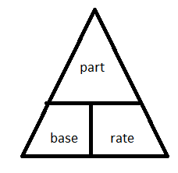  - $\frac{Part}{Base}=\frac{Rate \%}{100\%}$  - Ratios  - a to b a:b $\frac{a}{b}$  - Proportion  - $\frac{a}{b} = \frac{c}{d}$  - Cross multiplication  a x d = b x c  - Radicals  - Exponent (5³) and square root ($\sqrt{4}$)  - Scientific notation  - Absolute value  - Related operations  - $+ and -$are inverse operations  - $× and ÷$ are inverse operations  - Multiplication is repeated addition  - Division is repeated subtraction  - Computational algorithms

Mathematics (25%), Continued

Objective 7: Number Sense, continued | - Estimation  - Word problems  - Calculator use  - Assessment of number sense & operations

Objective 8: Algebra | Understand basic concepts of algebra.  - Use of patterns in math & contextual situations  - Algebraic symbols & expressions  - Properties of functions & relations  - Words, tables, graphs, rules  - Equations / systems of equations  - Graph properties  - Quadratic expression ( x² + 2x + 3)  - Factoring (FOIL – First, Outer, Inner, Last)  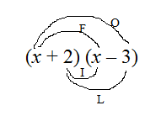  First: x²  Outer: -3x  Inner: +2x  Last: -6  - Application of linear, quadratic & exponential functions  - Assessment of algebraic concepts  - Solving inequalities ( $< ≤ > ≥$)  - Linear equations y = 2x + 4

Objective 9: Geometry | Understand geometry and measurement.  - Measurable attributes of objects (shapes, angles, lines)  - Units, systems and processes of measurement  - Application of techniques, tools and formulas to determine measurement  - Perimeter  - Area  - Surface area  - Volume

Mathematics (25%), Continued
Objective 9: Geometry, continued | - Types of angles  - Acute (less than 90º)  - Right (90º)  - Obtuse(greater than 90º and less than 180º)  - Straight (180º)  - Reflex (greater than 180º)  - Angle relationships  - Complementary(add to 90º)  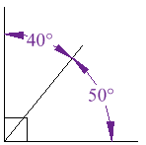  - Supplementary (add to 180º)  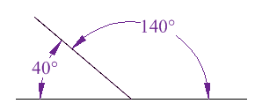  - Perpendicularity – intersecting lines that meet at a right angle ()  - Parallelism – lines that will never intersect ( )  - Congruence – means equal measure ($≅$)  - Similarity – same shape not same size ($\sim )$  - Congruent angle relationships  - Opposite or vertical angles are congruent  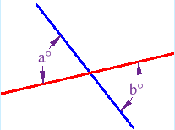

Mathematics (25%), Continued
Objective 9: Geometry, continued | - Angle relationships (continued)  - Parallel lines cut by a transversal  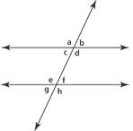  - Alternate Interior (c & f, d & e)  - Alternate Exterior (a & h, b & g)  - Corresponding (a & e, b & f, c & g, d & h)  - Proving theorems  - Pythagorean Theorem (only for right triangles)  $$a^{2}+b^{2}=c^{2}$$  - Geometric figures  - Triangles  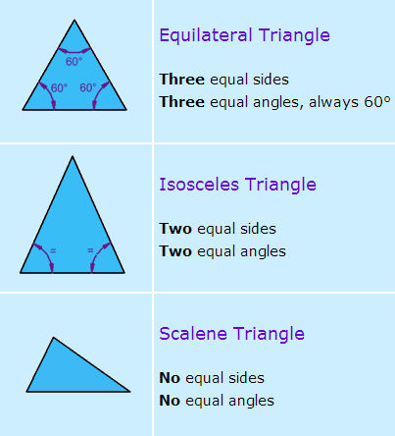  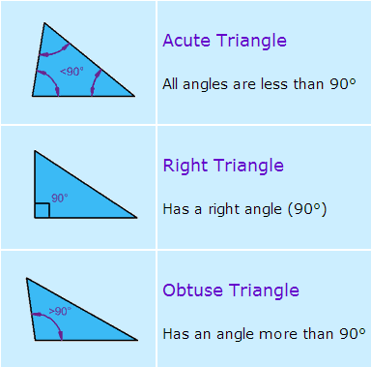  - Quadrilaterals  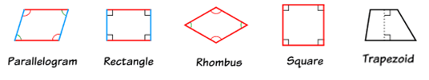  - Circles  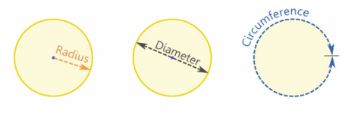

Mathematics (25%), Continued
Objective 9: Geometry, continued | - Geometric properties  - Use of transformations and symmetry  - Coordinate geometry  - Ordered pair (x-value, y-value)  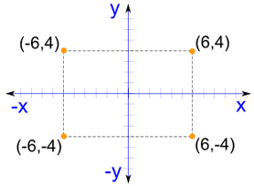  - Slope-intercept form of a line  where m is the slope and b is the y-intercept  $y=mx+b$  - m is the slope of the line  $$\frac{rise}{run}= \frac{y_{2} -y_{1}}{x_{2} -x}$$  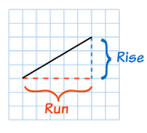  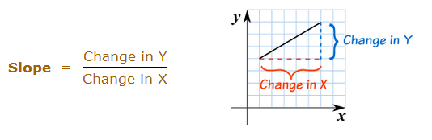  - Assessment of geometry and measurement concepts

Objective 10: Data Analysis | Understand data analysis, statistics, and probability.  - Organizing data  - Charts  - Graphs  - Tables  - Statistics and trend terminology  - Central tendency (mean, median, mode, range)  - Reading and interpreting data  - Frequency distribution & percentile  - Data analysis  - Bias factors & graph distortion  - Probability (represented as %, ratio, fraction, or decimal)  - $P= \frac{favorable}{total possible}$  - Independent vs. dependent probability

Mathematics (25%), Continued
US Length  Measures | The following facts will help you convert units of length:  - 1 foot (ft) = 12 inches (in)  - 1 yard (yd) = 3 ft  - 1 mile (mi) = 5280 ft This is generally the most unfamiliar fact  Tip: These units of length are all linear measures because they measure distance in one direction (i.e. a line). You cannot use them to convert square (Area) or cubic (Volume) measures without modifying them.

US Liquid  Volume Measures | The following facts will help you convert units of liquid volume:  - 1 cup (c) = 8 fluid ounces (fl oz)  - 1 pint (pt) = 2 c  - 1 quart (qt) = 2 pt  - 1 gallon (gal) = 4 qt

US Weight Measures | The following facts will help you convert units of weight:  - 1 pound (lb) = 16 ounces (oz)  - 1 ton (t) = 2000 lb

Time Measures | The following facts will help you convert units of time:  - 1 minute (min) = 60 seconds (sec)  - 1 hour (hr) = 60 minutes (min)  - 1 day = 24 hr  - 1 week = 7 days  - 1 year = 12 months = 365 days

Metric System | Tip: It’s actually much easier to convert units in the metric system than in the U.S. measurement system. You simply need to move the decimal point the appropriate number of decimal places.  To convert to smaller units move the decimal point right  kilo- 1000 hecto- 100 deka- 10 meter gram liter deci- ¹/₁₀ centi- ¹/₁₀₀ milli- ¹/₁₀₀₀  To convert to larger units move the decimal point left

Mathematics (25%), Continued

Area Formulas | 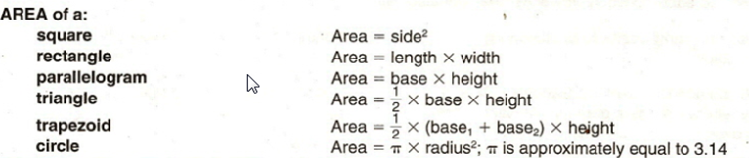

Perimeter Formulas | 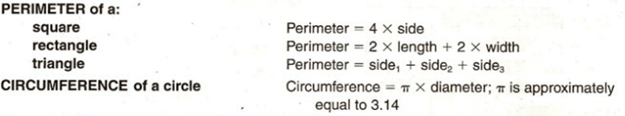

Volume Formulas | 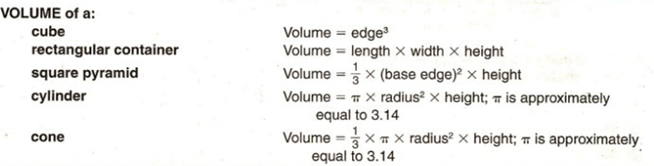

Coordinate Geometry | 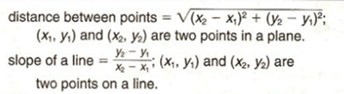  Slope of a horizontal line is 0; vertical line has no slope.  All lines with the same slope are parallel.  Slope-intercept form of a line (where m is the slope and b is the y-intercept)  $$y=mx+ b$$

Pythagorean Relationship | 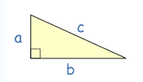  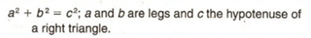

Mathematics (25%), Continued

Measures of Central Tendency | mean = x₁ + x₂ +. . . x_{n} where the x’s are the values for which a mean is  n  desired, and n is the total number of values for x.  median = the middle value of an odd number of ordered scores, and halfway between the two middle values of an even number of ordered scores.  mode = greatest frequency  range = largest - smallest

Distance | Distance = rate x time

Cost | Total cost = (number of units) x (price per unit)

Interest | Interest = principal x rate x time  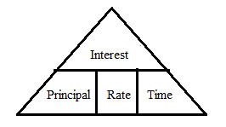

History and Social Science (10%)
Introduction | The MTEL ABE Test will contain 9 – 11 multiple choice questions on History and Social Science.

Objective 11: History | Understand chronology, major developments, and individuals in Massachusetts, United States, and world history.  - Characteristics & contributions of ancient civilizations  - Major transformations in human history  - Agricultural Revolution  - Scientific Revolution  - Industrial Revolution  - Information Revolution  - Major political, social, & economic developments & conflicts in US & World History since 1500  - Renaissance  - Reformation  - Colonization  - Civil Rights  - Breakup of USSR  - European Exploration & Settlement of the West  - Age of Enlightenment  - Great Depression  - U.S. as a world power  - Individuals who shaped MA history  - John Adams (1735 – 1826)  - 2nd President  - Founding father  - Abbey Kelley Foster  - Abolitionist  - Women’s rights  - Henry Knox (1811 – 1887)  - Springfield Armory  - Women’s Rights Convention 1850  - Individuals who shaped U.S. history  - Thomas Jefferson  - Frederick Douglas  - Abraham Lincoln  - Susan B. Anthony  - Franklin D. Roosevelt  - Rosa Parks  - Ann Hutchinson - dissenter  - Roger Williams - RI – dissenter  - Horace Mann – state system of schools

History and Social Science (10%), Continued
Objective 11: History, continued | - Individuals who shaped U.S. history (continued)  - Thoreau  - Emerson  - Individuals who shaped World history  - Pericles (461 – 429 BC)  - Greek statesman / Acropolis democracy  - Galileo  - Simon Bolivar (1783 – 1830)  - Venezuela Independence  - Mohandas Gandhi  - Mao Zedong  - Margaret Thatcher  - Nelson Mandela

Objective 12: Government | Understand basic principles and institutions of American government and their relation to the founding documents of the United States.  - Declaration of Independence 1776  - Concept & purpose  - U.S. Constitution  - Created 1787; ratified 1788; put into effect 1789  - 7 articles  - Bill of Rights – first 10 amendments 1791  - 27 Amendments in all  - Government structure and functions  - Local, state, national  - U.S. Electoral System  - Elements & operation  - Role of political parties & interest groups  - Citizens role in political process  - Rights and responsibilities of U.S. citizenship  - Contemporary issues in American democracy

Objective 13: Geography | Understand basic geographic principles and concepts, and major physical features of the world.  - Land masses & bodies of water  - Shape, location & relationship  - Major political units & divisions  - Geographic terms & concepts  - Region, location, plateau  - Resources  - Almanac, atlas, maps, globes

Science (10%)
Introduction | The MTEL ABE Test will contain 9 – 11 multiple choice questions on Science.

Objective 14: Physical and Life Science | Understand basic principles and concepts of physical and life sciences.  - Fundamental principles  - Conservation of energy  - Adaptation  - Properties of matter  - Forms of energy  - Mechanical  - Chemical  - Sound  - Heat  - Motion of objects  - Earth atmosphere & space concepts  - Organization of living things  - Heredity  - Evolution  - Ecology  - Human body & its systems

Objective 15: Scientific Inquiry | Understand basic principles and procedures of scientific inquiry.  - Generating questions  - Forming hypotheses  - Methods of observation  - Collecting & organizing data  - Measuring instruments & procedures  - Drawing conclusions  - Making generalizations  - Interpreting data, graphs, charts & tables  - Evaluating scientific claims & arguments

Application of Knowledge and Understanding (15%)

Introduction | The MTEL ABE Test will contain 2 open response questions on Application of Knowledge and Understanding.

Objective 16 –  Textual Evidence and Critical Thinking | Analyze and evaluate the organization, focus, unity, and/or expression of ideas in a written text AND apply critical thinking skills (i.e., analysis, interpretation, synthesis, and evaluation) to a written passage that presents an argument related to an ABE content area.  - Analysis of flaws related to the organization, focus, unity, or expression of ideas in a written work  - Identification and correction of errors of usage or mechanics in written texts  - Application of critical thinking skills to narrative, descriptive, and persuasive texts on a variety of topics  - Analysis  - Interpretation  - Synthesis  - Evaluation

