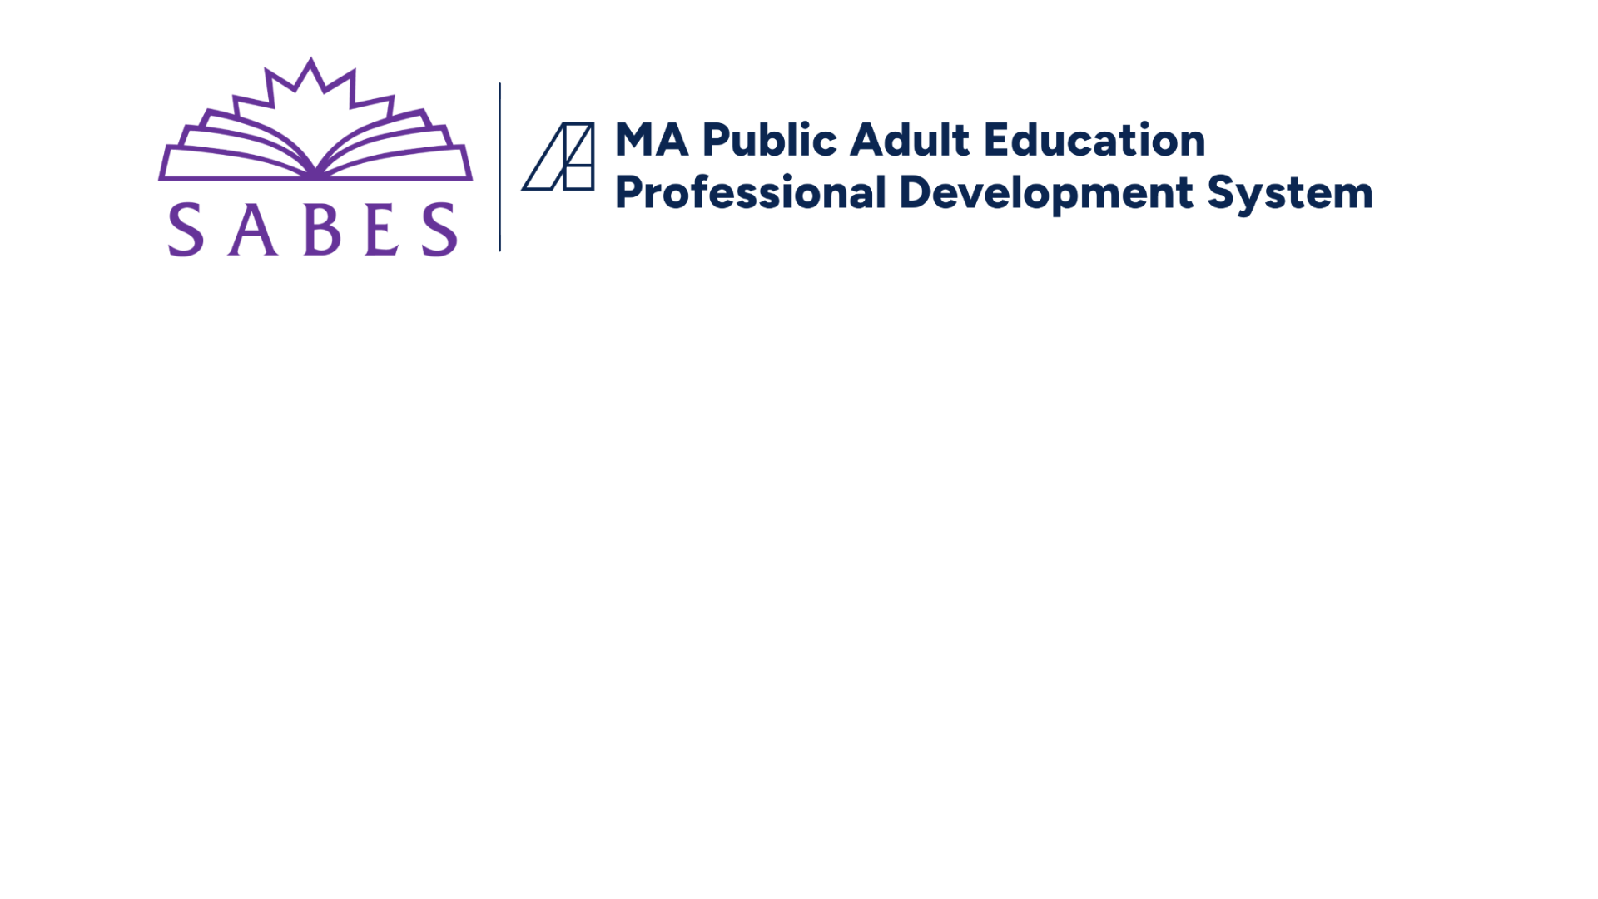

_______________________________________________________________________________________________________

**TEMPLATE: ELA Unit Plan**

*\*See* [*Design Tasks & Resources for ELA Unit Planning*](https://docs.google.com/document/d/1y5cJAdzecIOEsY-kd4xuC5VMiMqB57u-kX6R-j_N9VI/edit?tab=t.0) *for helpful tools.  
*See* [*Existing ELA Curricula*](https://sabes.org/content/existing-ela-curricula-adult-learners/ela-sabes-english-language-arts-curriculum) *for examples of unit plans developed by MA ABE practitioners.*

|  |  |
| --- | --- |
| **Program:** | **Class/Instructional Level/GLE Range:** |
| **Author(s):** | **Date Last Revised:** |

|  |  |
| --- | --- |
| **PART 1: OVERVIEW**  *(This part is duplicated on the Scope & Sequence for this level.)* | |
| **TIME**   * *Indicate the* ***estimated # of hours*** *(and weeks) required to complete the unit.* |  |
| **UNIT TOPIC/TITLE**   * *Frame titles around topics* ***relevant to adults*** *and* ***related to other content areas*** *(e.g., civics/current events/social studies, science and technology, health, literature themes, workforce preparation, etc.;* see [*TSTM*](https://www.doe.mass.edu/acls/frameworks/tstm.html)*).* * *Aim for a* ***pithy topic-related title*** *that can be remembered and used by teachers when referring to the unit.* |  |
| **RATIONALE**   * *Explain* ***why*** *adult learners will find the knowledge and skills they learn in this unit to be relevant to their lives and goals.* |  |
| **ESSENTIAL QUESTIONS**   * *Include open-ended, thought-provoking questions about the unit topic. These should call for* ***higher-order thinking*** *and help students* ***connect*** *and* ***engage*** *intellectually to the unit.* |  |
| **UNIT OUTCOME / CULMINATING ASSESSMENT**   * *Describe the desired outcome, focusing on the* ***central texts*** *and* ***end products*** *students will use to show their ELA learning (and understanding of the content topic).* * *When possible, include one or more* ***authentic performance task****(s), including ones that incorporate digital literacy and technology.* * *See* [*Examples*](https://docs.google.com/document/d/1SFKh_dYEOo0yepG2FDI7LWfq-ZE3_jdYERJtVZ_SpKU/edit?tab=t.0)*.* | Students will **read/analyze/listen** **to** [**specify the kinds of texts]** **in order to** advance their thinking about [**specify the SS/Science/Career topic**].  Students will **show their learning** by [**describe an end product/project that has real-world value**].  Teachers/students will **evaluate learning** by [**specify the tools*****e.g., rubrics, checklists***].  [NOTE: The end product should require the application of the ELA skills being taught.] |
| **PRIORITY ELA STANDARDS**   * *List the ~3-5* ***level-specific***[*CCRSAE-ELA standards*](https://www.sabes.org/content/ccr-standards-ela/ela-sabes-english-language-arts-curriculum-instruction-pd-team) *that will be explicitly* ***taught*** *and then* ***assessed*** *directly or indirectly* ***through the culminating assessment****.* * *Include standards from across the* ***Reading****,* ***Writing****,* ***Speaking/Listening****,* ***Language****, and* ***Reading Foundations*** *(for levels A-D) strands.* |  |
| [**KEY STUDENT MATERIALS**](http://sabes.org/content/text-levels-sets-and-complexity)   * *List* ***authentic*** *and* ***relevant*** *resources that students will read, listen to, or view (e.g., texts, videos, websites, podcasts).* * *Include* ***digital sources*** *and attend to representations of* ***different cultures and perspectives****.* * *Provide* ***text complexity levels****.* |  |

|  |  |
| --- | --- |
| **PART 2: IN-DEPTH VIEW** | |
| **UNIT OBJECTIVES** | **ASSESSMENT OF OBJECTIVES** |
| *TIP: Use* [*this alignment chart*](https://docs.google.com/document/d/1m7MTQiLvJDNIqso-eita6J7uaKyGHhJGjAQ1TaZs14M/edit?tab=t.0) *as you plan, and then copy and paste the last 2 columns into this section.* | |
| * *Include at least* ***one objective for each Priority ELA Standard*** *mentioned in PART 1.* * *Add rows as needed.* | * *Include at least* ***one assessment for each Unit Objective****.* * *Describe how students will* ***demonstrate*** *that they have learned each objective, in a way that directly or indirectly relates to the* ***culminating assessment*** *mentioned in PART 1.* * *Indicate how teachers and students will* ***measure*** *the extent of the learning (e.g., using rubrics, checklists).* * *Consider where* [*formative assessments*](https://sabes.org/content/ela-lens-assessment/ela-sabes-english-language-arts-curriculum-instruction-pd-team) *can be included.* |
| ***By the end of this unit, students will be able to:*** | ***Students will demonstrate their learning by:*** |
|  |  |
|  |  |
|  |  |
|  |  |
|  |  |

|  |
| --- |
| **KEY VOCABULARY**   * *Include academic words or phrases (****Tier 2****) and key content terms (****Tier 3****), unless teachers are expected to add these at the lesson plan level. Consider that each set of words will require multiple days of practice. [See* [*Word Tiers*](https://docs.google.com/presentation/d/1cdeMT2_TLNCtbzm2ewRERh_bHttzF6t0YkgHXNMRkiI/edit#slide=id.p2) *and* [*Vocabulary Resources.*](https://drive.google.com/drive/folders/18W5_P30_AihZ7xRP6q-Qv11HiOUkKk8Y)*]* |
|  |
| **PRIORITY LENSES**   * *Include brief summaries of how the unit addresses the following* [*MA priority lenses*](https://sabes.org/content/priority-lenses-ela-curriculum-instruction/ela-sabes-english-language-arts-curriculum)*. Provide additional explanations, details, and/or helpful hints as appropriate to help teachers address these priorities as fully as possible. [Click on the headings below for information about each lens. See* [*current MA units*](https://sabes.org/content/existing-ela-curricula-adult-learners/ela-sabes-english-language-arts-curriculum)*for examples of this section.)* |
| [**Evidence-Based Instruction**](https://sabes.org/content/ela-lens-evidence-based-instruction/ela-sabes-english-language-arts-curriculum-instruction) **(including** [**EBRI**](https://sabes.org/content/evidence-based-reading-instruction-ebri/ela-sabes-english-language-arts-curriculum)**):**  [**Culturally Responsive Teaching**](https://www.sabes.org/content/ela-lens-culturally-responsive-teaching/ela-sabes-english-language-arts-curriculum)**:**  [**Differentiation**](https://www.sabes.org/content/ela-lens-differentiation/ela-sabes-english-language-arts-curriculum-instruction-pd-team) (especially for English learners and students with learning disabilities):  [**Digital Literacy and Technology**](https://www.sabes.org/content/ela-lens-digital-literacy-technology/ela-sabes-english-language-arts-curriculum-instruction)**:** |
| **ADDITIONAL RECOMMENDATIONS**   * *What else do teachers need to know?* |
|  |
| **SUGGESTED SEQUENCE OF LESSONS[1]**   * *Provide a brief overview of what the focus of each lesson would be, as envisioned by the unit developers.*   *[See example* [*Topic Tracker*](https://docs.google.com/document/d/1l8HCfigjuvhojZdukhoZdfD0OLXNhYXF/edit#heading=h.sc2mwti6guct)*.]* |
| **Lesson 1**:  **Lesson 2**:  **Lesson 3**:  *(etc.)* |

*See* [***REVIEW GUIDE: ELA Unit Plan***](https://docs.google.com/document/d/1Yt5dL3e7C8tZwDqKSBW03E59QnrvncZqib1cZ0LRs44/edit?tab=t.0) *for important questions to address.*

1. Recommended: Include **Sample Lesson Plans** as part of the Unit Plan. These can be developed over time.