The Fishbone Diagram

Purpose
To reflect on core issues and identify root causes.

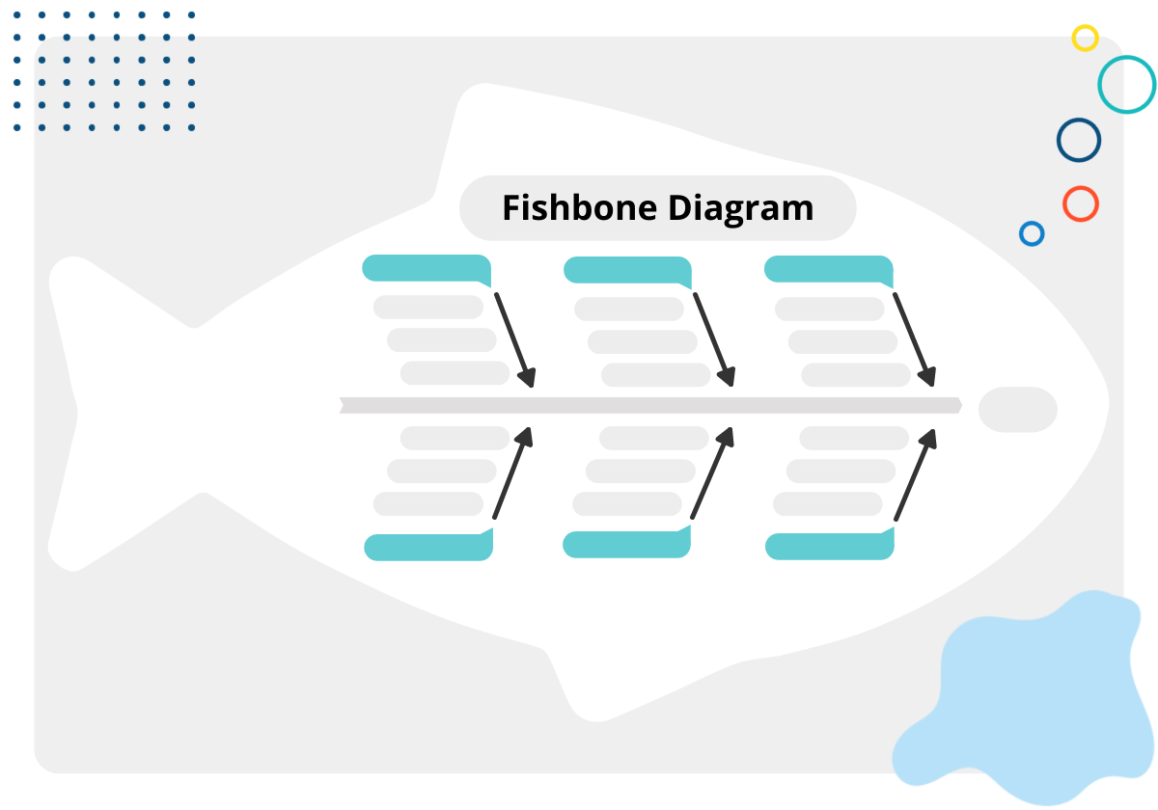
Activity Instructions
- Write the core issue at the "head" of the fish. This is the "effect."
- Define the categories of possible causes and write them at the end of each rib. You can create your own or use already existing category sets, such as people, materials, methods, measurement, environmental factors, and policies and procedures. You might also use the IPQs as possible causes to explore how different program areas work together.
- Brainstorm "causes" under each category. Ask "Why does this happen?" to stimulate brainstorming. Draw lines off of each rib and write down "causes." Place causes in more than one category if appropriate. Brainstorm possible causes for each category.


Fillable Template
Cause |  | Cause |  | Cause
Factor |  | Factor |  | Factor
Factor |  | Factor |  | Factor
Factor |  | Factor |  | Factor
 | ➤ |  | ➤ |  | ➤ | Problem Statement
Factor |  | Factor |  | Factor
Factor |  | Factor |  | Factor
Factor |  | Factor |  | Factor
Cause |  | Cause |  | Cause

